Live Exports via Darwin Port – FEBRUARY 2019

*Please note: figures are for stock exported through the Port of Darwin only; some NT stock are exported through interstate ports.*

Please note: the NT Cattle figures here have been rounded respectively and may not tally to totals.

*The figures listed below are correct as at February 28 2019 and are subject to change as further data becomes available.*

Live exports via Darwin port - February 2019

**OTHER LIVESTOCK**

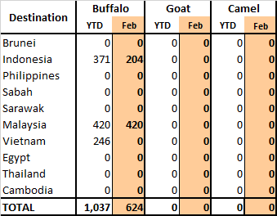

**LIVESTOCK MOVEMENT STATISTICS**

Reports for livestock movements from NT to Interstate, within NT and Interstate to NT are updated biannually - see [www.dpir.nt.gov.au/primary-industry/primary-industry-strategies-projects-and-research/livestock-movement-statistics](http://www.dpir.nt.gov.au/primary-industry/primary-industry-strategies-projects-and-research/livestock-movement-statistics)

\