Mineral Titles Act 2010
NOTICE OF LAND CEASING TO BE A MINERAL TITLE AREA
Title Type and Number: | Exploration Licence 30668
Area Ceased on: | 09 July 2019
Area: | 247 Blocks, 806.79 km²
Locality: | COANJULA
Name of Applicant(s)/Holder(s): | 100% CEDAR RESOURCES PTY LTD [ACN. 612 086 932]
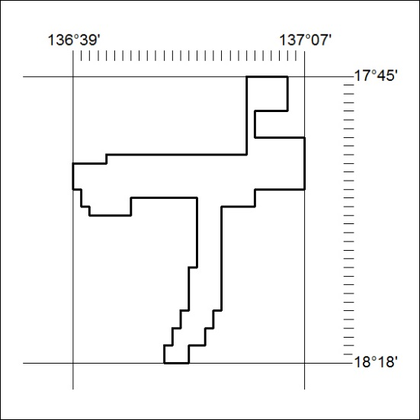

280/19

Mineral Titles Act
NOTICE OF GRANT OF A MINERAL TITLE
Title Type and Number: | Exploration Licence 32031
Granted: | 09 July 2019, for a period of 6 Years
Area: | 203 Blocks, 660.67 km²
Locality: | ROCKHAMPTON DOWNS
Name of Holder/s: | 100% PINNACLE GOLD PTY LTD [ACN. 151 778 424]
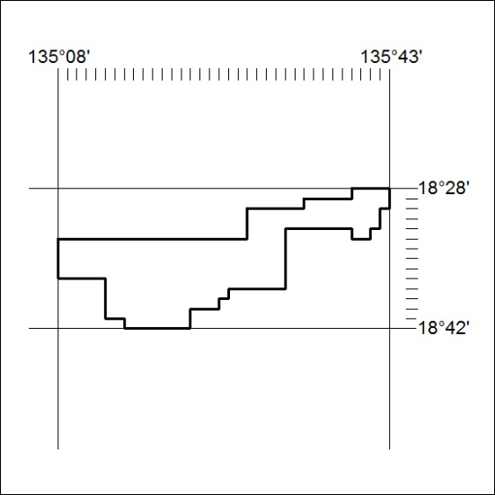
Area granted is indicated above. The titleholder is not permitted to exercise occupational rights on any land that is subject to a development title, or an application for a development title. Any land the subject of a Reserved Land gazettal under the Mineral Titles Act and all land vested in the Commonwealth of Australia is also excluded by description but not excised from the grant area.

281/19

Mineral Titles Act
NOTICE OF GRANT OF A MINERAL TITLE
Title Type and Number: | Exploration Licence 32032
Granted: | 09 July 2019, for a period of 6 Years
Area: | 200 Blocks, 652.83 km²
Locality: | MONMOONA
Name of Holder/s: | 100% PINNACLE GOLD PTY LTD [ACN. 151 778 424]
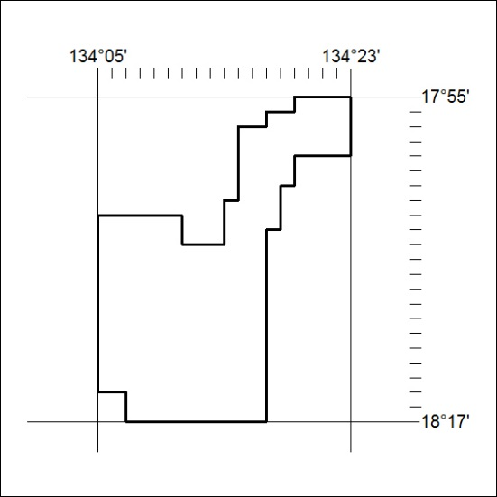
Area granted is indicated above. The titleholder is not permitted to exercise occupational rights on any land that is subject to a development title, or an application for a development title. Any land the subject of a Reserved Land gazettal under the Mineral Titles Act and all land vested in the Commonwealth of Australia is also excluded by description but not excised from the grant area.
282/19

Mineral Titles Act
NOTICE OF GRANT OF A MINERAL TITLE
Title Type and Number: | Exploration Licence 32039
Granted: | 05 July 2019, for a period of 6 Years
Area: | 200 Blocks, 657.89 km²
Locality: | WARRAMBAN
Name of Holder/s: | 100% PENNANT RESOURCES PTY LTD [ACN. 150 501 492]
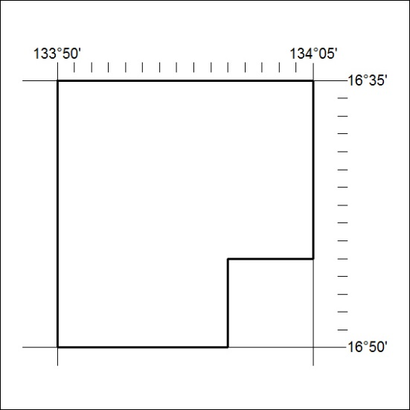
Area granted is indicated above. The titleholder is not permitted to exercise occupational rights on any land that is subject to a development title, or an application for a development title. Any land the subject of a Reserved Land gazettal under the Mineral Titles Act and all land vested in the Commonwealth of Australia is also excluded by description but not excised from the grant area.
283/19

