Mineral Titles Act 2010
NOTICE OF LAND CEASING TO BE A MINERAL TITLE APPLICATION AREA
Title Type and Number: | Exploration Licence in Retention 31739
Area ceased on: | 19 July 2019
Area: | 44084.00 Hectares
Locality: | AMMAROO
Name of Applicants(s)Holder(s): | 100% TERRITORY PHOSPHATE PTY LTD [ACN. 130 065 351]
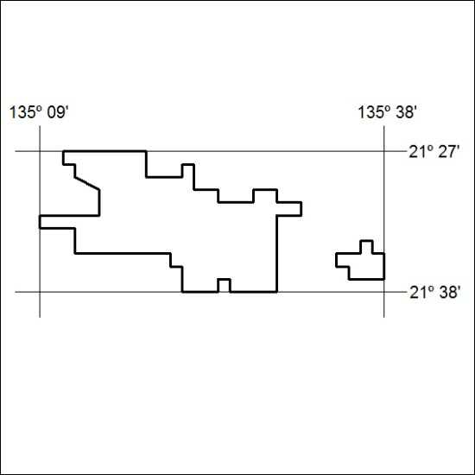

301/19

Mineral Titles Act 2010
NOTICE OF LAND CEASING TO BE A MINERAL TITLE APPLICATION AREA
Title Type and Number: | Exploration Licence in Retention 31740
Area ceased on: | 19 July 2019
Area: | 7658.00 Hectares
Locality: | SANDOVER
Name of Applicants(s)Holder(s): | 100% TERRITORY PHOSPHATE PTY LTD [ACN. 130 065 351]
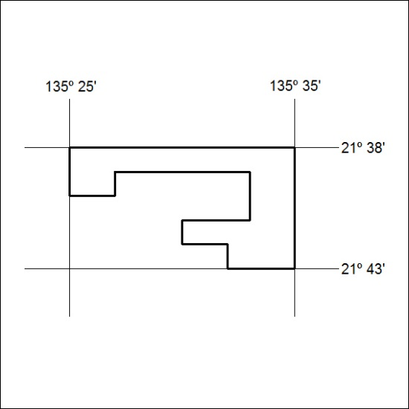

302/19

Mineral Titles Act 2010
NOTICE OF LAND CEASING TO BE A MINERAL TITLE APPLICATION AREA
Title Type and Number: | Exploration Licence in Retention 31741
Area ceased on: | 19 July 2019
Area: | 7829.00 Hectares
Locality: | AMMAROO
Name of Applicants(s)Holder(s): | 100% TERRITORY PHOSPHATE PTY LTD [ACN. 130 065 351]
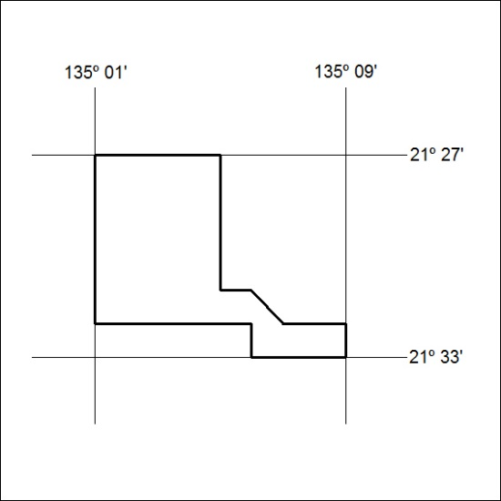

303/19

Mineral Titles Act 2010
NOTICE OF LAND CEASING TO BE A MINERAL TITLE APPLICATION AREA
Title Type and Number: | Exploration Licence in Retention 31742
Area ceased on: | 19 July 2019
Area: | 40825.00 Hectares
Locality: | SANDOVER
Name of Applicants(s)Holder(s): | 100% TERRITORY PHOSPHATE PTY LTD [ACN. 130 065 351]
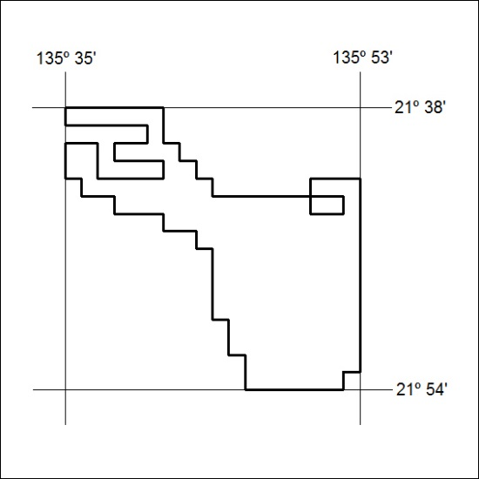

304/19

Mineral Titles Act 2010
NOTICE OF LAND CEASING TO BE A MINERAL TITLE APPLICATION AREA
Title Type and Number: | Exploration Licence in Retention 31743
Area ceased on: | 19 July 2019
Area: | 1599.00 Hectares
Locality: | GEORGE CREEK
Name of Applicants(s)Holder(s): | 100% TERRITORY PHOSPHATE PTY LTD [ACN. 130 065 351]
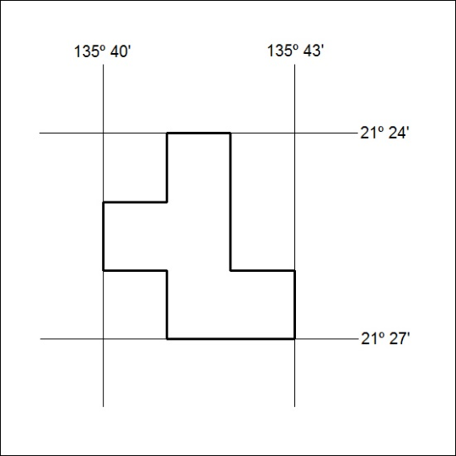

305/19

Mineral Titles Act 2010
NOTICE OF LAND CEASING TO BE A MINERAL TITLE APPLICATION AREA
Title Type and Number: | Exploration Licence in Retention 31744
Area ceased on: | 19 July 2019
Area: | 7027.00 Hectares
Locality: | SANDOVER
Name of Applicants(s)Holder(s): | 100% TERRITORY PHOSPHATE PTY LTD [ACN. 130 065 351]
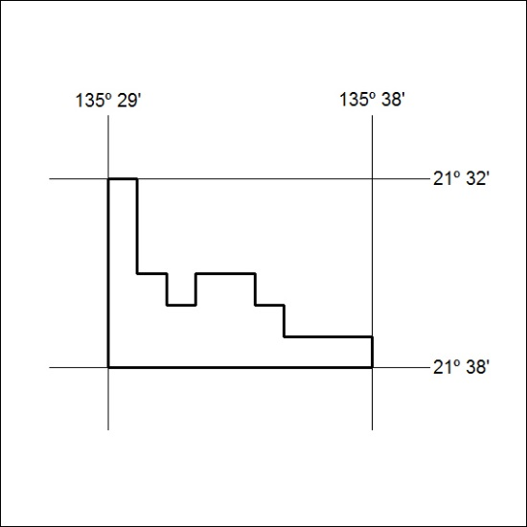

306/19

Mineral Titles Act 2010
NOTICE OF LAND CEASING TO BE A MINERAL TITLE APPLICATION AREA
Title Type and Number: | Exploration Licence in Retention 31745
Area ceased on: | 19 July 2019
Area: | 21402.00 Hectares
Locality: | SANDOVER
Name of Applicants(s)Holder(s): | 100% TERRITORY PHOSPHATE PTY LTD [ACN. 130 065 351]
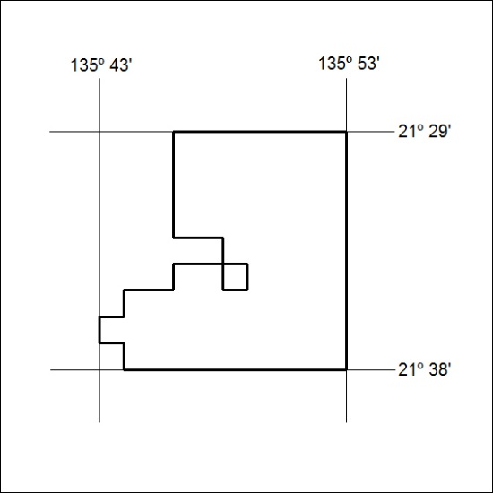

307/19

Mineral Titles Act 2010
NOTICE OF LAND CEASING TO BE A MINERAL TITLE APPLICATION AREA
Title Type and Number: | Exploration Licence in Retention 31746
Area ceased on: | 19 July 2019
Area: | 1281.00 Hectares
Locality: | GEORGE CREEK
Name of Applicants(s)Holder(s): | 100% TERRITORY PHOSPHATE PTY LTD [ACN. 130 065 351]
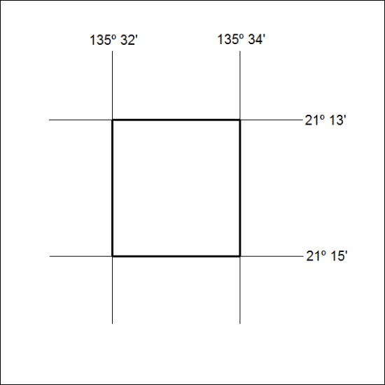

308/19

Mineral Titles Act 2010
NOTICE OF LAND CEASING TO BE A MINERAL TITLE APPLICATION AREA
Title Type and Number: | Exploration Licence in Retention 31747
Area ceased on: | 19 July 2019
Area: | 30699.00 Hectares
Locality: | GEORGE CREEK
Name of Applicants(s)Holder(s): | 100% TERRITORY PHOSPHATE PTY LTD [ACN. 130 065 351]
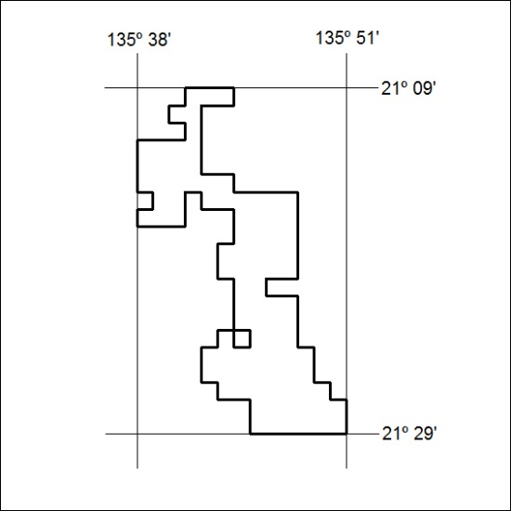

309/19

Mineral Titles Act 2010
NOTICE OF LAND CEASING TO BE A MINERAL TITLE APPLICATION AREA
Title Type and Number: | Exploration Licence in Retention 31748
Area ceased on: | 19 July 2019
Area: | 40068.00 Hectares
Locality: | GEORGE CREEK
Name of Applicants(s)Holder(s): | 100% TERRITORY PHOSPHATE PTY LTD [ACN. 130 065 351]
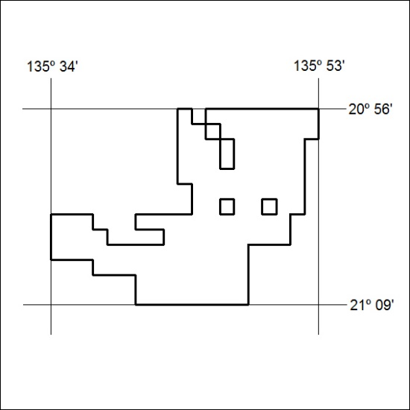

310/19

Mineral Titles Act 2010
NOTICE OF LAND CEASING TO BE A MINERAL TITLE APPLICATION AREA
Title Type and Number: | Exploration Licence in Retention 31749
Area ceased on: | 19 July 2019
Area: | 8642.00 Hectares
Locality: | GEORGE CREEK
Name of Applicants(s)Holder(s): | 100% TERRITORY PHOSPHATE PTY LTD [ACN. 130 065 351]
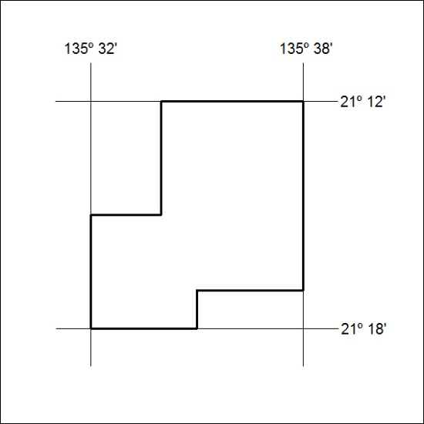

311/19

Mineral Titles Act 2010
NOTICE OF LAND CEASING TO BE A MINERAL TITLE APPLICATION AREA
Title Type and Number: | Exploration Licence in Retention 31750
Area ceased on: | 19 July 2019
Area: | 10525.00 Hectares
Locality: | SANDOVER
Name of Applicants(s)Holder(s): | 100% TERRITORY PHOSPHATE PTY LTD [ACN. 130 065 351]
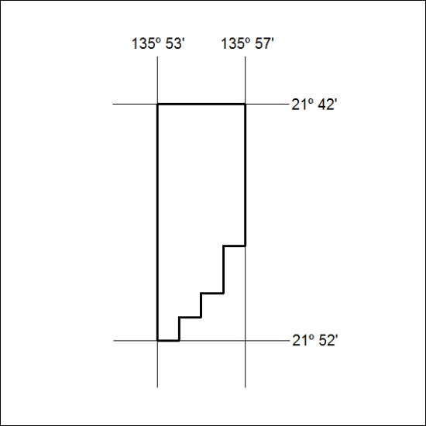

312/19

