Mineral Titles Act 2010
NOTICE OF LAND CEASING TO BE A MINERAL TITLE AREA
Title Type and Number: | Exploration Licence 24987
Area Ceased on: | 02 August 2019
Area: | 71 Blocks, 220.37 km²
Locality: | EBENEZER
Name of Applicant(s)/Holder(s): | 100% TERRITORY POTASH PTY LTD* [ACN. 116 070 207]
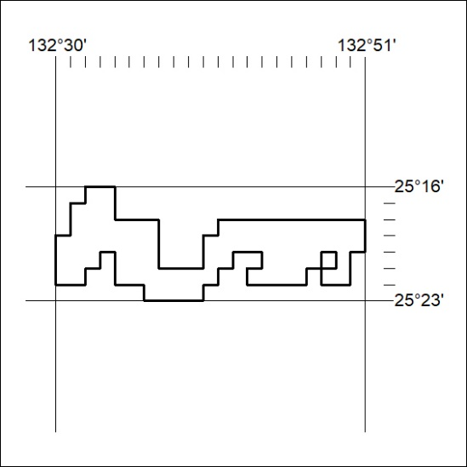

325/19

Mineral Titles Act 2010
NOTICE OF LAND CEASING TO BE A MINERAL TITLE AREA
Title Type and Number: | Exploration Licence 25080
Area Ceased on: | 02 August 2019
Area: | 204 Blocks, 633.58 km²
Locality: | ANGAS
Name of Applicant(s)/Holder(s): | 100% TERRITORY POTASH PTY LTD* [ACN. 116 070 207]
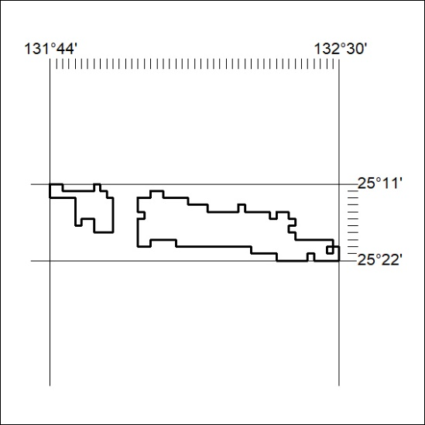

326/19
Mineral Titles Act 2010
NOTICE OF LAND CEASING TO BE A MINERAL TITLE AREA
Title Type and Number: | Exploration Licence 28205
Area Ceased on: | 02 August 2019
Area: | 19 Blocks, 59.04 km²
Locality: | CURTIN
Name of Applicant(s)/Holder(s): | 100% TERRITORY POTASH PTY LTD* [ACN. 116 070 207]
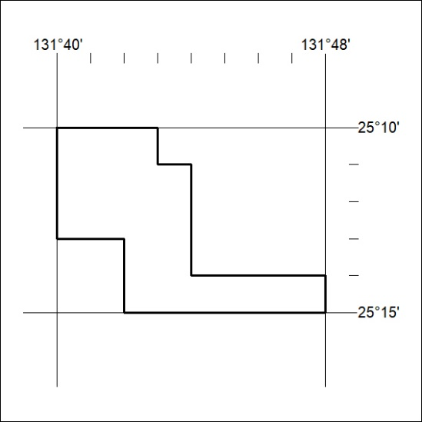

327/19

Mineral Titles Act 2010
NOTICE OF LAND CEASING TO BE A MINERAL TITLE AREA
Title Type and Number: | Exploration Licence 28272
Area Ceased on: | 02 August 2019
Area: | 19 Blocks, 59.03 km²
Locality: | ANGAS
Name of Applicant(s)/Holder(s): | 100% TERRITORY POTASH PTY LTD* [ACN. 116 070 207]
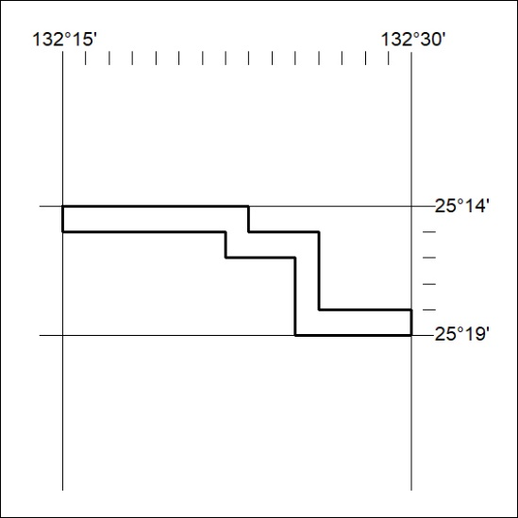

328/19
Mineral Titles Act 2010
NOTICE OF LAND CEASING TO BE A MINERAL TITLE AREA
Title Type and Number: | Exploration Licence 28872
Area Ceased on: | 02 August 2019
Area: | 11 Blocks, 34.15 km²
Locality: | EBENEZER
Name of Applicant(s)/Holder(s): | 100% TERRITORY POTASH PTY LTD* [ACN. 116 070 207]
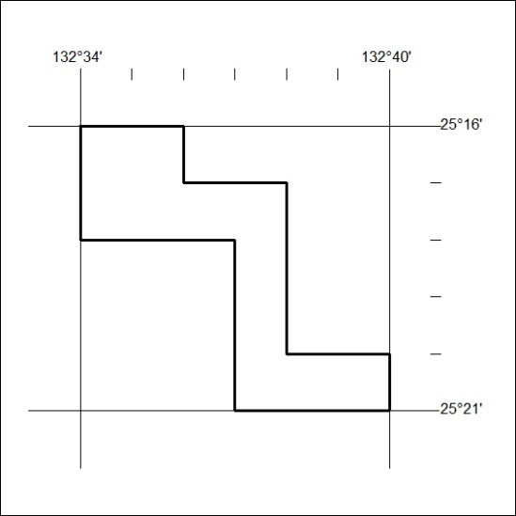

329/19

Mineral Titles Act 2010
NOTICE OF LAND CEASING TO BE A MINERAL TITLE AREA
Title Type and Number: | Exploration Licence 30381
Area Ceased on: | 02 August 2019
Area: | 4 Blocks, 12.43 km²
Locality: | CURTIN
Name of Applicant(s)/Holder(s): | 100% TERRITORY POTASH PTY LTD* [ACN. 116 070 207]
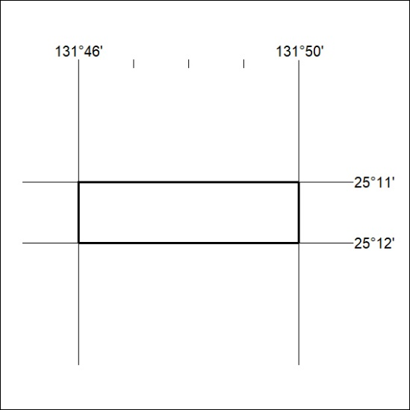

330/19
Mineral Titles Act 2010
NOTICE OF LAND CEASING TO BE A MINERAL TITLE AREA
Title Type and Number: | Exploration Licence 30382
Area Ceased on: | 02 August 2019
Area: | 8 Blocks, 22.22 km²
Locality: | CURTIN
Name of Applicant(s)/Holder(s): | 100% TERRITORY POTASH PTY LTD* [ACN. 116 070 207]
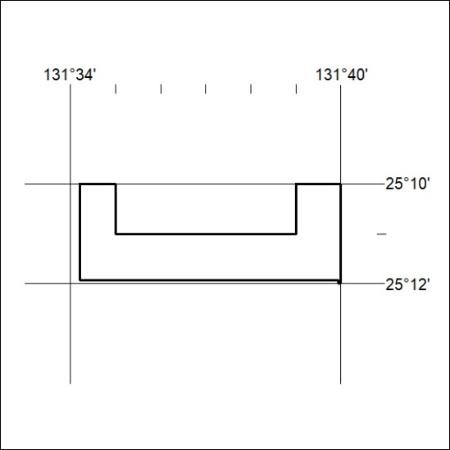

331/19

