Mineral Titles Act 2010
NOTICE OF LAND CEASING TO BE A MINERAL TITLE APPLICATION AREA
Title Type and Number: | Exploration Licence 26903
Area Ceased on: | 26 September 2019
Area: | 74 Blocks, 200.28 km²
Locality: | STUDHOLME
Name of Applicant(s)/Holder(s): | 100% PRODIGY GOLD NL* [ACN. 009 127 020]
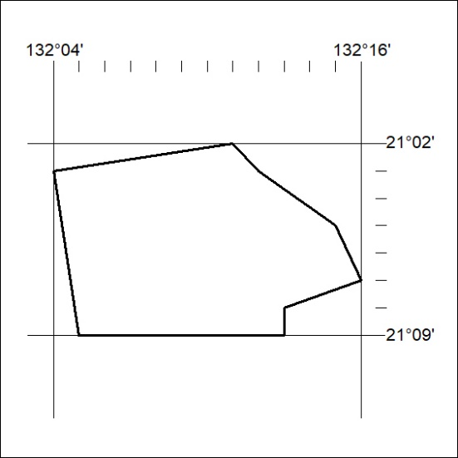

405/19

