Mineral Titles Act
NOTICE OF GRANT OF A MINERAL TITLE
Title Type and Number: | Extractive Mineral Exploration Licence 32129
Granted: | 23 January 2020, for a period of 2 Years
Area: | 4 Blocks, 13.23 km²
Locality: | LARRIMAH
Name of Holder/s: | 100% TERRITORY SANDS PTY LTD [ACN. 632 797 972]
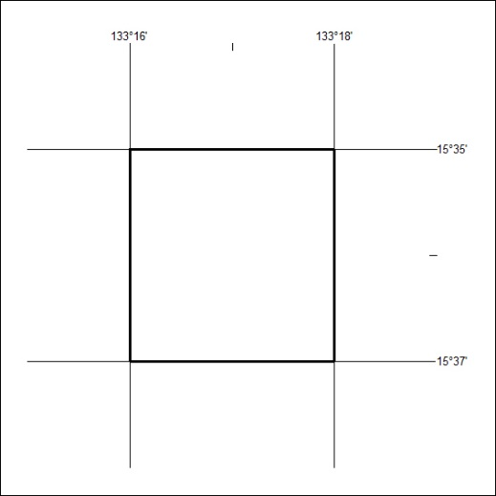
Area granted is indicated above. The titleholder is not permitted to exercise occupational rights on any land that is subject to a development title, or an application for a development title. Any land the subject of a Reserved Land gazettal under the Mineral Titles Act and all land vested in the Commonwealth of Australia is also excluded by description but not excised from the grant area.

23/20

Mineral Titles Act
NOTICE OF GRANT OF A MINERAL TITLE
Title Type and Number: | Extractive Mineral Exploration Licence 32130
Granted: | 23 January 2020, for a period of 2 Years
Area: | 4 Blocks, 13.23 km²
Locality: | LARRIMAH
Name of Holder/s: | 100% TERRITORY SANDS PTY LTD [ACN. 632 797 972]
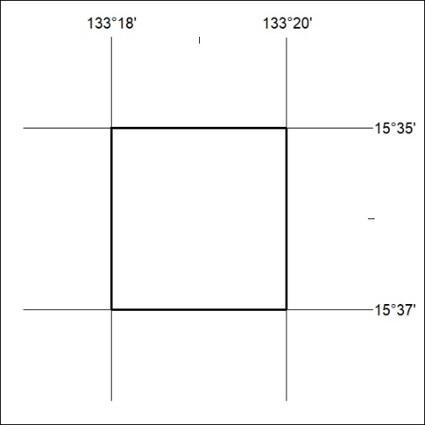
Area granted is indicated above. The titleholder is not permitted to exercise occupational rights on any land that is subject to a development title, or an application for a development title. Any land the subject of a Reserved Land gazettal under the Mineral Titles Act and all land vested in the Commonwealth of Australia is also excluded by description but not excised from the grant area.

24/20

Mineral Titles Act
NOTICE OF GRANT OF A MINERAL TITLE
Title Type and Number: | Extractive Mineral Exploration Licence 32131
Granted: | 23 January 2020, for a period of 2 Years
Area: | 4 Blocks, 13.22 km²
Locality: | LARRIMAH
Name of Holder/s: | 100% TERRITORY SANDS PTY LTD [ACN. 632 797 972]
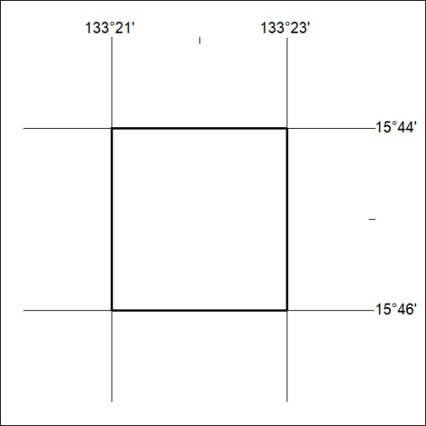
Area granted is indicated above. The titleholder is not permitted to exercise occupational rights on any land that is subject to a development title, or an application for a development title. Any land the subject of a Reserved Land gazettal under the Mineral Titles Act and all land vested in the Commonwealth of Australia is also excluded by description but not excised from the grant area.

25/20

Mineral Titles Act
NOTICE OF GRANT OF A MINERAL TITLE
Title Type and Number: | Extractive Mineral Exploration Licence 32132
Granted: | 23 January 2020, for a period of 2 Years
Area: | 4 Blocks, 13.21 km²
Locality: | LARRIMAH
Name of Holder/s: | 100% TERRITORY SANDS PTY LTD [ACN. 632 797 972]
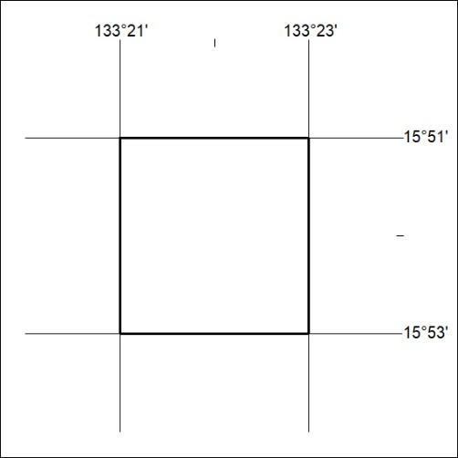
Area granted is indicated above. The titleholder is not permitted to exercise occupational rights on any land that is subject to a development title, or an application for a development title. Any land the subject of a Reserved Land gazettal under the Mineral Titles Act and all land vested in the Commonwealth of Australia is also excluded by description but not excised from the grant area.

26/20

Corrigendum
Notice Number 03/19 appearing in MN01/19 on 3 January 2019 is hereby cancelled and replaced by the following:

Mineral Titles Act
NOTICE OF GRANT OF A MINERAL TITLE
Title Type and Number: | Exploration Licence 31543
Granted: | 02 January 2019, for a period of 6 Years
Area: | 77 Blocks, 448.91 km²
Locality: | BRAHMA
Name of Holder/s: | 100% TYPHON MINERALS PTY LTD [ACN. 614 887 464]
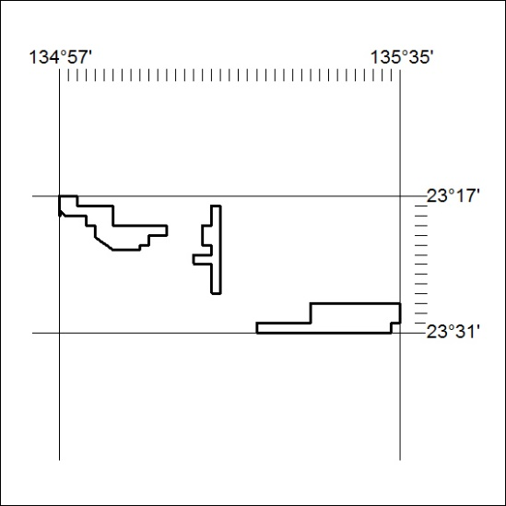
Area granted is indicated above. The titleholder is not permitted to exercise occupational rights on any land that is subject to a development title, or an application for a development title. Any land the subject of a Reserved Land gazettal under the Mineral Titles Act and all land vested in the Commonwealth of Australia is also excluded by description but not excised from the grant area.

27/20

