Mineral Titles Act 2010
NOTICE OF LAND CEASING TO BE A MINERAL TITLE AREA
Title Type and Number: | Exploration Licence 29579
Area Ceased on: | 30 March 2020
Area: | 10 Blocks, 31.71 km²
Locality: | JERVOIS RANGE
Name of Applicant(s)/Holder(s): | 100% DBL BLUES PTY LTD [ACN. 140 024 442]
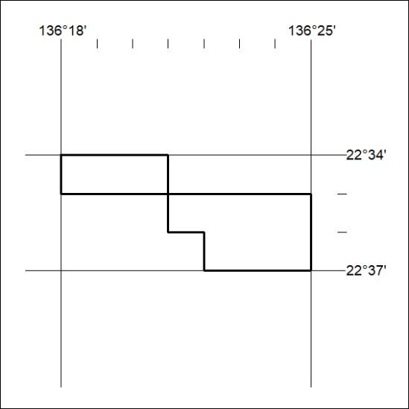
156/20

Mineral Titles Act 2010
NOTICE OF LAND CEASING TO BE A MINERAL TITLE APPLICATION AREA
Title Type and Number: | Exploration Licence 32188
Area Ceased on: | 31 March 2020
Area: | 131 Blocks, 410.63 km²
Locality: | SEIGAL
Name of Applicant(s)/Holder(s): | 100% HARKISS MINERAL DISCOVERY PTY LTD [ACN. 603 435 856]
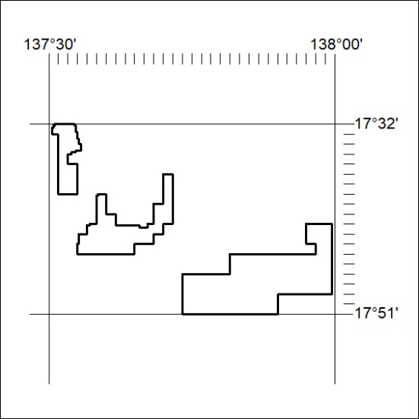
157/20

