Mineral Titles Act 2010
NOTICE OF LAND CEASING TO BE A MINERAL TITLE AREA
Title Type and Number: | Exploration Licence 32176
Area Ceased on: | 03 April 2020
Area: | 242 Blocks, 752.59 km²
Locality: | CARRARA
Name of Applicant(s)/Holder(s): | 100% STRATEGIC ENERGY RESOURCES LIMITED* [ACN. 051 212 429]
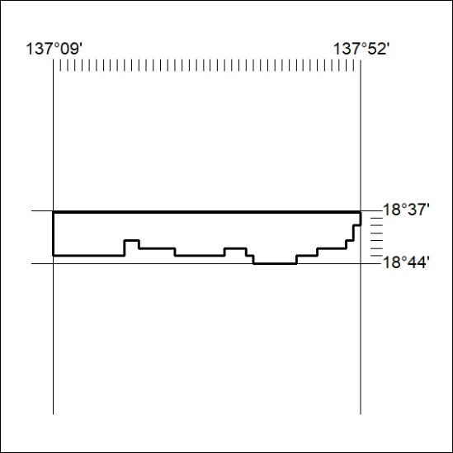
160/20

