Mineral Titles Act 2010
NOTICE OF LAND CEASING TO BE A MINERAL TITLE AREA
Title Type and Number: | Exploration Licence 31140
Area Ceased on: | 01 July 2020
Area: | 165 Blocks, 524.98 km²
Locality: | ANNINGIE
Name of Applicant(s)/Holder(s): | 100% LITHIUM DEVELOPMENTS PTY LTD [ACN. 612 245 020]
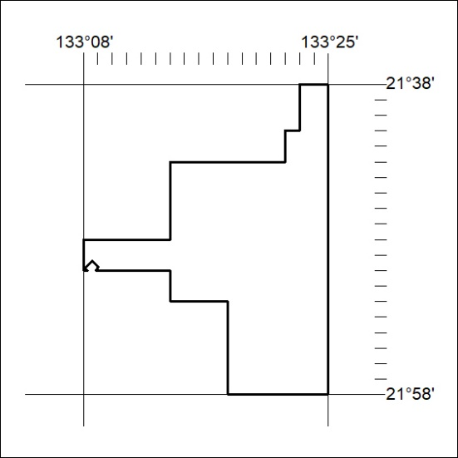

213/20

Mineral Titles Act 2010
NOTICE OF LAND CEASING TO BE A MINERAL TITLE AREA
Title Type and Number: | Exploration Licence 31305
Area Ceased on: | 01 July 2020
Area: | 22 Blocks, 70.00 km²
Locality: | DOREEN
Name of Applicant(s)/Holder(s): | 100% LITCHFIELD MINERALS PTY LTD [ACN. 612 660 429]
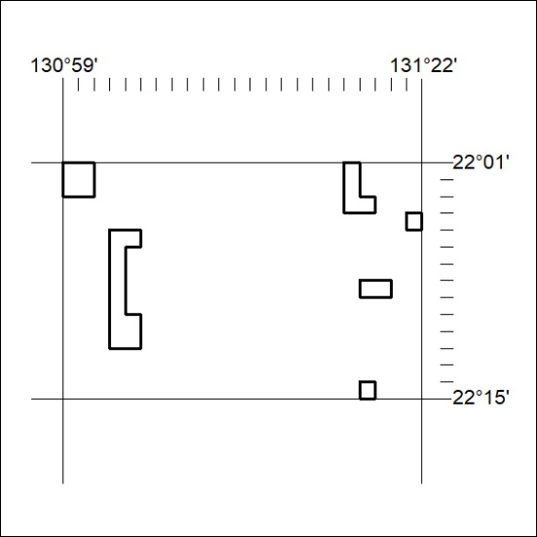

214/20
Mineral Titles Act 2010
NOTICE OF LAND CEASING TO BE A MINERAL TITLE APPLICATION AREA
Title Type and Number: | Exploration Licence 32422
Area Ceased on: | 01 July 2020
Area: | 4 Blocks, 13.36 km²
Locality: | McKINLAY RIVER
Name of Applicant(s)/Holder(s): | 100% SPUNDAILY PTY. LIMITED [ACN. 009 617 109]
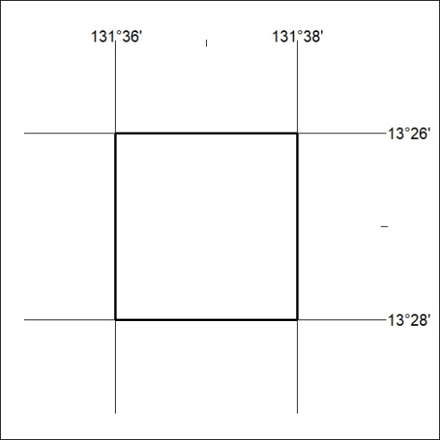

215/20

Mineral Titles Act 2010
NOTICE OF LAND CEASING TO BE A MINERAL TITLE APPLICATION AREA
Title Type and Number: | Exploration Licence 32423
Area Ceased on: | 01 July 2020
Area: | 4 Blocks, 13.36 km²
Locality: | McKINLAY RIVER
Name of Applicant(s)/Holder(s): | 100% TOTTEN Robert
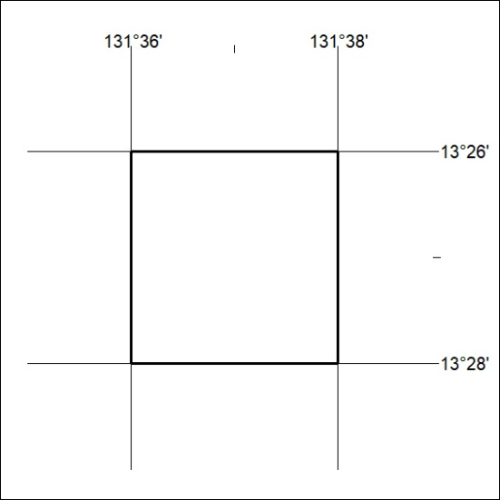

216/20
Mineral Titles Act 2010
NOTICE OF LAND CEASING TO BE A MINERAL TITLE APPLICATION AREA
Title Type and Number: | Exploration Licence 32425
Area Ceased on: | 01 July 2020
Area: | 4 Blocks, 13.36 km²
Locality: | McKINLAY RIVER
Name of Applicant(s)/Holder(s): | 100% PNX METALS LIMITED* [ACN. 127 446 271]

217/20

