Mineral Titles Act 2010
NOTICE OF LAND CEASING TO BE A MINERAL TITLE AREA
Title Type and Number: | Extractive Mineral Permit 30790
Area ceased on: | 13 August 2020
Area: | 3.00 Hectare
Locality: | BATCHELOR
Name of Applicants(s)Holder(s): | 100% GO WIDE CATTLE COMPANY PTY LTD [ACN. 602 629 710]
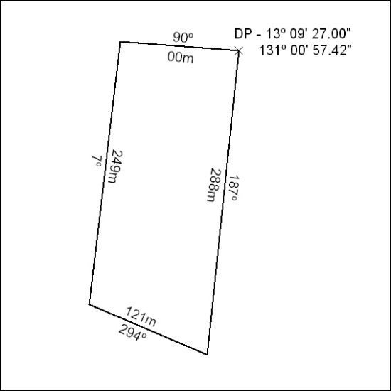

274/20

Mineral Titles Act
NOTICE OF GRANT OF A MINERAL TITLE
Title Type and Number: | Exploration Licence 32369
Granted: | 13 August 2020, for a period of 6 Years
Area: | 200 Blocks, 615.68 km²
Locality: | SENTINEL BORE
Name of Holder/s: | 100% ENIGMA MINING LIMITED [ACN. 009 225 558]
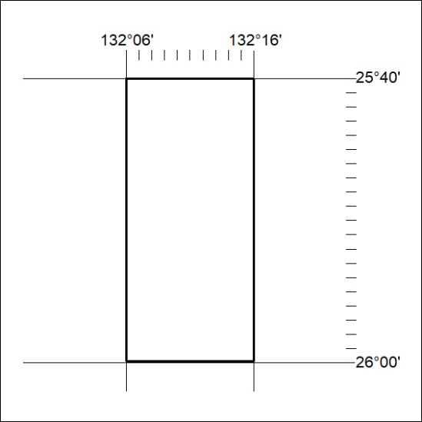
Area granted is indicated above. The titleholder is not permitted to exercise occupational rights on any land that is subject to a development title, or an application for a development title. Any land the subject of a Reserved Land gazettal under the Mineral Titles Act and all land vested in the Commonwealth of Australia is also excluded by description but not excised from the grant area.

275/20

Mineral Titles Act
NOTICE OF GRANT OF A MINERAL TITLE
Title Type and Number: | Exploration Licence 32370
Granted: | 13 August 2020, for a period of 6 Years
Area: | 200 Blocks, 615.68 km²
Locality: | SENTINEL BORE
Name of Holder/s: | 100% ENIGMA MINING LIMITED [ACN. 009 225 558]
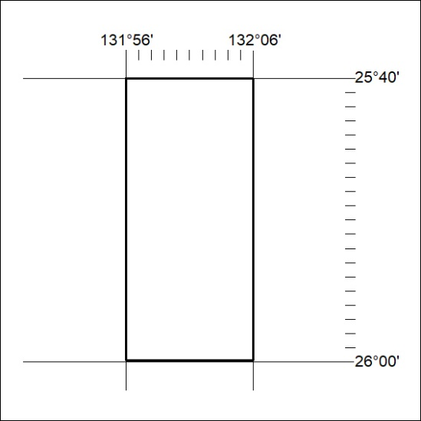
Area granted is indicated above. The titleholder is not permitted to exercise occupational rights on any land that is subject to a development title, or an application for a development title. Any land the subject of a Reserved Land gazettal under the Mineral Titles Act and all land vested in the Commonwealth of Australia is also excluded by description but not excised from the grant area.

276/20

