Mineral Titles Act 2010
NOTICE OF LAND CEASING TO BE A MINERAL TITLE AREA
Title Type and Number: | Exploration Licence in Retention 97
Area ceased on: | 19 August 2020
Area: | 236.00 Hectares
Locality: | BATCHELOR
Name of Applicants(s)Holder(s): | 100% KIRKLAND LAKE GOLD AUSTRALIA PTY LTD* [ACN. 136 505 587]
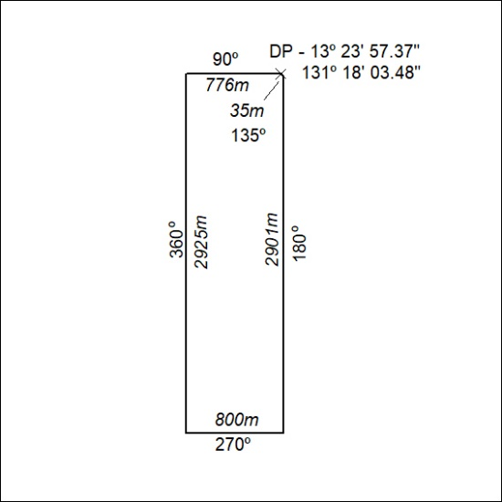

298/20

