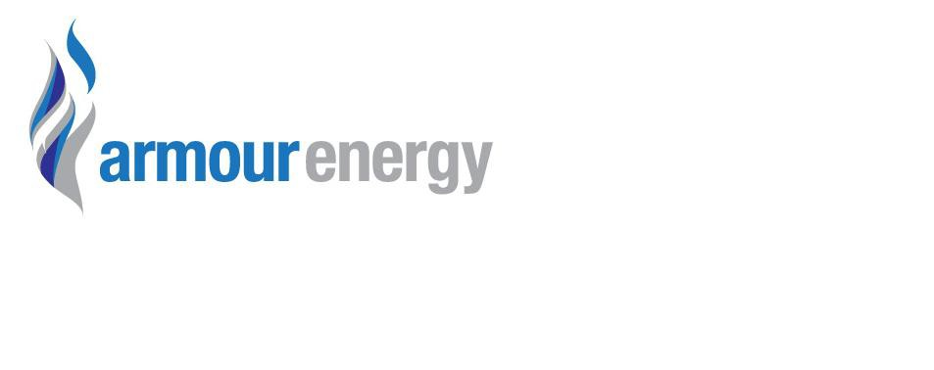

|  |  |
| --- | --- |
| **Document Title** | **EMP Summary (2014)**  **EP170-EP190 DCIP Work Program** |
| **Document Number** | **EP171-190-ENV-GEN-PLN-003** |

|  |  |  |  |  |  |
| --- | --- | --- | --- | --- | --- |
| Rev | Status | Prepared by | Checked by | Approved By | Date |
| A | For Review | Luke Titus | Josh Bluett | Roger Cressey | 11/08/2014 |
| 1 | Final | Luke Titus | Josh Bluett | Roger Cressey | 11/08/2014 |
|  |  |  |  |  |  |

**CONTENTS**

1 Coordinates and locality maps (legible and at appropriate scale) of the activity ................................ 3

2 Description of the activity ......................................................................................................... 3

3 Description of the environment where activity will occur .............................................................. 4

4 Description of the activity in relation to the environment (including best environmental practice) ...... 5

5 State major environmental hazards and risks; describe hazard/risk assessment process and controls measures ........................................................................................................................................ 6

6 Provide an overall description of the environmental management approach ..................................... 6

7 Advice on consultation undertaken and provision for ongoing consultation ..................................... 7

8 State contact details of operator’s nominated liaison personnel for the activity ................................. 8

**1 Coordinates and locality maps (legible and at appropriate scale) of the activity**

|  |  |  |  |  |
| --- | --- | --- | --- | --- |
| **DCIP SURVEY** | **GDA94 - Zone53** | | | |
| **Corners** | **Lat** |  | **Long** |  |
| **Western Point** | -16.9617 |  | 136.301 |  |
| **Southern Point** | -16.9855 |  | 136.316 |  |
| **Estaren Point** | -16.9717 |  | 136.339 |  |
| **Northern Point** | -16.9483 |  | 136.325 |  |

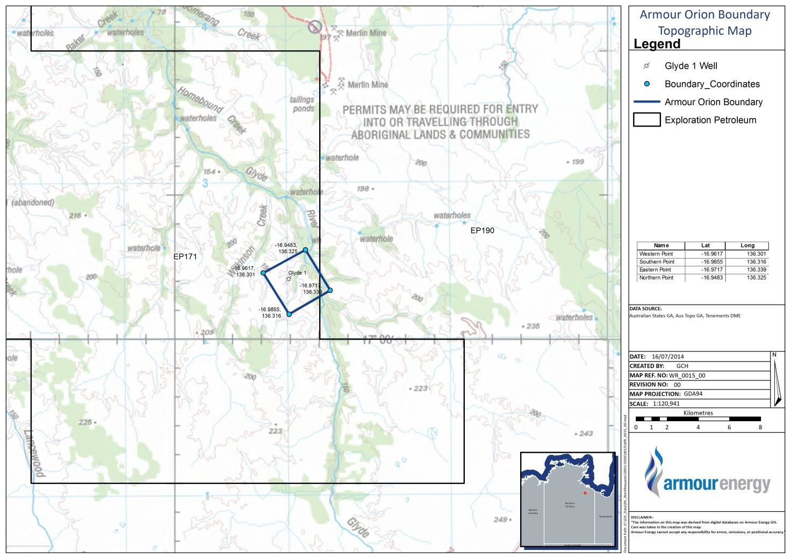

**Figure 1**- Location map and area of the ORION 3D DCIP Survey, Glyde Sub-basin, McArthur Basin; EP171

& EP190.

**2 Description of the activity**

Armour Energy plans to acquire approximately 9-km² of ORION 3D DC resistivity and IP chargeability (DCIP) data across a selected portion of the Glyde Sub-Basin located in 100% working interest Armour Energy granted tenements EP 171 & EP 190 during the 2014 dry season. The

proposed work program area is within the Glyde Sub-basin of the McArthur River Basin, NT and located on sections of McArthur River Station and a Crown Pastoral lease managed by Wardell Nominees.

The type of survey is an ORION 3D DC resistivity and IP chargeability (DCIP) with an estimated start date of Monday, August 25, 2014. The proposed survey work has a calculated area required to complete the survey of approximately 3km X 3km or 9-km² **(see Figure 1).**

The time to acquire the survey data is expected to be approximately 21 days and estimated to cost

$500k. The survey will require helicopter support to-from the cleared Glyde-1 well pad and the staging area located at the Heartbreak Hotel Armour Camp, Cape Crawford, NT.

A total of six (6) Quantec Geoscience personnel, one (1) Armour Energy Supervisor and two (2) traditional owners who speak for the work program area will be dropped off daily to locate, move and place receivers at pre-determined sites on the surface. A photo of a receiver station equipment is provided in **Figure 2**.

The objective of the work program is to assist in providing some definition of potential hydrocarbon bearing gas reservoirs and future drilling locations that will target the Coxco-Teena Dolomite.

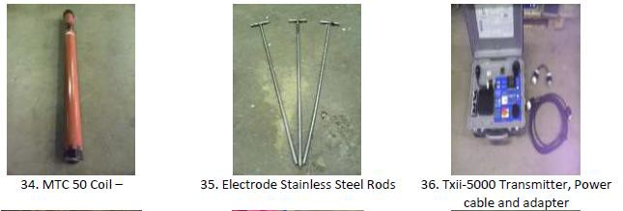

**Figure 2**- Acquisition technology for the ORION 3D DCIP Survey, Glyde Sub-basin, McArthur Basin; EP171

& EP190.

**3 Description of the environment where activity will occur**

The landscape type is mainly, open, rocky, very sparsely vegetated and part of the Glyde River drainage system. There are numerous ephemeral creeks and the area contains a number of near- permanent waterholes. Apart from riparian vegetation along the Glyde River and associated watercourses, the hills and surrounding areas are mostly vegetated by sparse eucalypt woodland with some grassy understorey. Largely the land systems are ecologically consistent throughout the work program area.

Erosion control measures as required within the Armour Energy project EMP and the associated Land Management procedures. There is little to no soil in the work program area. The work program area is dominated by the Bukulara Sandstone of the Georgina Basin and is considered an arid range type.

The work program is in part of the McArthur River Station Perpetual Pastoral Lease and is used primarily for cattle grazing. To the east is the Crown Pastoral Pastoral Lease managed by Wardell Nominees is also used for cattle grazing.

The nearest community is the township of Borroloola. Borroloola is dominantly a service community for the nearby Xstrata McArthur River Zinc Mine and associated port facilities at Bing Bong and the surrounding cattle grazing stations.

Within the area sites of indigenous Cultural Sensitivity are known to exist and Armour Energy has implemented a cultural heritage management agreement with the Northern Land Council and the local Aboriginal Group under a Native Title Agreement.

**4 Description of the activity in relation to the environment (including best environmental practice)**

The work program involves the placement of electric measurement tools that are powered by small battery packs and then left for several hours to monitor electric fields at a given site. For each site there is no clearing or soil disturbance necessary and the equipment is simply laid on the surface. **Figures 3 and 4** demonstrate what a site looks like both during and after recording is done.

Field equipment and personnel will be transferred to-and-from the site by helicopter. The Glyde well pad will serve as landing pad and site locations will be hiked too or supported by transfer using a smaller R-44 helicopter.

A total of six (6) Quantec Geoscience personnel, one (1) Armour Energy Supervisor and two (2) traditional owners who speak for the work program area will be dropped off daily to locate, move and place receivers at pre-determined sites on the surface.

Armour Energy and Quantec Geosciences will supply field based staff with hotel accommodation at the Heartbreak Hotel, Cape Crawford, NT. Facilities at the hotel will be used to handle all gray water and no field based waste facilities will be needed at any time during the survey.

Rehabilitation will be in accordance with the principles set out in the approved Armour Energy

Environmental Management Plan. Since this is a very low impact survey, no rehabilitation is likely.

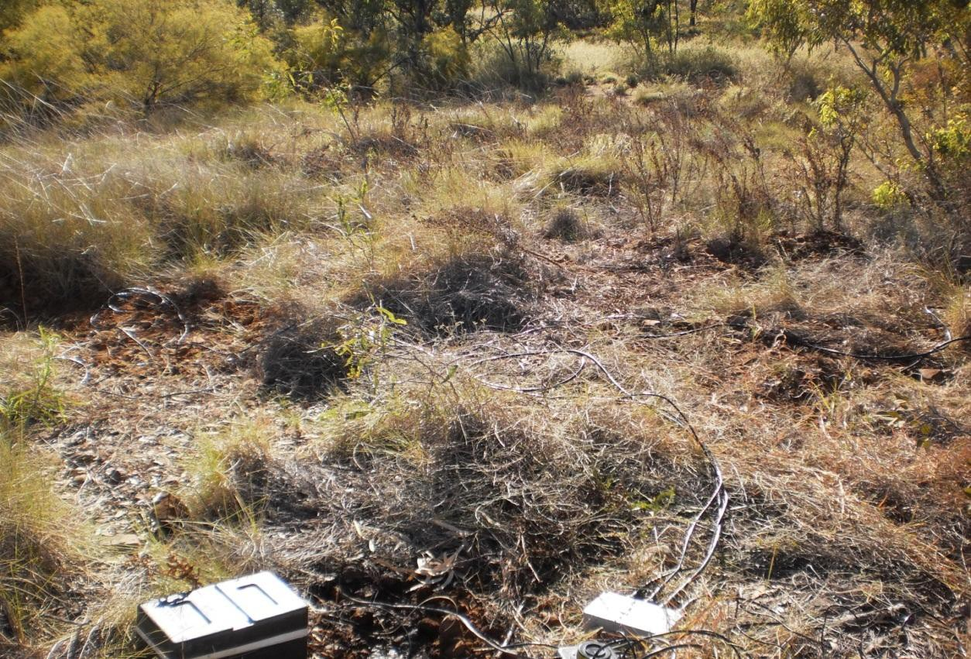

**Figure 3**- Example DCIP location site during data acquisition.

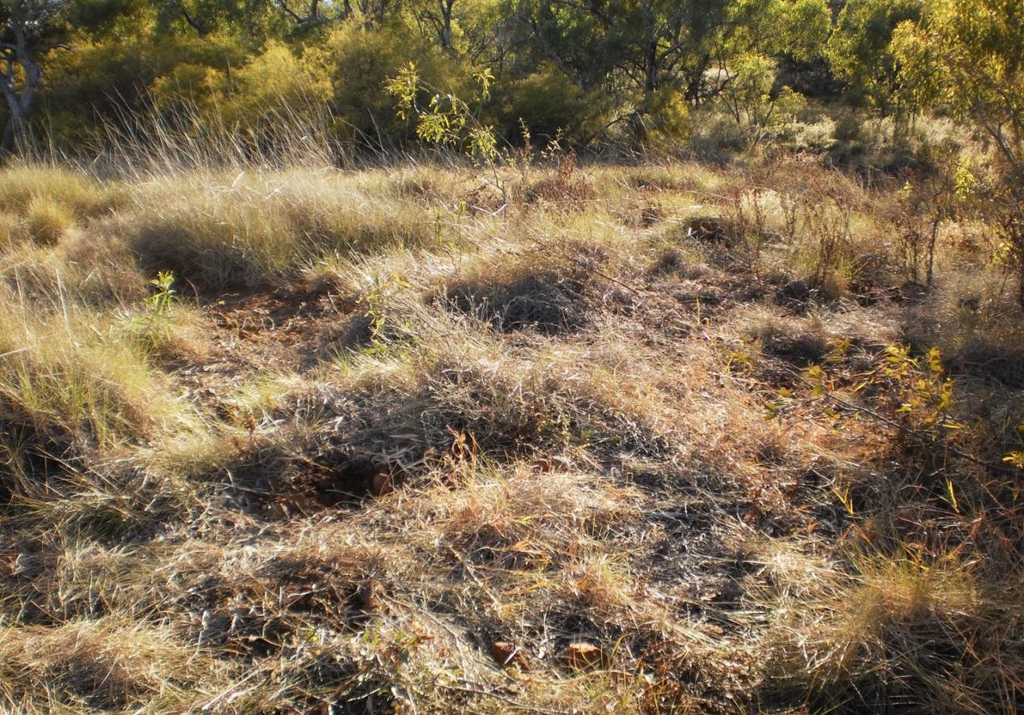

**Figure 4**- Example DCIP location site after data acquisition.

**5 State major environmental hazards and risks; describe hazard/risk assessment process and controls measures**

A risk assessment is included in Armour Energy’s environmental management framework documentation. The various risk assessments were reviewed by a qualified person and has been peer reviewed within Armour Energy. The various risk assessments lists all identified potential hazards and their respective treatment processes to reduce the likelihood of an unplanned event occurring which may damage the environment.

No major environmental issues were identified for the DCIP work program and the survey is deemed very low to inconsequential to the environmental.

**6 Provide an overall description of the environmental management approach**

Armour Energy will undertake its activities in compliance with the APPEA Code of Environmental Practice 2008. The Armour Energy Environmental Management Plan is constructed using this Code as its guide and incorporates the additional directions from NTDME. Further, specific local requirements resulting from consultation with Traditional Owners, Local Government, Landholders and Environmental Consultants are all captured within the Environmental Management Plan.

At a basic level Armour Energy will seek to minimise its footprint. All areas are assessed and monitored by people who are qualified and any rehabilitation will be in accordance with the APPEA Code of Environmental practice and specifications set by qualified third parties. Site rehabilitation will be monitored for effectiveness in accordance with Armour Energy’s Rehabilitation Monitoring Procedure.

*A*armourenergy

**armourenergy**



**Environmental Policy**

Policy Statement

Armour Energy is committed to proactive management of its environmental responsibilities,striving to achieve industry best practice environmental management. This

commitment extends to all aspects of its activities including sesi mci construction, production, logistics and management support.

acquisition, drilling,

Expectations

We will achieve by ensuring that all environmental obligations and environmental management measures are met or exceeded in relation to performance targets.

Measure

Armour Energy will:

• Integrate environmental management into lhe planning and operation of all Armour

Energy's business activities

• Comply with all statutory and l egalconditions and obfigalions

• Assist all employees to ensure they meet theri environmental obligations through training, education and communication

Promote a company culture with strong environmentalprinciples

• Contribute to the sustainable development of communities and conduct activities based on decisions that recognise both short and long-term economic, environmental and socialconsiderations

• Eliminate or manage hazards and practices that could cause accident, injury or illness to people, damage to property or unacceptable effects on the environment

Continually improve its environmental performance, make every reasonable effort to prevent pollution, reduce waste and greenhouse gas emissions, conserve energy and recycle materials

• Ensure that all contractors comply with Armour Energy's environmental requirements Allocate clear lines of accountability and impel ment a system that regularly monitors, reviews, audits and reports on environmental performance to management. regulatory authorities and stakeholders.

Scope and Responsibility

This Policy applies to all personnel involved in Armour Energy operations As a

cornerstone to the Armour Energy Environmental Policy, the expectations, measures and supporting plans, procedures and guidelines of this Policy provide for the management of the environment in the Armour Energy workplace.

The Chief Executive Offteer and supporting management are responsible for the

implementation and enforcement of this Policy

' h employeEy<;Onsultant, contractor, service provdi er and visitor is responsible for mplying itn and supporting this pol1cy



Robbert de eijer, Chief Executive Officer

W

"? '

Date: 1 *I* l Review date: 1' 1 August 2014

7 Advice on consultation undertaken and provision for ongoing consultation

Extensive consultation has been undertaken in the region particularly with Traditional Owners on a number of occasions (ongoing). The following people have been consulted with in respect of this campatgn:

• Northem Land Council (NLC),

• Closed forums with Traditional Owner people who speak for the various areas with EP 171 & EP 190.

• Open forums in Borroloola.

• Forums which include representative Anthropologists.

• Ongoing NLC consultation (weekly) informing them of progress and any matters raised by the Monitors.

• Landholders and Neighbouring Mine Operators.

• Northern Territory Department of Mines and Energy.

• Local Government (Council).

• Local businesses.

**8 State contact details of operator’s nominated liaison personnel for the activity**

Contact: Luke Titus

Mob: 0488444350

Email: [ltitus@armourenergy.com.au](mailto:ltitus@armourenergy.com.au)