

**HIDDEN VALLEY-S2**

**STRATIGRAPHIC WELL**

**ENVIRONMENTAL PLAN SUMMARY**

**TABLE OF CONTENTS**

**1. INTRODUCTION ..........................................................................................................................................3**

**2. DESCRIPTION OF ACTIVITY..........................................................................................................................4**

**3. DESCRIPTION OF THE ENVIRONMENT.........................................................................................................4**

**4. DESCRIPTION OF THE ACTIVITY IN RELATION TO THE ENVIRONMENT ........................................................5**

**5. ENVIRONMENTAL RISKS OF PROPOSED ACTIVITY AND CONTROL MEASURES ............................................5**

**6. CONSULTATION ..........................................................................................................................................6**

**7. PANGAEA RESOURCES LIAISON PERSONNEL...............................................................................................6**

**1. INTRODUCTION**

EP-168 is located approximately 500 km southeast of Darwin in the Northern Territory (NT) in the western McArthur Basin. The tenement falls within the Victoria-Daly, Roper & Barkley Shires plus the Katherine Municipality. The proposed Hidden Valley-S2 stratigraphic well will be located in the central western portion of EP-168, approximately 208 km south-southeast of Katherine and approximately 80 km west of the Stuart Highway.

***Table 1: Hidden Valley-S2 Well Data Summary***

|  |  |
| --- | --- |
| **Well Name and Number:** | Hidden Valley-S2 |
| **Designation:** | Petroleum stratigraphic well |
| **Permit:** | EP-168 |
| **Basin:** | McArthur Basin |
| **Proposed Location:**  (MGA94, Zone 53S) | Latitude 16° 18' 32.63”S (GDA94)  Longitude 132° 37' 16.41”E (GDA94)  Easting 245,824.00mE (MGA94, Zone 53S)  Northing 8,195,395.00mN (MGA94, Zone 53S) |

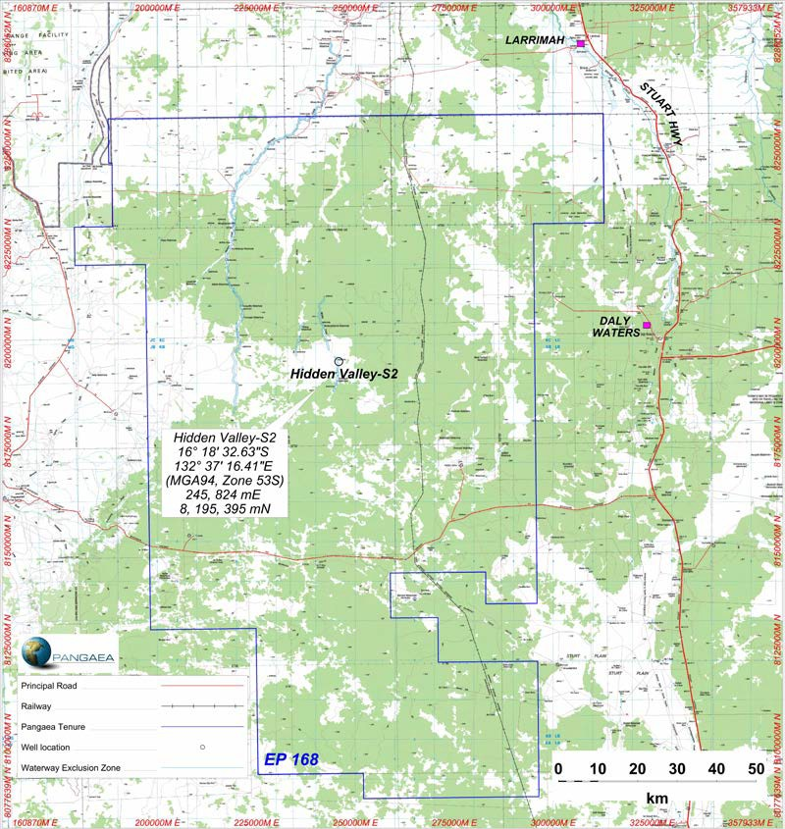

***Figure 1: EP-168 Hidden Valley-S2 Well Site***

**2. DESCRIPTION OF ACTIVITY**

The objectives of the Hidden Valley-S2 Stratigraphic Well in EP-168 are to:

• Identify thick intervals of organic shale;

• Confirm the stratigraphy and tie this stratigraphy to the regional seismic interpretation;

• Collect well velocity information to improve the time to depth conversion for the regional seismic interpretation; and

• Acquire cores and wireline logs for analysis in order to evaluate the shale units within the McArthur

Group.

The evaluation proposed for the well will comprise of coring and wireline logging operations. The final well will be sealed by leaving the cemented surface, conductor casings and cementing from total depth to surface to ensure complete isolation of all porous formations, aquifers and potential reservoirs.

**3. DESCRIPTION OF THE ENVIRONMENT**

The drilling and related activities are proposed and confined within the Sturt Plateau bioregion. The Sturt

Plateau bioregion comprises 99,719 km² and falls solely within the Northern Territory.

The region’s climate is ‘semi-arid tropical, with rainfall concentrated in the wet season months between November and April. Though rainfall can be variable from year to year, there is a distinct gradient of decreasing mean annual falls from 850mm in the north to less than 500mm’ in southern areas of EP168, with nearly all the rainfall occurring between November and April1, 2. The mean maximum temperature varies from 27°C in July to 40°C and beyond in November.

The Sturt Plateau bioregion mostly comprises a gently undulating plain underlain by Cretaceous sandstones. Soils are predominantly neutral sandy red and yellow earths. The most extensive vegetation in the bioregion is eucalypt woodland (dominated by variable-barked bloodwood Eucalyptus dichromophloia) with understoreys of mid-height tussock grasses on the plains and soft spinifex & tussock grasses on the ridges. There are also large areas of lancewood (Acacia shirleyi) thickets, bullwaddy (Macropteranthes keckwickii) woodlands, Acacia shrublands on deep sands, and eucalypt open forests - dominated by a range of species including Darwin stringybark (E. tetrodonta) - over tussock grass understorey3.

Most of the bioregion is generally in moderate to good condition, due at least in part to the lack of intensive development. There are pervasive, but generally minor impacts associated with weeds, feral animals, pastoralism and changed fire regimes (Department of Land & Resource Management, 2014). The Sturt Plateau bioregion is currently listed as a high priority conservation area in the Interim Bio- regionalisation of Australia Report due to its under-representation and potential biodiversity4. However, there is ‘some conservation management occurring on some pastoral properties in the bioregion, principally through exclosure fencing of wetland and riparian areas’ (Department of Land & Resource Management, 2014).

1 Williams et al (1997) ‘Torch, trees, teeth and tussocks’ in *Frontiers in Ecology, Building the Links*. Eds. N. Klomp and I. Lunt. Elsevier, Oxford: pp55-66.

2 Hennessy et al (2004) *Climate Change in the Northern Territory*, CSIRO, Melbourne, Victoria.

3 Department of Land & Resource Management (2014) *Sturt Plateau - Bioregional Description*. Downloaded at <http://lrm.nt.gov.au/plants-and-animals/herbarium/nature/bioregional/sturtplateau#.U5OiQF5Rf1o>

4 Parks and Wildlife Commission of the Northern Territory (2005) *Bullwaddy Conservation Reserve Plan of Management*.

**4. DESCRIPTION OF THE ACTIVITY IN RELATION TO THE ENVIRONMENT**

The Hidden Valley-S2 stratigraphic well has been designed with due consideration of the surface and subsurface environments. The site has been designed and will be constructed to avoid large scale levelling and clearance of vegetation.

The well has been designed to:

• Isolate permeable zones within the well;

• Protect potable water aquifers;

• Prevent uncontrolled discharge of water, gas or oil from the well while drilling; and

• Prevent cross flow between potential aquifers, reservoirs or formations.

These objectives are achieved by the appropriate selection of:

• Surface equipment (including drilling rig and well control equipment);

• Surface facilities/pits for the containment of drilling fluids;

• Casings and setting of casing depths to ensure aquifers are isolated;

• Drilling techniques;

• Down hole technology; and

• Well completion procedures.

**5. ENVIRONMENTAL RISKS OF PROPOSED ACTIVITY AND CONTROL MEASURES**

**Fauna and flora**

Potential impacts to surrounding flora and fauna at the well site will be assessed and reduced by measures including weed and pest inspections on all vehicles and personnel clothing prior to arrival at site, the use of signage and appropriate fencing.

**Groundwater**

The well will be grouted and completed according to industry best practice sealing requirements. Any well that encounters an artesian or sub-artesian flow will be sealed to prevent contamination or cross- contamination of aquifers and will be sealed with cement plugs to prevent surface discharge of groundwater. Appropriate sedimentation and erosion control measures will be put in place at the well site. The amount of hazardous material stored and used on site shall be kept to a minimum.

**Noise and surface**

Speed limits will be enforced on access tracks to limit and minimise dust and noise generation. Vehicular movements to and from the work site will be minimised by travel during daylight hours and be compliant with land access agreements. Soil erosion will be minimised by the use of existing tracks, deviating around creeks, river banks and naturally formed depressions and not accessing roads in wet conditions.

**Waste management**

Waste will be stored in suitable receptacles and disposed of accordingly at municipal managed locations. Hazardous material shall be transported, stored and handled in accordance with the requirements of the relevant legislation and guidelines.

**6. CONSULTATION**

During the past several months Pangaea has consulted with stakeholders, which has included:

• A detailed cultural heritage assessment and clearance process with the Northern Land Council and

Traditional Owners;

• Signing voluntary access agreements with Pastoralists;

• Involvement in joint NTDME-APPEA-CSIRO public forums and information nights held in major towns and centres in NT;

• Notifying local government councils, police authorities and local businesses of exploration activities; and

• Complying with legislation and guidelines from the NT Department of Mines and Energy.

Pangaea’s engagement aimed to identify and address any issues of concern, reach agreement and in general engage in goodwill communication.

Pangaea will continue this process with stakeholders throughout the life of the project.

**7. PANGAEA RESOURCES LIAISON PERSONNEL**

|  |  |  |
| --- | --- | --- |
| **Sydney Office** | | |
| External Affairs Manager | [Ricky.Mantaring@pangaea.net.au](mailto:Ricky.Mantaring@pangaea.net.au) | Phone: (02) 9017 9600 |