Overview
The rural industries and fisheries in the Northern Territory (NT) include cattle (interstate and live export), other livestock (buffalo, crocodiles and goats), horticulture (fruit, vegetables, nursery and cut flowers) and mixed farming (fodder and forestry). The fisheries industry comprises harvesting of wild catch (including the Northern Prawn Fleet) and aquaculture. A substantial recreational fishing sector generates tourism activity and provides lifestyle amenity. The percentage contribution of each industry to the rural and fisheries total is illustrated in Figure 1, with the cattle, fisheries and horticulture industries being the major players.

Figure 1: Contribution of Industry to Sector Production Value, 2015-16
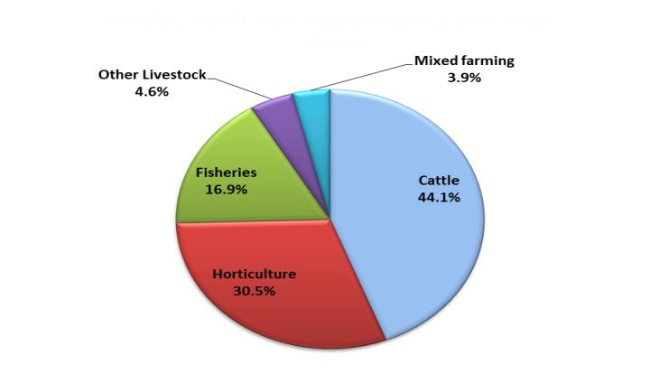
Source: Department of Primary Industry and Resources data collections

The rural industries and fisheries have significant links to other sectors of the Territory economy such as manufacturing, transport and storage, retail and wholesale trade. These industries are vital in regional areas, providing economic stimulus and employment for approximately 2,623 persons in 2015-16 (ABS). This labour force estimate is subject to high sampling variability. The sectors also account for a significant proportion of the Territory's non-mineral export revenue, with the live cattle trade. Territory rural industries and fisheries accounted for 2.5% of Gross State Product (GSP) in 2015-16, above the national proportion of 2.2% (Table 1). Exports of Territory rural and fisheries produce are dominated by live cattle exports (mainly to Indonesia and Vietnam), aquaculture, fishing, forestry and to a lesser extent agriculture services.

In 2015-16, the total estimated value of rural industries and fisheries production was $736.0 million, an increase of 8.1% over the previous year, a result reflective of the improving production and market conditions for NT primary industries and fisheries (see Figure 2). The increase is primarily due to a 23.4% growth in the value of horticultural production to $224.5 million, a 21.5% increase in fisheries production to $124.3 million (driven by the wild stock catch and NPF output), 24.5% rise in other livestock production (mainly crocodile production) to $34.0 million and a 17.7% increase in the value of mixed farming to $28.8 million (driven by hay-fodder for cattle production). These increases were offset by a 5.9% decrease in the value of cattle production to $324.4 million (due to falling exports while interstate movements and abattoir increased).

Table 1: Agriculture, Forestry and Fisheries Contribution to GSP by State
2015-16 | % Contribution to GSP
Tasmania | 8.9%
South Australia | 4.5%
Queensland | 2.5%
Northern Territory | 2.5%
Victoria | 2.4%
Western Australia | 2.1%
New South Wales | 1.3%
Australian Capital Territory | 0.1%
Australia (% of GDP) | 2.2%
Source: ABS 5220.0

Figure 2: NT Rural Industries and Fisheries Production Value
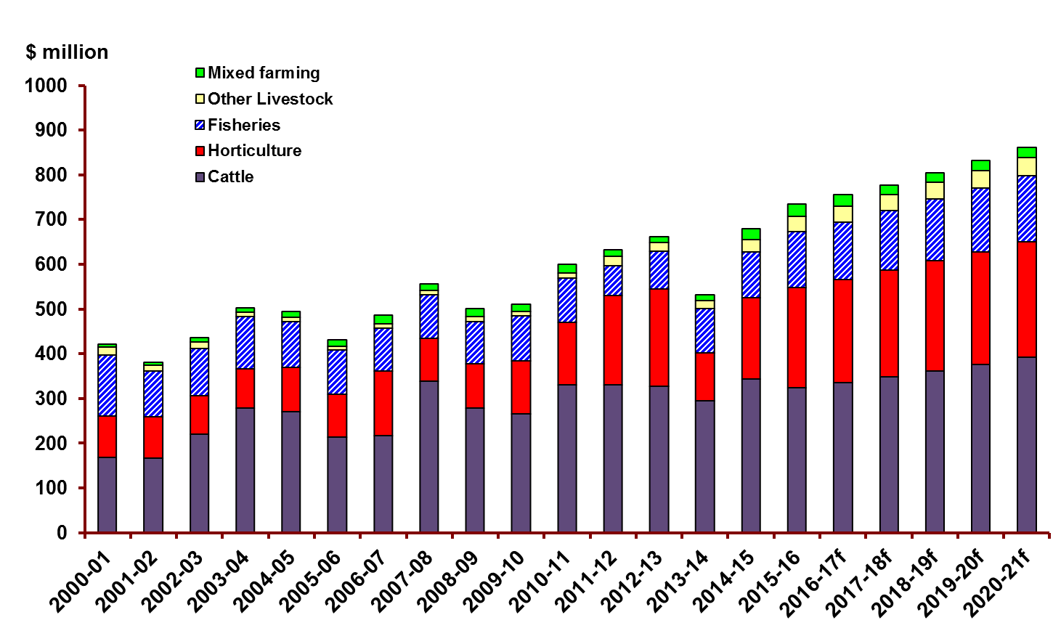
Source: Department of Primary Industry and Resources data collections

Table 2: Gross Value of Territory Rural Industries and Fisheries Production ($ million)
Value of horticultural production ($ million)
 | 2013-14 | 2014-15 | 2015-16 | 2016-17f | 2017-18f | 2018-19f
Mangoes | 35.0 | 95.5 | 88.5 | 91.2 | 93.9 | 96.7
Table Grapes | 0.0 | 0.8 | 8.0 | 8.2 | 8.5 | 8.7
Bananas | 0.0 | 0.0 | 0.0 | 0.0 | 0.0 | 0.0
Melons | 34.0 | 45.8 | 52.6 | 54.2 | 55.8 | 57.5
Other fruits | 5.5 | 4.7 | 8.0 | 8.2 | 8.5 | 8.7
Vegetables | 16.1 | 17.2 | 41.5 | 42.8 | 44.1 | 45.4
Nursery-Cut Flowers & Turf | 17.4 | 17.9 | 18.0 | 18.5 | 19.1 | 19.7
Local markets | 0.0 | 0.0 | 7.9 | 8.1 | 8.3 | 8.6
Total | 108.0 | 182.0 | 224.5 | 231.2 | 238.2 | 245.3
Value of fisheries production ($ million)
 | 2013-14 | 2014-15 | 2015-16 | 2016-17f | 2017-18f | 2018-19f
Fish | 26.0 | 26.2 | 31.6 | 32.6 | 33.5 | 34.6
Crustaceans | 4.2 | 4.6 | 3.0 | 3.1 | 3.2 | 3.3
Aquaculture | 15.2 | 24.1 | 24.5 | 25.3 | 26.0 | 26.8
Molluscs & Echinoderms | 0.2 | 0.2 | 0.3 | 0.3 | 0.3 | 0.3
Total NT Fisheries | 45.6 | 55.1 | 59.4 | 61.2 | 63.0 | 64.9
Crustaceans-NPF | 53.4 | 47.2 | 64.9 | 67.5 | 70.3 | 73.1
Total Fisheries | 99.0 | 102.4 | 124.3 | 128.7 | 133.3 | 138.0
Value of cattle, other livestock and mixed farming ($ million)
 | 2013-14 | 2014-15 | 2015-16 | 2016-17f | 2017-18f | 2018-19f
Cattle | 295.0 | 344.7 | 324.4 | 335.6 | 348.8 | 362.9
Other Livestock | 18.0 | 27.3 | 34.0 | 35.1 | 36.2 | 37.3
Field crops | 13.3 | 24.4 | 20.0 | 20.6 | 21.2 | 21.9
Poppy | 0.0 | 0.0 | 2.4 | 0.0 | 0.0 | 0.0
Forestry | 0.0 | 0.0 | 6.4 | 5.4 | 0.0 | 0.0
Total | 326.2 | 396.4 | 387.1 | 396.7 | 406.2 | 422.0
Total NT Rural Industries and Fisheries Production Value ($ million)
 | 2013-14 | 2014-15 | 2015-16 | 2016-17f | 2017-18f | 2018-19f
Horticulture | 108.0 | 182.0 | 224.5 | 231.2 | 238.2 | 245.3
Fisheries | 99.0 | 102.4 | 124.3 | 128.7 | 133.3 | 138.0
Cattle | 295.0 | 344.7 | 324.4 | 335.6 | 348.8 | 362.9
Other Livestock | 18.0 | 27.3 | 34.0 | 35.1 | 36.2 | 37.3
Mixed Farming | 13.3 | 24.4 | 28.8 | 26.0 | 21.2 | 21.9
Grand Total | 533.3 | 680.7 | 736.0 | 756.6 | 777.6 | 805.3

Source: Department of Primary Industry and Resources data collections, f = forecast
Please note all figures here have been rounded respectively and may not tally to totals.
NPF = Northern Prawn Fleet (Commonwealth-managed fishery)
Cattle valuations are calculated using farm gate production values not market or whole of industry contribution values
Locals Markets value is derived from production sold at markets located mainly in Darwin plus production sold to supermarket chains.

Forecasting Notes
No data was collected for Bananas for 2015-16 therefore no forecasts were generated.
No forecasts were generated for Poppy as the $2.4m (2015-16) represents a one-off trial crop not ongoing production.
No forecasts were generated for Forestry as the $6.4m (2015-16) represents only one of two shipments of woodchips and a forecast is not available beyond 2016-17. Large plantations of African Mahogany and Sandalwood in the NT have not reached maturity and therefore their value cannot be included at this point.

Please use this data from 1 July 2017 to 30 June 2018 only
Table 3: Gross Value of Territory Rural Industries and Fisheries Production (Percentage changes)
 | 12-13 to 13-14 | 13-14 to 14-15 | 14-15 to 15-16
 | % | % | %
Mangoes | -49.5% | 172.6% | -7.3%
Table Grapes | -100.0% | 0.0% | 0.0%
Bananas | -100.0% | 0.0% | 0.0%
Melons | -46.6% | 34.7% | 14.7%
Other fruits | 884.9% | -14.1% | 70.2%
Vegetables | -73.1% | 6.7% | 142.0%
Nursery-Cut Flowers & Turf | 7.7% | 3.0% | 0.4%
Local markets | 0.0% | 0.0% | 0.0%
Total | -50.2% | 68.4% | 23.4%
 | 12-13 to 13-14 | 13-14 to 14-15 | 14-15 to 15-16
 | % | % | %
Fish | -6.3% | 1.0% | 20.5%
Crustaceans | -33.6% | 8.5% | -34.8%
Aquaculture | -39.9% | 58.4% | 1.9%
Molluscs & Echinoderms | 0.0% | 0.0% | 17.8%
Total NT Fisheries | -23.3% | 21.1% | 7.8%
Crustaceans - NPF | 119.5% | -11.6% | 37.5%
Total Fisheries | 18.2% | 3.4% | 21.5%
 | 12-13 to 13-14 | 13-14 to 14-15 | 14-15 to 15-16
 | % | % | %
Cattle | -10.2% | 16.8% | -5.9%
Other Livestock | -13.6% | 51.9% | 24.5%
Field crops | 2.3% | 84.0% | -18.1%
Poppy | 0.0% | 0.0% | 0.0%
Forestry | 0.0% | 0.0% | 0.0%
 | 12-13 to 13-14 | 13-14 to 14-15 | 14-15 to 15-16
 | % | % | %
Horticulture | -50.2% | 68.4% | 23.4%
Fisheries | 18.2% | 3.4% | 21.5%
Cattle | -10.2% | 16.8% | -5.9%
Other Livestock | -13.6% | 51.9% | 24.5%
Mixed Farming | 2.3% | 84.0% | 17.7%
Total | -19.6% | 27.7% | 8.1%
Source: Department of Primary Industry and Resources data collections
NPF = Northern Prawn Fleet (Commonwealth-managed fishery)

Please use this data from 1 July 2017 to 30 June 2018 only.

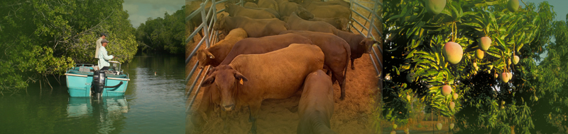
\

Acknowledgements
The important contributions made by staff of the Department of Primary Industry and Resources and NT Farmers Association are gratefully acknowledged.
The author would like to thank the following contributors:
Biosecurity and Product Integrity: Adele Kluth
NT Farmers Association: Ian Baker, Samantha Tocknell
Fisheries Group: Murray Barton, Thor Saunders, Hock Seng Lee
Crocodile Farmers Association of the NT: Gae Mackay

Prepared by: Michael Jean

Contact Details
Michael Jean
Senior Economist
Department of Primary Industry and Resources
GPO Box 3000, DARWIN NT 0801 Australia

Telephone: +61 8 8999 2242
Email: michael.jean@nt.gov.au

Disclaimer
While all care has been taken to ensure that information contained in this document is true and correct at the time of publication, changes in circumstances after the time of publication may impact on the accuracy of its information.
The Northern Territory of Australia gives no warranty or assurance, and makes no representation as to the accuracy of any information or advice contained in this publication, or that it is suitable for your intended use.
You should not rely upon information in this publication for the purpose of making any serious, business or investment decisions without obtaining independent and/or professional advice in relation to your particular situation.
The NT of Australia disclaims any liability or responsibility or duty of care towards any person for loss or damage caused by any use of or reliance on the information contained in this publication.

