Mineral Titles Act
NOTICE OF LAND CEASING TO BE A MINERAL TITLE
Title Type and Number: | Extractive Mineral Permit 31888
Area ceased on: | 03 August 2018
Area: | 19.00 Hectare
Locality: | NOONAMAH
Name of Applicants(s)Holder(s): | 100% A AND SF MADDALOZZO PTY. LIMITED [ACN. 009 624 015]
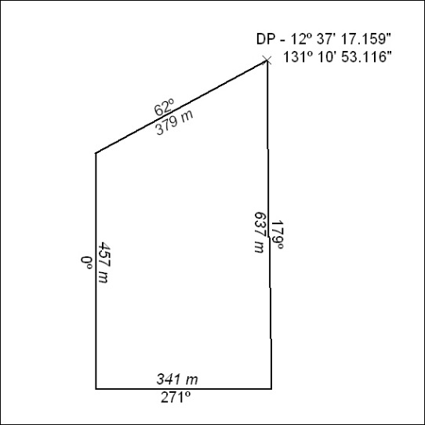

322/18

Mineral Titles Act
NOTICE OF LAND CEASING TO BE A MINERAL TITLE AREA
Title Type and Number: | Extractive Mineral Exploration Licence 31878
Area Ceased on: | 03 August 2018
Area: | 4 Blocks, 12.95 km²
Locality: | KOOLPINYAH
Name of Applicant(s)/Holder(s): | 100% A AND SF MADDALOZZO PTY. LIMITED [ACN. 009 624 015]
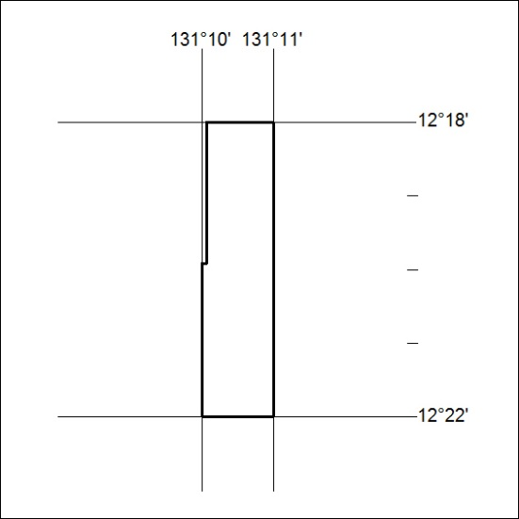

333/18

Mineral Titles Act
NOTICE OF LAND CEASING TO BE A MINERAL TITLE AREA
Title Type and Number: | Extractive Mineral Exploration Licence 31879
Area Ceased on: | 03 August 2018
Area: | 4 Blocks, 12.28 km²
Locality: | KOOLPINYAH
Name of Applicant(s)/Holder(s): | 100% A AND SF MADDALOZZO PTY. LIMITED [ACN. 009 624 015]
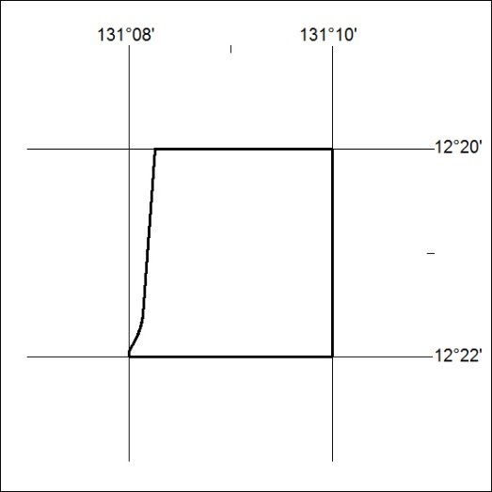

334/18

Mineral Titles Act
NOTICE OF GRANT OF A MINERAL TITLE
Title Type and Number: | Exploration Licence 31686
Granted: | 01 August 2018, for a period of 6 Years
Area: | 28 Blocks, 92.20 km²
Locality: | BATTEN
Name of Holder/s: | 100% BMEX LIMITED* [ACN. 615 217 680]
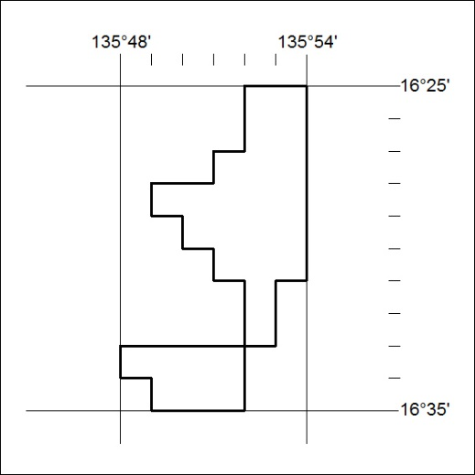
Area granted is indicated above. The titleholder is not permitted to exercise occupational rights on any land that is subject to a development title, or an application for a development title. Any land the subject of a Reserved Land gazettal under the Mineral Titles Act and all land vested in the Commonwealth of Australia is also excluded by description but not excised from the grant area.

335/18

Mineral Titles Act
NOTICE OF GRANT OF A MINERAL TITLE
Title Type and Number: | Exploration Licence 31737
Granted: | 01 August 2018, for a period of 6 Years
Area: | 155 Blocks, 478.74 km²
Locality: | HENBURY
Name of Holder/s: | 100% BMEX LIMITED* [ACN. 615 217 680]
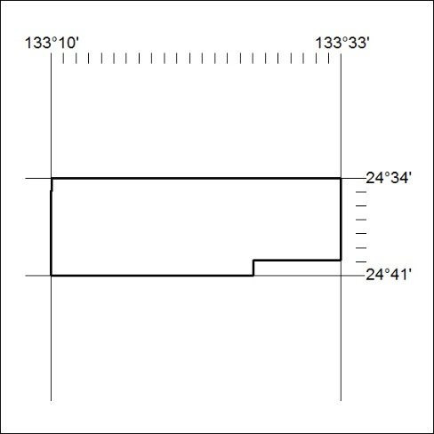
Area granted is indicated above. The titleholder is not permitted to exercise occupational rights on any land that is subject to a development title, or an application for a development title. Any land the subject of a Reserved Land gazettal under the Mineral Titles Act and all land vested in the Commonwealth of Australia is also excluded by description but not excised from the grant area.

336/18

Mineral Titles Act
NOTICE OF GRANT OF A MINERAL TITLE
Title Type and Number: | Exploration Licence 31753
Granted: | 01 August 2018, for a period of 6 Years
Area: | 72 Blocks, 215.26 km²
Locality: | NICHOLSON RIVER
Name of Holder/s: | 100% TM RESOURCES PTY LTD [ACN. 601 076 091]
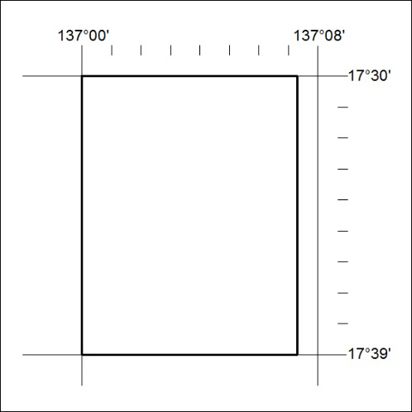
Area granted is indicated above. The titleholder is not permitted to exercise occupational rights on any land that is subject to a development title, or an application for a development title. Any land the subject of a Reserved Land gazettal under the Mineral Titles Act and all land vested in the Commonwealth of Australia is also excluded by description but not excised from the grant area.

337/18

