Mineral Titles Act
NOTICE OF LAND CEASING TO BE A MINERAL TITLE AREA
Title Type and Number: | Exploration Licence 31394
Area Ceased on: | 08 February 2019
Area: | 243 Blocks, 813.87 km²
Locality: | MITCHELL RANGES
Name of Applicant(s)/Holder(s): | 100% CENTREPEAK RESOURCES GROUP PTY LTD [ACN. 604 084 282]
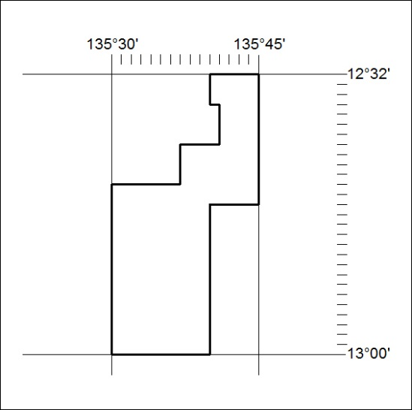

49/19

Mineral Titles Act
NOTICE OF LAND CEASING TO BE A MINERAL TITLE AREA
Title Type and Number: | Exploration Licence 31395
Area Ceased on: | 08 February 2019
Area: | 160 Blocks, 535.18 km²
Locality: | KOOLATONG
Name of Applicant(s)/Holder(s): | 100% CENTREPEAK RESOURCES GROUP PTY LTD [ACN. 604 084 282]
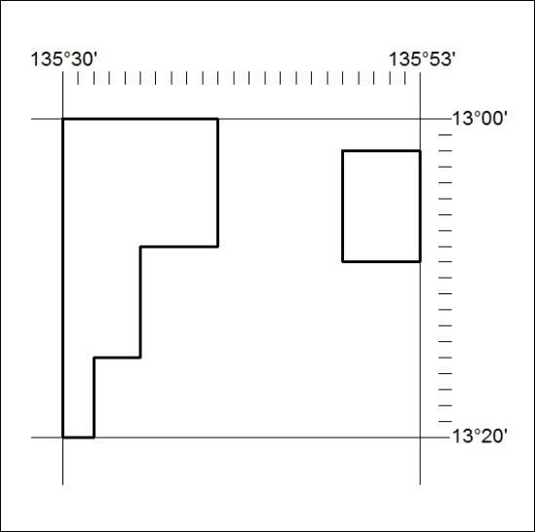

50/19

Mineral Titles Act
NOTICE OF LAND CEASING TO BE A MINERAL TITLE AREA
Title Type and Number: | Exploration Licence 31435
Area Ceased on: | 08 February 2019
Area: | 110 Blocks, 366.21 km²
Locality: | PHELP
Name of Applicant(s)/Holder(s): | 100% CENTREPEAK RESOURCES GROUP PTY LTD [ACN. 604 084 282]
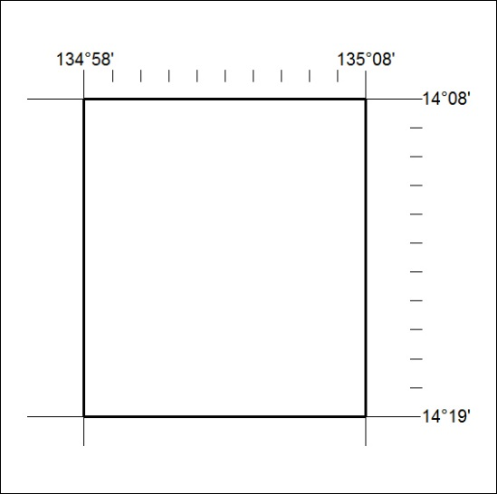

51/19

Mineral Titles Act
NOTICE OF LAND CEASING TO BE A MINERAL TITLE AREA
Title Type and Number: | Exploration Licence 31537
Area Ceased on: | 11 February 2019
Area: | 229 Blocks, 720.64 km²
Locality: | ILLOGWA
Name of Applicant(s)/Holder(s): | 100% GBE EXPLORATION PTY LTD [ACN. 121 535 948]
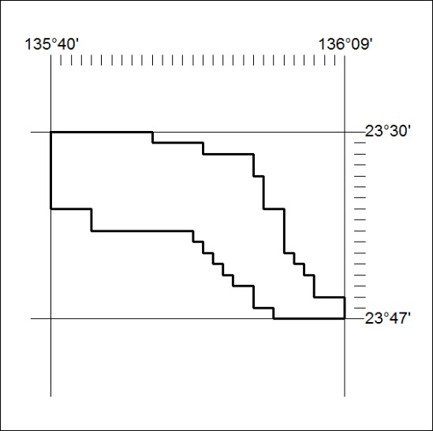

52/19

