Mineral Titles Act 2010
NOTICE OF LAND CEASING TO BE A MINERAL TITLE AREA
Title Type and Number: | Mineral Authority 27945
Area ceased on: | 02 May 2019
Area: | 14.00 Hectare
Locality: | DARWIN
Name of Applicants(s)Holder(s): | 100% STRANGWAYS DEVELOPMENTS PTY. LIMITED [ACN. 009 600 748]
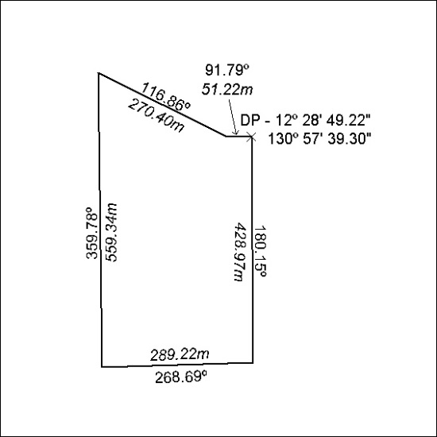

153/19

Mineral Titles Act
NOTICE OF GRANT OF A MINERAL TITLE
Title Type and Number: | Exploration Licence 31984
Granted: | 07 May 2019, for a period of 6 Years
Area: | 57 Blocks, 182.30 km²
Locality: | GEORGE CREEK
Name of Holder/s: | 100% MAGNET EXPLORATION PTY LTD [ACN. 623 568 918]
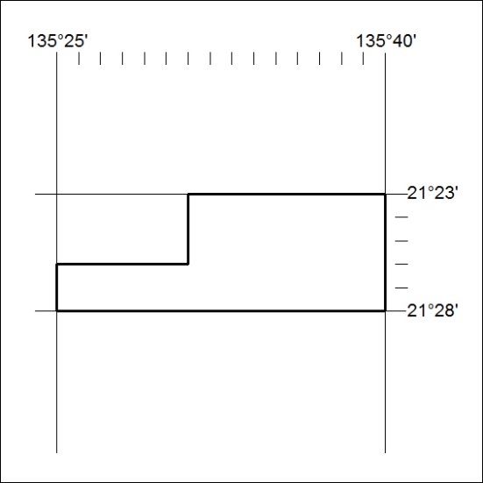
Area granted is indicated above. The titleholder is not permitted to exercise occupational rights on any land that is subject to a development title, or an application for a development title. Any land the subject of a Reserved Land gazettal under the Mineral Titles Act and all land vested in the Commonwealth of Australia is also excluded by description but not excised from the grant area.

154/19

Mineral Titles Act
NOTICE OF GRANT OF A MINERAL TITLE
Title Type and Number: | Exploration Licence 31997
Granted: | 07 May 2019, for a period of 6 Years
Area: | 27 Blocks, 87.59 km²
Locality: | FLYNN
Name of Holder/s: | 100% MAGNET EXPLORATION PTY LTD [ACN. 623 568 918]
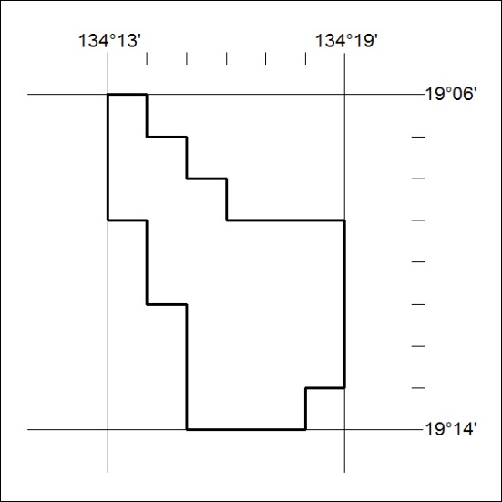
Area granted is indicated above. The titleholder is not permitted to exercise occupational rights on any land that is subject to a development title, or an application for a development title. Any land the subject of a Reserved Land gazettal under the Mineral Titles Act and all land vested in the Commonwealth of Australia is also excluded by description but not excised from the grant area.
155/19

Mineral Titles Act
NOTICE OF GRANT OF A MINERAL TITLE
Title Type and Number: | Exploration Licence 31998
Granted: | 07 May 2019, for a period of 6 Years
Area: | 69 Blocks, 220.69 km²
Locality: | ELKEDRA
Name of Holder/s: | 100% MAGNET EXPLORATION PTY LTD [ACN. 623 568 918]
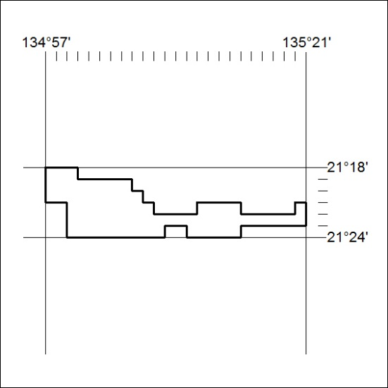
Area granted is indicated above. The titleholder is not permitted to exercise occupational rights on any land that is subject to a development title, or an application for a development title. Any land the subject of a Reserved Land gazettal under the Mineral Titles Act and all land vested in the Commonwealth of Australia is also excluded by description but not excised from the grant area.
156/19

Mineral Titles Act
NOTICE OF GRANT OF A MINERAL TITLE
Title Type and Number: | Exploration Licence 31999
Granted: | 07 May 2019, for a period of 6 Years
Area: | 221 Blocks, 730.06 km²
Locality: | DELAMERE
Name of Holder/s: | 100% MAGNET EXPLORATION PTY LTD [ACN. 623 568 918]
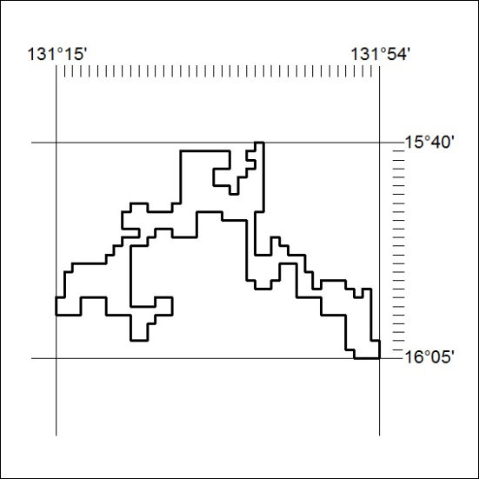
Area granted is indicated above. The titleholder is not permitted to exercise occupational rights on any land that is subject to a development title, or an application for a development title. Any land the subject of a Reserved Land gazettal under the Mineral Titles Act and all land vested in the Commonwealth of Australia is also excluded by description but not excised from the grant area.
157/19

Mineral Titles Act
NOTICE OF GRANT OF A MINERAL TITLE
Title Type and Number: | Exploration Licence 32000
Granted: | 07 May 2019, for a period of 6 Years
Area: | 232 Blocks, 762.67 km²
Locality: | MONTEJINNI
Name of Holder/s: | 100% MAGNET EXPLORATION PTY LTD [ACN. 623 568 918]
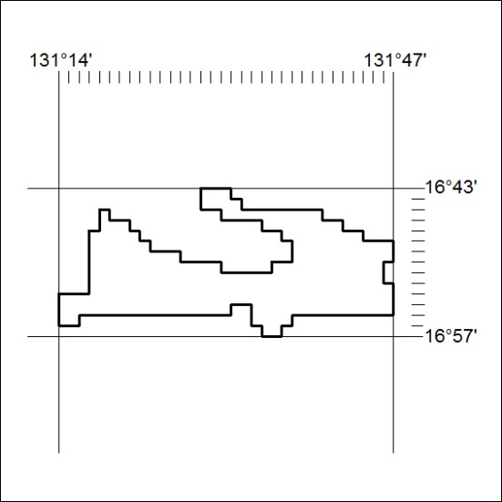
Area granted is indicated above. The titleholder is not permitted to exercise occupational rights on any land that is subject to a development title, or an application for a development title. Any land the subject of a Reserved Land gazettal under the Mineral Titles Act and all land vested in the Commonwealth of Australia is also excluded by description but not excised from the grant area.
158/19

Mineral Titles Act
NOTICE OF GRANT OF A MINERAL TITLE
Title Type and Number: | Exploration Licence 32003
Granted: | 03 May 2019, for a period of 6 Years
Area: | 3 Blocks, 10.04 km²
Locality: | NOONAMAH
Name of Holder/s: | 100% PRIMARY MINERALS PTY LTD* [ACN. 153 582 962]
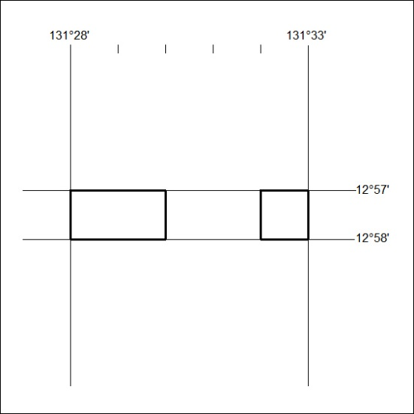
Area granted is indicated above. The titleholder is not permitted to exercise occupational rights on any land that is subject to a development title, or an application for a development title. Any land the subject of a Reserved Land gazettal under the Mineral Titles Act and all land vested in the Commonwealth of Australia is also excluded by description but not excised from the grant area.
159/19

Mineral Titles Act
NOTICE OF GRANT OF A MINERAL TITLE
Title Type and Number: | Exploration Licence 32019
Granted: | 07 May 2019, for a period of 6 Years
Area: | 183 Blocks, 584.45 km²
Locality: | SANDOVER
Name of Holder/s: | 100% MAGNET EXPLORATION PTY LTD [ACN. 623 568 918]
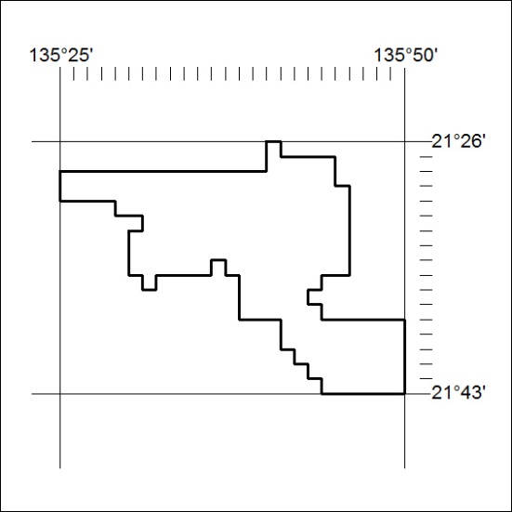
Area granted is indicated above. The titleholder is not permitted to exercise occupational rights on any land that is subject to a development title, or an application for a development title. Any land the subject of a Reserved Land gazettal under the Mineral Titles Act and all land vested in the Commonwealth of Australia is also excluded by description but not excised from the grant area.
160/19

