Mineral Titles Act 2010
NOTICE OF LAND CEASING TO BE A MINERAL TITLE AREA
Title Type and Number: | Exploration Licence 30048
Area Ceased on: | 05 June 2019
Area: | 22 Blocks, 72.78 km²
Locality: | BING BONG
Name of Applicant(s)/Holder(s): | 60% MMG EXPLORATION PTY LTD* [ACN. 119 136 659], 40% SANDFIRE RESOURCES NL [ACN. 105 154 185]
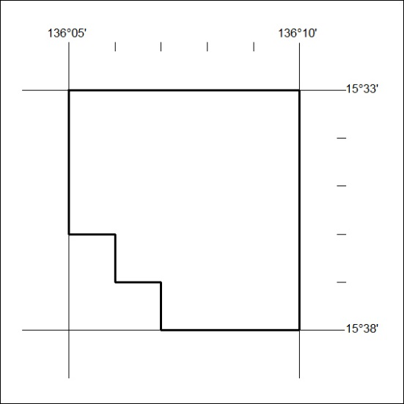

245/19

