Mineral Titles Act 2010
NOTICE OF LAND CEASING TO BE A MINERAL TITLE AREA
Title Type and Number: | Exploration Licence 29051
Area Ceased on: | 05 June 2019
Area: | 2 Blocks, 6.58 km²
Locality: | PINE CREEK
Name of Applicant(s)/Holder(s): | 100% ENDEAVOUR INVESTMENTS (NT) PTY LTD [ACN. 133 112 811]
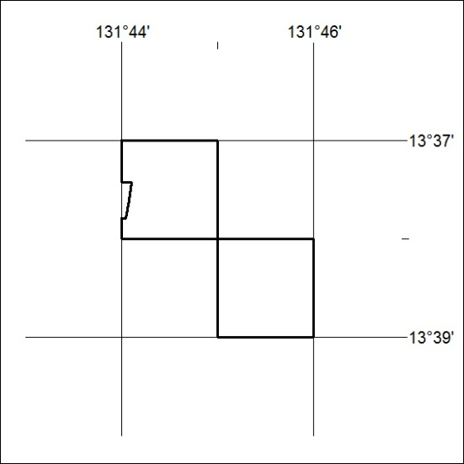

246/19

