Mineral Titles Act 2010
NOTICE OF LAND CEASING TO BE A MINERAL TITLE APPLICATION AREA
Title Type and Number: | Exploration Licence 31996
Area Ceased on: | 17 December 2019
Area: | 46 Blocks, 143.79 km²
Locality: | HULL
Name of Applicant(s)/Holder(s): | 100% GEMPART (NT) PTY LTD* [ACN. 081 859 896]
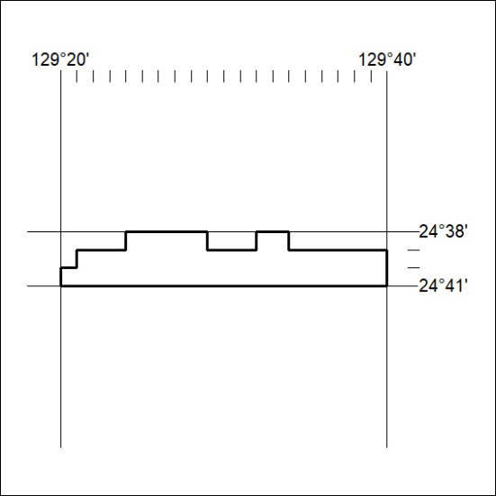

535/19

