Mineral Titles Act
NOTICE OF GRANT OF A MINERAL TITLE
Title Type and Number: | Extractive Mineral Permit 30347
Granted: | 07 January 2020, for a period of 5 Years
Area: | 10.00 Hectares
Locality: | TAWALLAH RANGE
Name of Holder/s: | 100% NRR MINING PTY LTD* [ACN. 619 218 665]
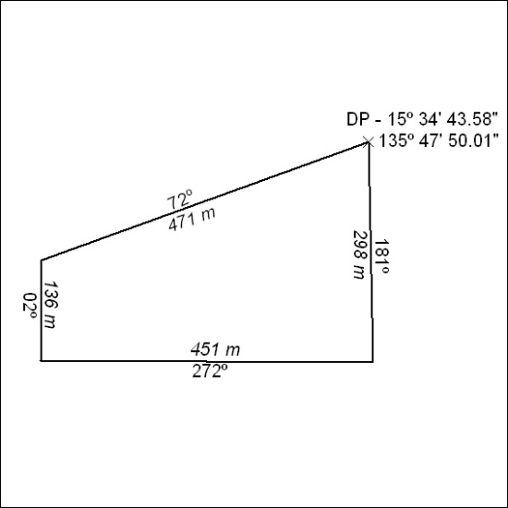

19/20

Mineral Titles Act 2010
NOTICE OF LAND CEASING TO BE A MINERAL TITLE AREA
Title Type and Number: | Exploration Licence 27979
Area Ceased on: | 16 January 2020
Area: | 30 Blocks, 97.08 km²
Locality: | BUCK
Name of Applicant(s)/Holder(s): | 100% PRODIGY GOLD NL* [ACN. 009 127 020]
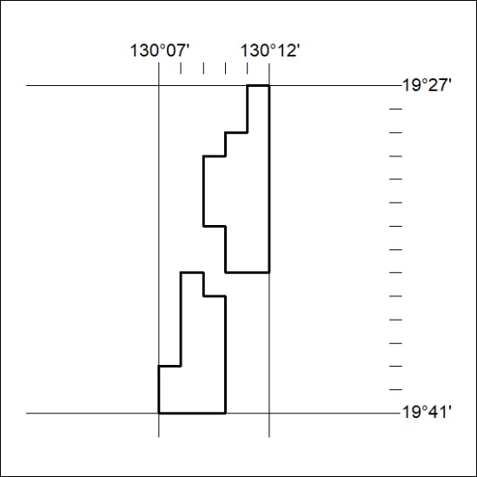

20/20
Mineral Titles Act 2010
NOTICE OF LAND CEASING TO BE A MINERAL TITLE AREA
Title Type and Number: | Exploration Licence 31579
Area Ceased on: | 16 January 2020
Area: | 26 Blocks, 76.46 km²
Locality: | BARKLY
Name of Applicant(s)/Holder(s): | 100% TRUSCOTT MINING CORPORATION LTD [ACN. 116 420 378]
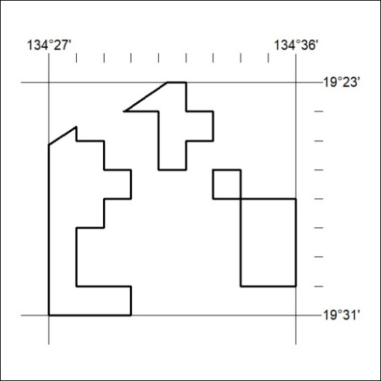

21/20

