Mineral Titles Act 2010
NOTICE OF LAND CEASING TO BE A MINERAL TITLE AREA
Title Type and Number: | Exploration Licence 31795
Area Ceased on: | 17 July 2020
Area: | 10 Blocks, 33.41 km²
Locality: | BATCHELOR
Name of Applicant(s)/Holder(s): | 100% BACCHUS RESOURCES PTY LTD [ACN. 606 340 872]
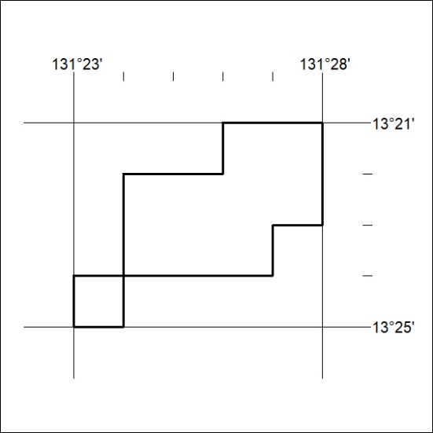

232/20

Mineral Titles Act 2010
NOTICE OF LAND CEASING TO BE A MINERAL TITLE AREA
Title Type and Number: | Extractive Mineral Permit 29969
Area ceased on: | 16 July 2020
Area: | 10.00 Hectare
Locality: | ALICE SPRINGS
Name of Applicants(s)Holder(s): | 100% NORTH CONCRETE (NT) PTY LTD [ACN. 128 802 997]
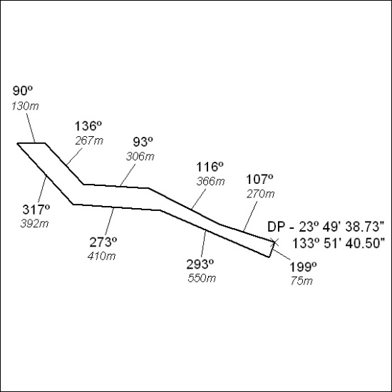

233/20

