Mineral Titles Act
NOTICE OF GRANT OF A MINERAL TITLE
Title Type and Number: | Exploration Licence 32349
Granted: | 29 July 2020, for a period of 6 Years
Area: | 120 Blocks, 364.96 km²
Locality: | ILLOGWA
Name of Holder/s: | 100% GEMPART (NT) PTY LTD* [ACN. 081 859 896]
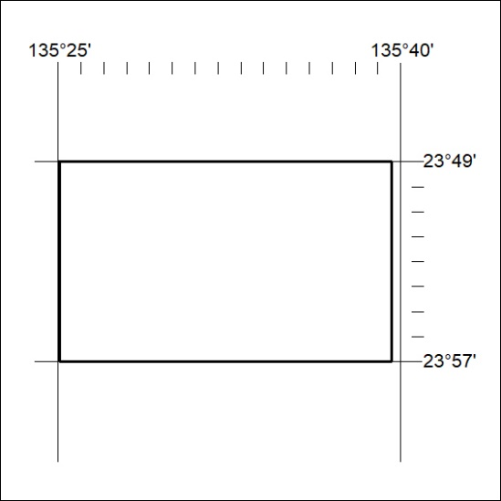
Area granted is indicated above. The titleholder is not permitted to exercise occupational rights on any land that is subject to a development title, or an application for a development title. Any land the subject of a Reserved Land gazettal under the Mineral Titles Act and all land vested in the Commonwealth of Australia is also excluded by description but not excised from the grant area.

246/20

Corrigendum
Notice Number 244/20 appearing in MN69/20 on 28 July 2020 is hereby cancelled and replaced by the following:

Mineral Titles Act
NOTICE OF GRANT OF A MINERAL TITLE
Title Type and Number: | Mineral Lease 32277
Granted: | 27 July 2020, for a period of 12 Years
Area: | 124.10 Hectares
Locality: | LUCY
Name of Holder/s: | 100% JINKA MINERALS LIMITED [ACN. 131 851 404]
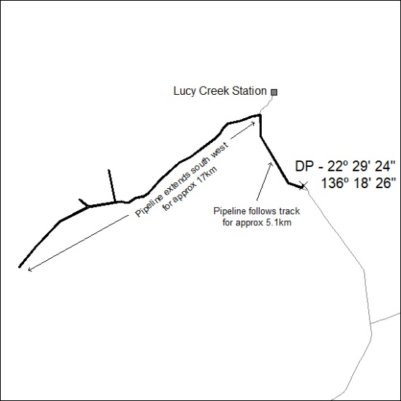

247/20

