Mineral Titles Act
NOTICE OF GRANT OF A MINERAL TITLE
Title Type and Number: | Exploration Licence 32306
Granted: | 17 August 2020, for a period of 6 Years
Area: | 39 Blocks, 126.32 km²
Locality: | ALROY
Name of Holder/s: | 100% STRATEGIC ENERGY RESOURCES LIMITED* [ACN. 051 212 429]
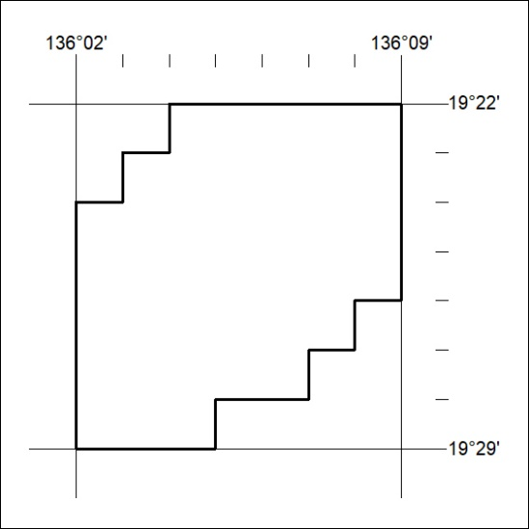
Area granted is indicated above. The titleholder is not permitted to exercise occupational rights on any land that is subject to a development title, or an application for a development title. Any land the subject of a Reserved Land gazettal under the Mineral Titles Act and all land vested in the Commonwealth of Australia is also excluded by description but not excised from the grant area.
278/20

Mineral Titles Act
NOTICE OF GRANT OF A MINERAL TITLE
Title Type and Number: | Exploration Licence 32307
Granted: | 17 August 2020, for a period of 6 Years
Area: | 4 Blocks, 12.98 km²
Locality: | ALROY
Name of Holder/s: | 100% STRATEGIC ENERGY RESOURCES LIMITED* [ACN. 051 212 429]
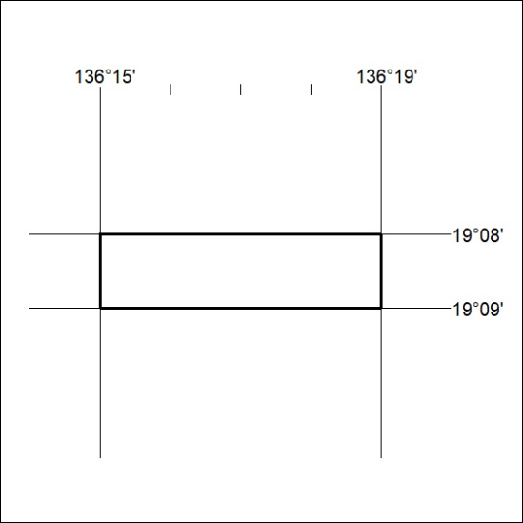
Area granted is indicated above. The titleholder is not permitted to exercise occupational rights on any land that is subject to a development title, or an application for a development title. Any land the subject of a Reserved Land gazettal under the Mineral Titles Act and all land vested in the Commonwealth of Australia is also excluded by description but not excised from the grant area.
279/20

