Mineral Titles Act 2010
NOTICE OF LAND CEASING TO BE A MINERAL TITLE AREA
Title Type and Number: | Exploration Licence 31456
Area Ceased on: | 31 August 2020
Area: | 177 Blocks, 553.03 km²
Locality: | CHARLOTTE
Name of Applicant(s)/Holder(s): | 100% BMEX LIMITED* [ACN. 615 217 680]
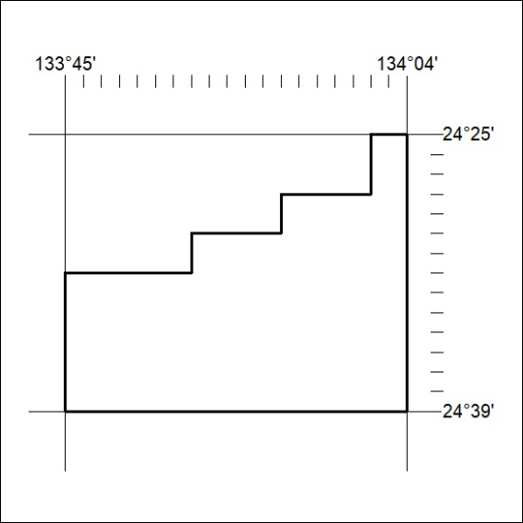

300/20

Mineral Titles Act 2010
NOTICE OF LAND CEASING TO BE A MINERAL TITLE APPLICATION AREA
Title Type and Number: | Exploration Licence 32195
Area Ceased on: | 26 August 2020
Area: | 30 Blocks, 94.77 km²
Locality: | QUARTZ
Name of Applicant(s)/Holder(s): | 100% BARFUSS INVESTMENTS PTY LTD [ACN. 239 973 505]
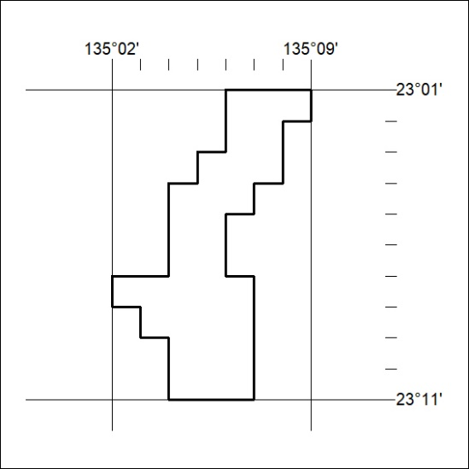

301/20
Corrigendum
Notice Number 288/20 appearing in MN83/20 on 20 August 2020 is hereby cancelled and replaced by the following:

Mineral Titles Act 2010
NOTICE OF LAND CEASING TO BE A MINERAL TITLE AREA
Title Type and Number: | Exploration Licence 31574
Area Ceased on: | 30 August 2020
Area: | 30 Blocks, 99.49 km²
Locality: | MARANBOY
Name of Applicant(s)/Holder(s): | 100% FIDDLER'S CREEK MINING COMPANY PTY LTD * [ACN. 099 215 648]
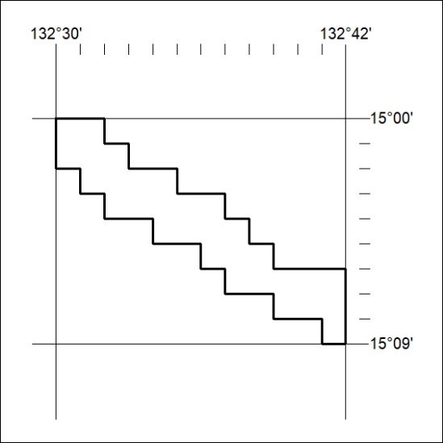

302/20

Corrigendum
Notice Number 289/20 appearing in MN83/20 on 20 August 2020 is hereby cancelled and replaced by the following:

Mineral Titles Act 2010
NOTICE OF LAND CEASING TO BE A MINERAL TITLE AREA
Title Type and Number: | Exploration Licence 31575
Area Ceased on: | 30 August 2020
Area: | 31 Blocks, 102.51 km²
Locality: | ELSEY
Name of Applicant(s)/Holder(s): | 100% FIDDLER'S CREEK MINING COMPANY PTY LTD * [ACN. 099 215 648]
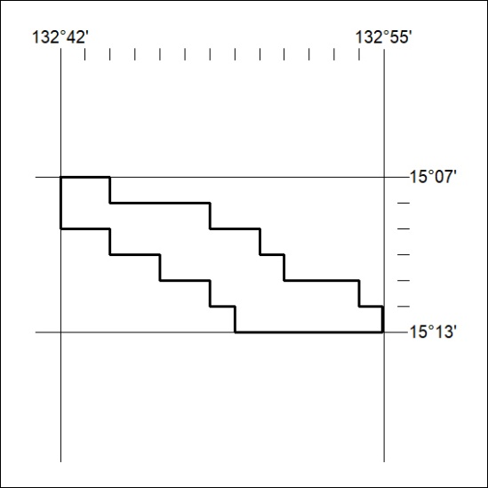

303/20

