Mineral Titles Act 2010
NOTICE OF LAND CEASING TO BE A MINERAL TITLE AREA
Title Type and Number: | Exploration Licence 27941
Area Ceased on: | 20 October 2020
Area: | 13 Blocks, 41.43 km²
Locality: | BARROW
Name of Applicant(s)/Holder(s): | 100% ENIGMA MINING LIMITED [ACN. 009 225 558]
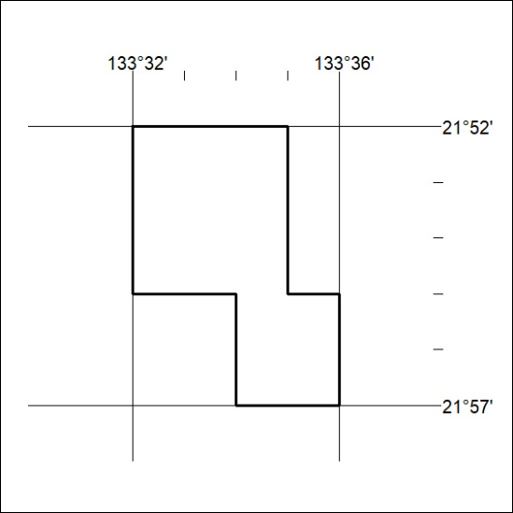

340/20

Mineral Titles Act 2010
NOTICE OF LAND CEASING TO BE A MINERAL TITLE AREA
Title Type and Number: | Exploration Licence 27974
Area Ceased on: | 19 October 2020
Area: | 72 Blocks, 222.71 km²
Locality: | CHARLOTTE
Name of Applicant(s)/Holder(s): | 100% TELLUS HOLDINGS LTD* [ACN. 138 119 829]
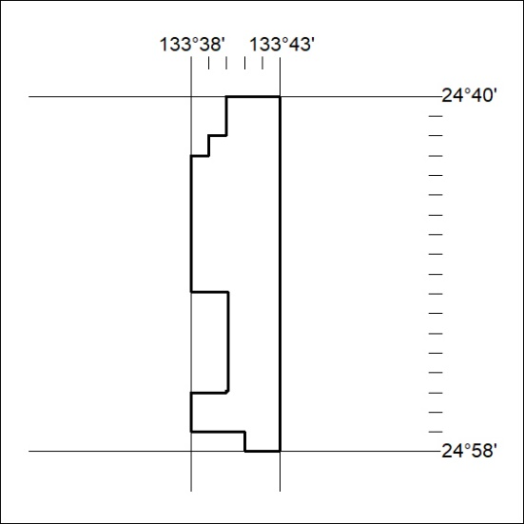

341/20

