Mineral Titles Act 2010
NOTICE OF LAND CEASING TO BE A MINERAL TITLE APPLICATION AREA
Title Type and Number: | Exploration Licence 31848
Area Ceased on: | 09 November 2020
Area: | 225 Blocks, 701.08 km²
Locality: | BLOODS RANGE
Name of Applicant(s)/Holder(s): | 100% GEMPART (NT) PTY LTD* [ACN. 081 859 896]
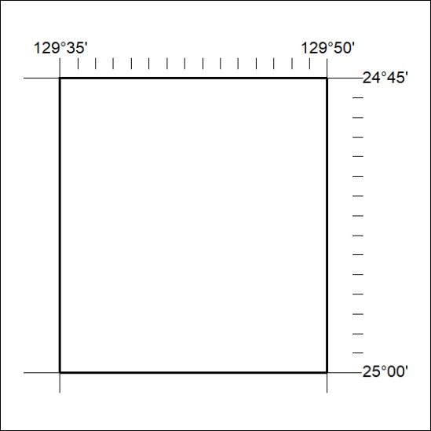

361/20

