Mineral Titles Act 2010
NOTICE OF LAND CEASING TO BE A MINERAL TITLE AREA
Title Type and Number: | Exploration Licence in Retention 46
Area ceased on: | 16 November 2020
Area: | 121.00 Hectares
Locality: | VAUGHAN
Name of Applicants(s)Holder(s): | 100% ENERGY METALS LTD [ACN. 111 306 533]
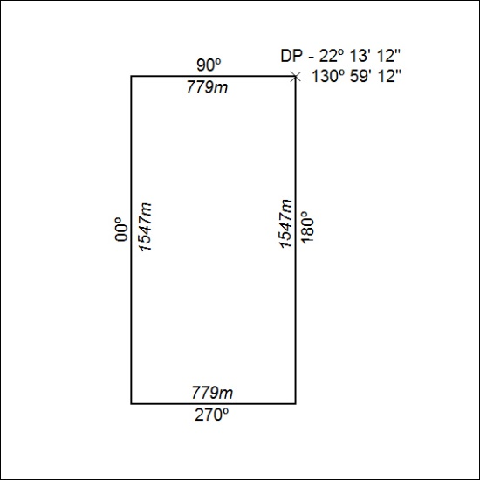
(Area now amalgamated into Exploration Licence in Retention 32252 under s102)

367/20

Mineral Titles Act 2010
NOTICE OF LAND CEASING TO BE A MINERAL TITLE AREA
Title Type and Number: | Exploration Licence in Retention 47
Area ceased on: | 16 November 2020
Area: | 197.00 Hectares
Locality: | VAUGHAN
Name of Applicants(s)Holder(s): | 100% ENERGY METALS LTD [ACN. 111 306 533]
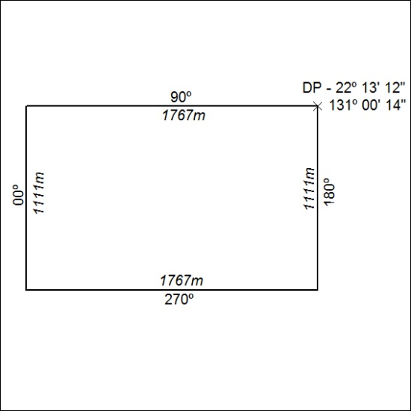
(Area now amalgamated into Exploration Licence in Retention 32252 under s102)

368/20

Mineral Titles Act 2010
NOTICE OF LAND CEASING TO BE A MINERAL TITLE AREA
Title Type and Number: | Exploration Licence in Retention 48
Area ceased on: | 16 November 2020
Area: | 99.00 Hectare
Locality: | VAUGHAN
Name of Applicants(s)Holder(s): | 100% ENERGY METALS LTD [ACN. 111 306 533]
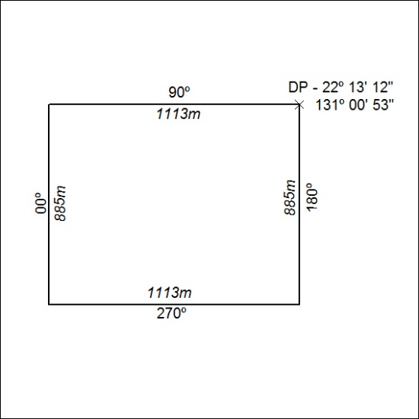
(Area now amalgamated into Exploration Licence in Retention 32252 under s102)

369/20

Mineral Titles Act 2010
NOTICE OF LAND CEASING TO BE A MINERAL TITLE AREA
Title Type and Number: | Exploration Licence in Retention 49
Area ceased on: | 16 November 2020
Area: | 112.00 Hectares
Locality: | DOREEN
Name of Applicants(s)Holder(s): | 100% ENERGY METALS LTD [ACN. 111 306 533]
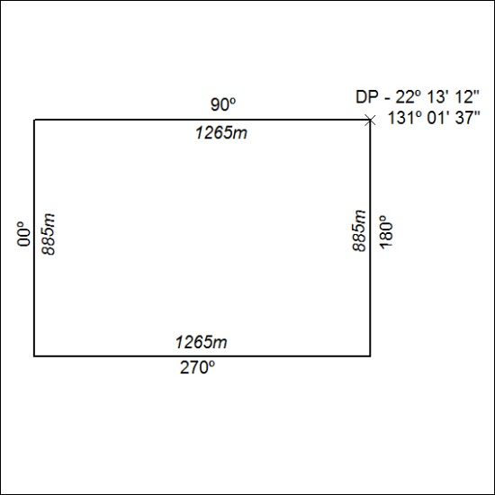
(Area now amalgamated into Exploration Licence in Retention 32252 under s102)

370/20

Mineral Titles Act 2010
NOTICE OF LAND CEASING TO BE A MINERAL TITLE AREA
Title Type and Number: | Exploration Licence in Retention 50
Area ceased on: | 16 November 2020
Area: | 114.00 Hectares
Locality: | DOREEN
Name of Applicants(s)Holder(s): | 100% ENERGY METALS LTD [ACN. 111 306 533]
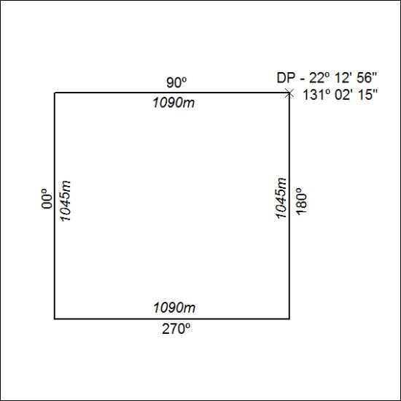
(Area now amalgamated into Exploration Licence in Retention 32252 under s102)

371/20

Mineral Titles Act 2010
NOTICE OF LAND CEASING TO BE A MINERAL TITLE AREA
Title Type and Number: | Exploration Licence in Retention 51
Area ceased on: | 16 November 2020
Area: | 69.00 Hectare
Locality: | DOREEN
Name of Applicants(s)Holder(s): | 100% ENERGY METALS LTD [ACN. 111 306 533]
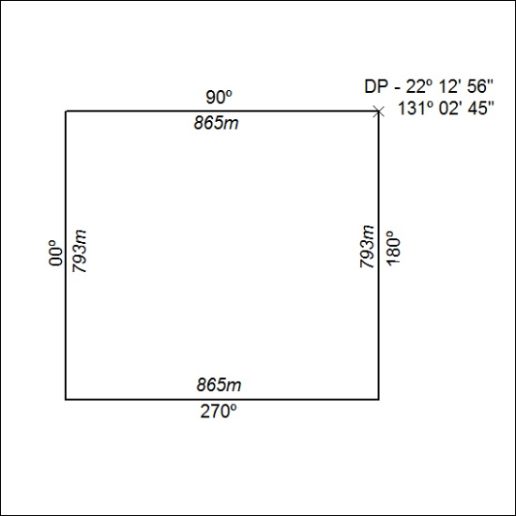
(Area now amalgamated into Exploration Licence in Retention 32252 under s102)

372/20

Mineral Titles Act 2010
NOTICE OF LAND CEASING TO BE A MINERAL TITLE AREA
Title Type and Number: | Exploration Licence in Retention 52
Area ceased on: | 16 November 2020
Area: | 132.00 Hectares
Locality: | DOREEN
Name of Applicants(s)Holder(s): | 100% ENERGY METALS LTD [ACN. 111 306 533]
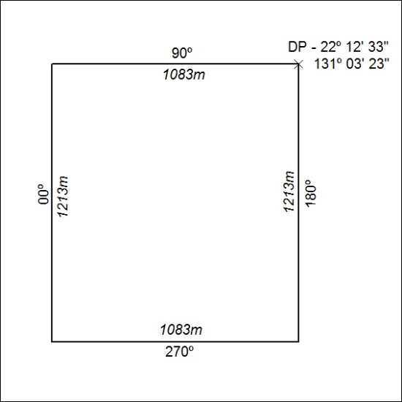
(Area now amalgamated into Exploration Licence in Retention 32252 under s102)

373/20

Mineral Titles Act 2010
NOTICE OF LAND CEASING TO BE A MINERAL TITLE AREA
Title Type and Number: | Exploration Licence in Retention 53
Area ceased on: | 16 November 2020
Area: | 85.00 Hectare
Locality: | DOREEN
Name of Applicants(s)Holder(s): | 100% ENERGY METALS LTD [ACN. 111 306 533]
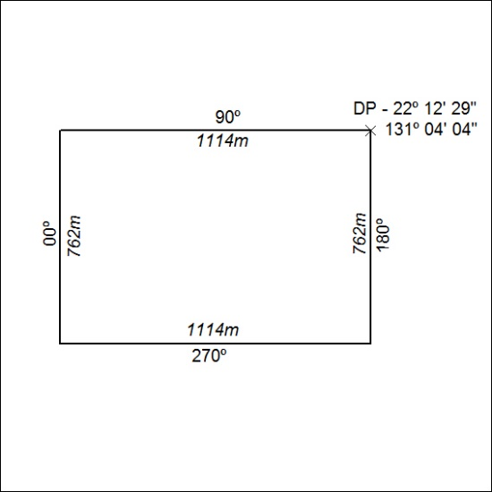
(Area now amalgamated into Exploration Licence in Retention 32252 under s102)

374/20

Mineral Titles Act 2010
NOTICE OF LAND CEASING TO BE A MINERAL TITLE AREA
Title Type and Number: | Exploration Licence in Retention 54
Area ceased on: | 16 November 2020
Area: | 84.00 Hectare
Locality: | DOREEN
Name of Applicants(s)Holder(s): | 100% ENERGY METALS LTD [ACN. 111 306 533]
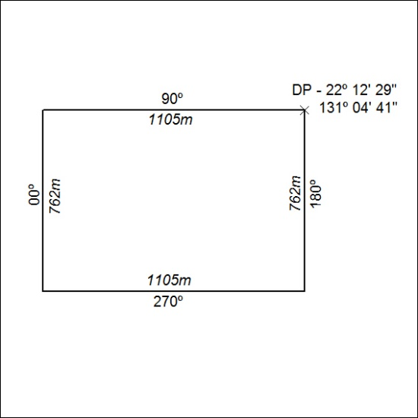
(Area now amalgamated into Exploration Licence in Retention 32252 under s102)

375/20

Mineral Titles Act 2010
NOTICE OF LAND CEASING TO BE A MINERAL TITLE AREA
Title Type and Number: | Exploration Licence in Retention 55
Area ceased on: | 16 November 2020
Area: | 204.00 Hectares
Locality: | DOREEN
Name of Applicants(s)Holder(s): | 100% ENERGY METALS LTD [ACN. 111 306 533]
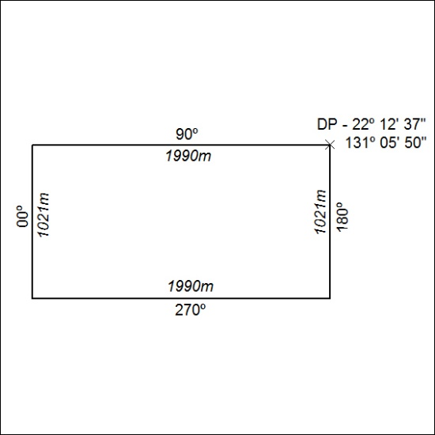
(Area now amalgamated into Exploration Licence in Retention 32252 under s102)

376/20

