Mineral Titles Act
NOTICE OF LAND CEASING TO BE A MINERAL TITLE AREA
Title Type and Number: | Exploration Licence 29905
Area Ceased on: | 15 April 2018
Area: | 11 Blocks, 34.84 km²
Locality: | NAPPERBY
Name of Applicant(s)/Holder(s): | 100% OZ URANIUM (NT) PTY LTD [ACN. 161 904 847]
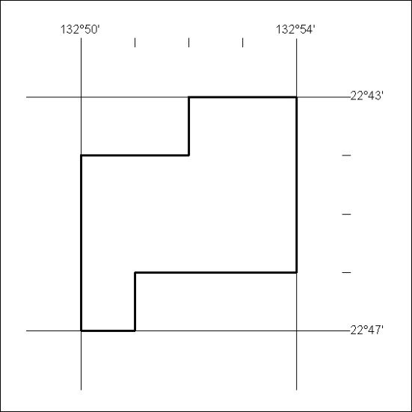

137/18

