Mineral Titles Act
NOTICE OF LAND CEASING TO BE A MINERAL TITLE AREA
Title Type and Number: | Exploration Licence 28967
Area Ceased on: | 03 July 2018
Area: | 14 Blocks, 44.29 km²
Locality: | NAPPERBY
Name of Applicant(s)/Holder(s): | 100% AUSTRALIA MINING & GEMSTONE CO. PTY LTD [ACN. 114 395 247]
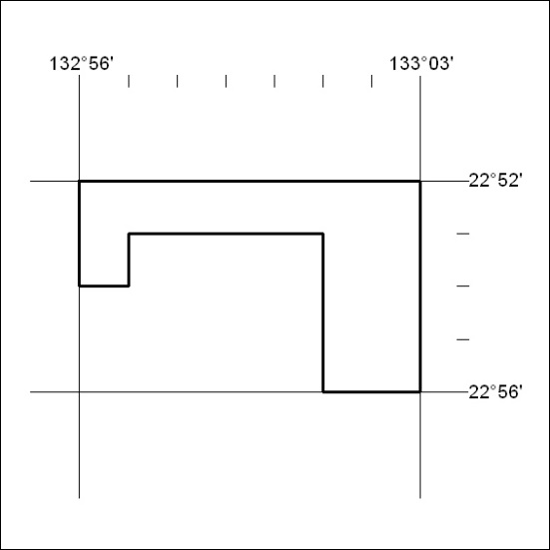

227/18

Mineral Titles Act
NOTICE OF LAND CEASING TO BE A MINERAL TITLE
Title Type and Number: | Authorised Holdings (Northern) 31
Area ceased on: | 01 June 2018
Area: | 2.00 Hectare
Locality: | DARWIN
Name of Applicants(s)Holder(s): | 100% HOWARTH John
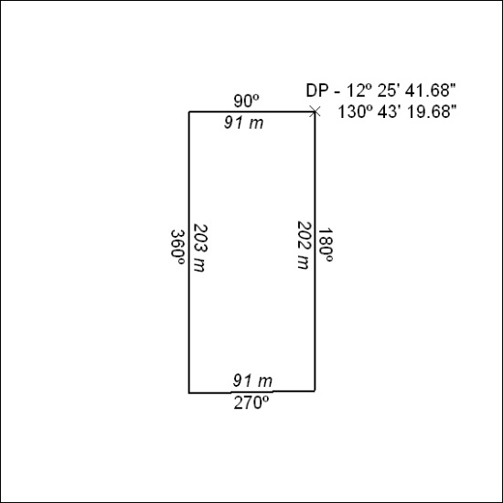

228/18

Mineral Titles Act
NOTICE OF GRANT OF A MINERAL TITLE
Title Type and Number: | Exploration Licence 31728
Granted: | 01 June 2018, for a period of 6 Years
Area: | 240 Blocks, 761.04 km²
Locality: | DENISON
Name of Holder/s: | 100% ELM RESOURCES PTY LTD [ACN. 612 700 606]
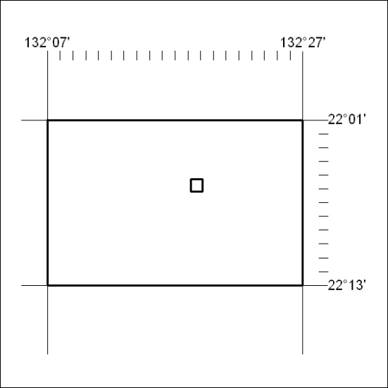
Area granted is indicated above. The titleholder is not permitted to exercise occupational rights on any land that is subject to a development title, or an application for a development title. Any land the subject of a Reserved Land gazettal under the Mineral Titles Act and all land vested in the Commonwealth of Australia is also excluded by description but not excised from the grant area.

229/18

