Associate Professor Andrew Robson and Dr Moshiur Rahman  
University of New England  
[Andrew.robson@une.edu.au](mailto:Andrew.robson@une.edu.au) and [mrahma37@une.edu.au](mailto:mrahma37@une.edu.au)

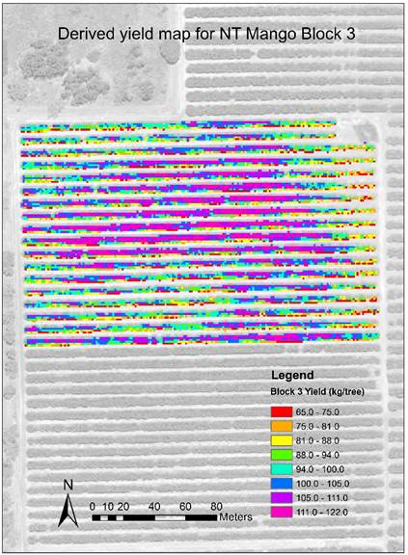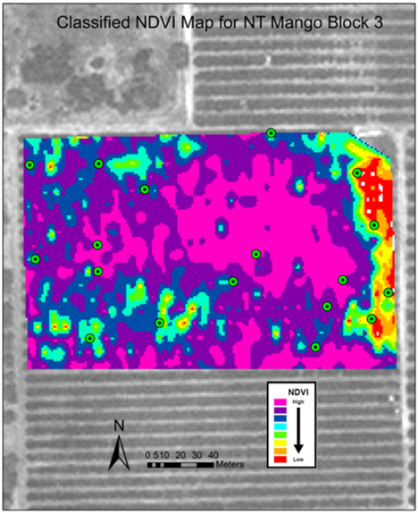

An accurate determination of mango yield parameters: fruit weight (kg/tree) and fruit number, prior to harvest, can greatly assist growers with decisions around harvest logistics (e.g. labour, equipment, packing, storage, and transport) and forward selling.

Additionally, having a stronger understanding of yield variability across an orchard can greatly assist growers with improved management decisions, such as targeted agronomy to determine the drivers of poor production and the subsequent variable rate application of water, nutrient, insecticide etc.

In this study, spectral reflectance properties of mango canopies and tree crown area (TCA) were measured from (30 cm resolution) WorldView 3 (WV3) satellite imagery. Eighteen trees per orchard were selected for ground truthing the imagery and to establish an ‘orchard specific algorithm’ between the yield parameters to TCA and a number of vegetation indices (VIs) derived from the canopy reflectance values. Using this algorithm, a yield prediction for the rest of the trees in the orchard was made. This process was applied to a number of mango orchards in the Northern Territory (NT) and Bundaberg (QLD) growing regions during the 2016 and 2017 harvest seasons.



For the 2017 season, the prediction accuracies produced for three NT orchards ranged from 88% to 130% using only vegetation indices (VIs) values derived from the canopy reflectance data. Combining VIs data with TCA produced prediction accuracies of better than 95%. For Bundaberg region, predictions using only VIs ranged from 77% to 99% for both years.

The accuracy of these results suggests that the reported process may provide as an effective tool for pre-harvest yield forecasting in the Australian mango industry as well as a potential method for mapping yield variability, in the absence of a commercial yield monitor.