Mineral Titles Act
NOTICE OF GRANT OF A MINERAL TITLE
Title Type and Number: | Exploration Licence 31957
Granted: | 15 February 2019, for a period of 6 Years
Area: | 41 Blocks, 129.88 km²
Locality: | NAPPERBY
Name of Holder/s: | 100% ARAFURA RESOURCES LIMITED [ACN. 080 933 455]
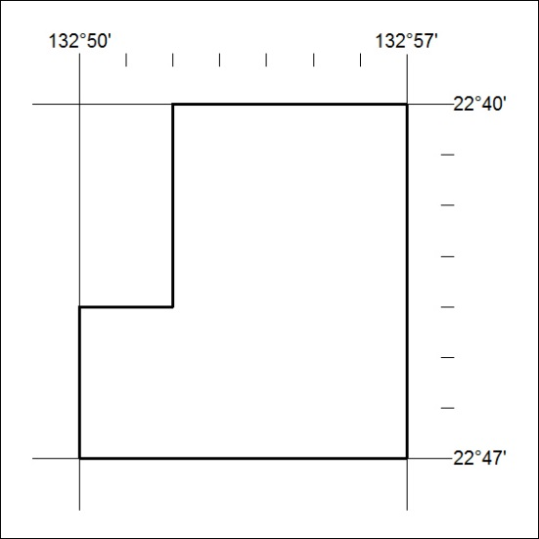
Area granted is indicated above. The titleholder is not permitted to exercise occupational rights on any land that is subject to a development title, or an application for a development title. Any land the subject of a Reserved Land gazettal under the Mineral Titles Act and all land vested in the Commonwealth of Australia is also excluded by description but not excised from the grant area.

55/19

Mineral Titles Act
NOTICE OF GRANT OF A MINERAL TITLE
Title Type and Number: | Extractive Mineral Permit 31595
Granted: | 15 February 2019, for a period of 5 Years
Area: | 98.64 Hectares
Locality: | PINE CREEK
Name of Holder/s: | 100% JN. MOUSELLIS CIVIL CONTRACTORS PTY LTD [ACN. 122 603 990]
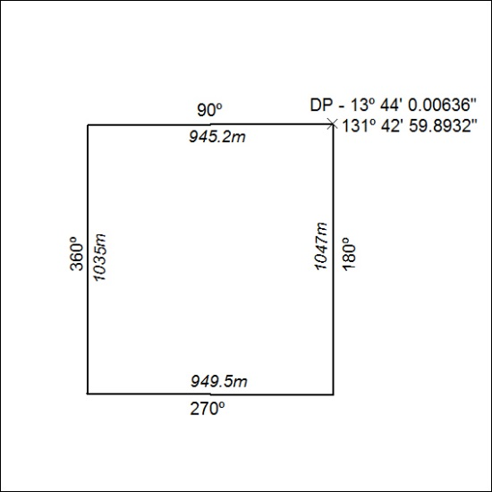

56/19

