Mineral Titles Act
NOTICE OF LAND CEASING TO BE A MINERAL TITLE AREA
Title Type and Number: | Exploration Licence 31822
Area Ceased on: | 25 February 2019
Area: | 189 Blocks, 619.91 km²
Locality: | CALVERT HILLS
Name of Applicant(s)/Holder(s): | 100% MANGROVE RESOURCES PTY LTD [ACN. 612 043 240]
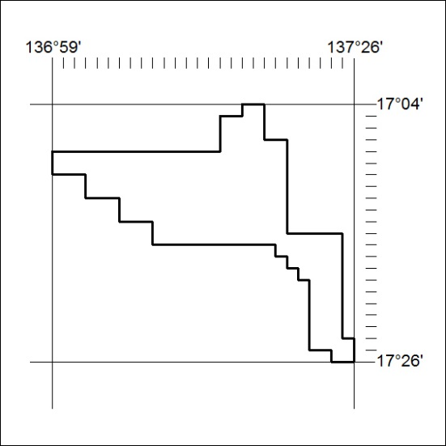

59/19

Mineral Titles Act
NOTICE OF LAND CEASING TO BE A MINERAL TITLE AREA
Title Type and Number: | Exploration Licence 31823
Area Ceased on: | 25 February 2019
Area: | 202 Blocks, 662.13 km²
Locality: | WOLLOGORANG
Name of Applicant(s)/Holder(s): | 100% MANGROVE RESOURCES PTY LTD [ACN. 612 043 240]
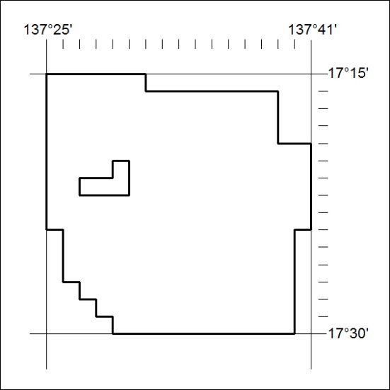

60/19

