Mineral Titles Act
NOTICE OF LAND CEASING TO BE A MINERAL TITLE
Title Type and Number: | Mineral Lease (Central) 57
Area ceased on: | 12 March 2019
Area: | 16.00 Hectare
Locality: | TENNANT CREEK
Name of Applicants(s)Holder(s): | 70% METEORIC RESOURCES NL [ACN. 107 985 651], 30% SANTEXCO PTY LTD [ACN. 002 910 296]
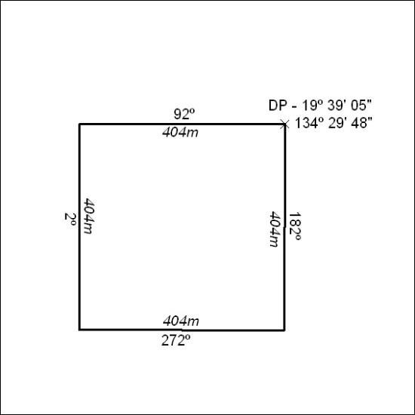

77/19

Mineral Titles Act
NOTICE OF LAND CEASING TO BE A MINERAL TITLE
Title Type and Number: | Mineral Lease (Central) 217
Area ceased on: | 12 March 2019
Area: | 16.00 Hectare
Locality: | TENNANT CREEK
Name of Applicants(s)Holder(s): | 70% METEORIC RESOURCES NL [ACN. 107 985 651], 30% SANTEXCO PTY LTD [ACN. 002 910 296]
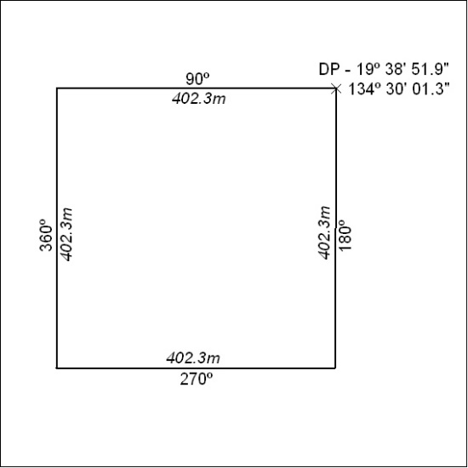

78/19

Mineral Titles Act
NOTICE OF LAND CEASING TO BE A MINERAL TITLE
Title Type and Number: | Mineral Lease (Central) 218
Area ceased on: | 12 March 2019
Area: | 16.00 Hectare
Locality: | TENNANT CREEK
Name of Applicants(s)Holder(s): | 70% METEORIC RESOURCES NL [ACN. 107 985 651], 30% SANTEXCO PTY LTD [ACN. 002 910 296]
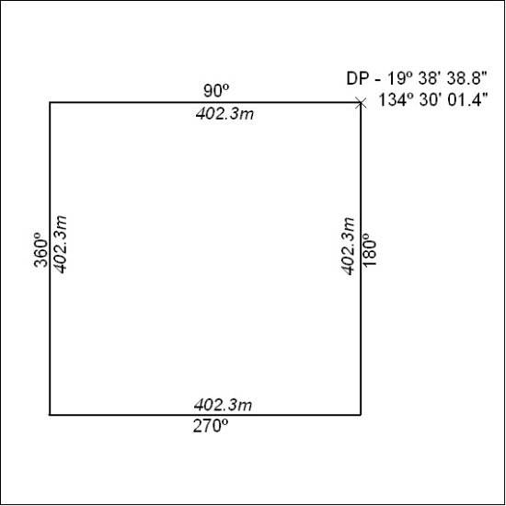

79/19

Mineral Titles Act
NOTICE OF LAND CEASING TO BE A MINERAL TITLE
Title Type and Number: | Mineral Lease (Central) 219
Area ceased on: | 12 March 2019
Area: | 16.00 Hectare
Locality: | TENNANT CREEK
Name of Applicants(s)Holder(s): | 70% METEORIC RESOURCES NL [ACN. 107 985 651], 30% SANTEXCO PTY LTD [ACN. 002 910 296]
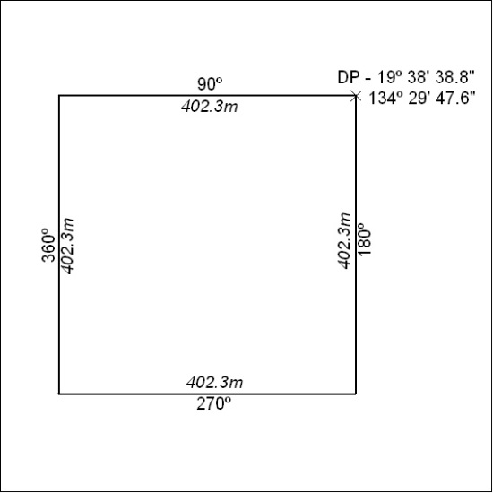

80/19

Mineral Titles Act
NOTICE OF LAND CEASING TO BE A MINERAL TITLE
Title Type and Number: | Mineral Lease (Central) 220
Area ceased on: | 12 March 2019
Area: | 16.00 Hectare
Locality: | TENNANT CREEK
Name of Applicants(s)Holder(s): | 70% METEORIC RESOURCES NL [ACN. 107 985 651], 30% SANTEXCO PTY LTD [ACN. 002 910 296]
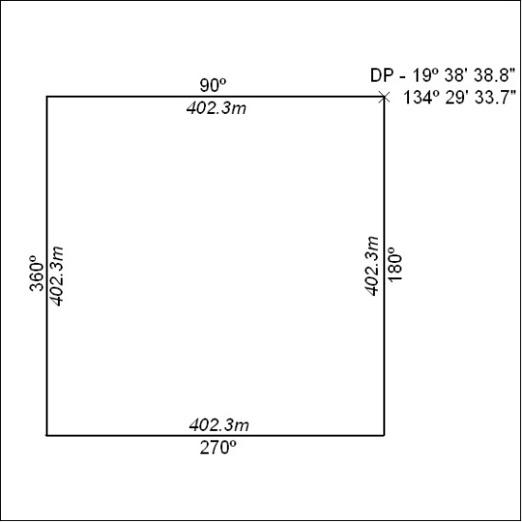

81/19

Mineral Titles Act
NOTICE OF LAND CEASING TO BE A MINERAL TITLE
Title Type and Number: | Mineral Lease (Central) 221
Area ceased on: | 12 March 2019
Area: | 16.00 Hectare
Locality: | TENNANT CREEK
Name of Applicants(s)Holder(s): | 70% METEORIC RESOURCES NL [ACN. 107 985 651], 30% SANTEXCO PTY LTD [ACN. 002 910 296]
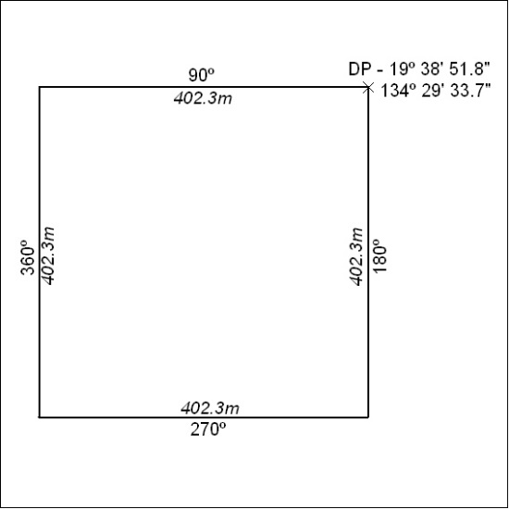

82/19

Mineral Titles Act
NOTICE OF LAND CEASING TO BE A MINERAL TITLE
Title Type and Number: | Mineral Lease (Central) 222
Area ceased on: | 12 March 2019
Area: | 16.00 Hectare
Locality: | TENNANT CREEK
Name of Applicants(s)Holder(s): | 70% METEORIC RESOURCES NL [ACN. 107 985 651], 30% SANTEXCO PTY LTD [ACN. 002 910 296]
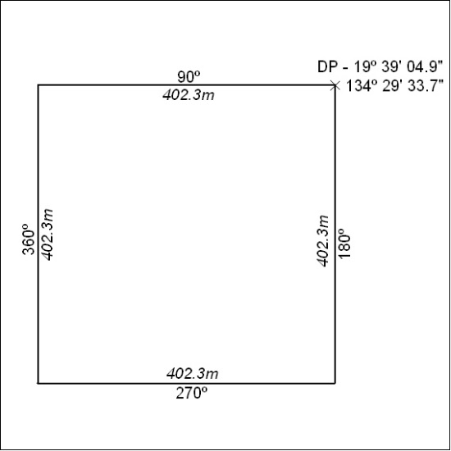

83/19

Mineral Titles Act
NOTICE OF LAND CEASING TO BE A MINERAL TITLE
Title Type and Number: | Mineral Lease (Central) 223
Area ceased on: | 12 March 2019
Area: | 16.00 Hectare
Locality: | TENNANT CREEK
Name of Applicants(s)Holder(s): | 70% METEORIC RESOURCES NL [ACN. 107 985 651], 30% SANTEXCO PTY LTD [ACN. 002 910 296]
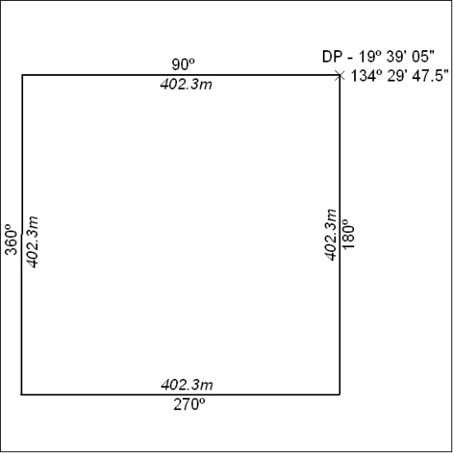

84/19

Mineral Titles Act
NOTICE OF LAND CEASING TO BE A MINERAL TITLE
Title Type and Number: | Mineral Lease (Central) 224
Area ceased on: | 12 March 2019
Area: | 16.00 Hectare
Locality: | TENNANT CREEK
Name of Applicants(s)Holder(s): | 70% METEORIC RESOURCES NL [ACN. 107 985 651], 30% SANTEXCO PTY LTD [ACN. 002 910 296]
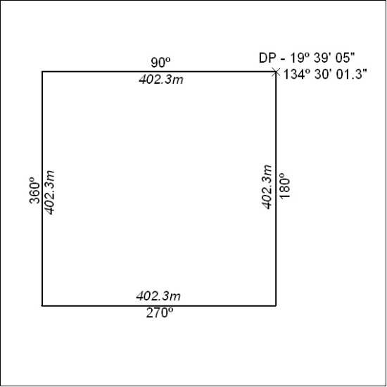

85/19

