Mineral Titles Act 2010
NOTICE OF LAND CEASING TO BE A MINERAL TITLE AREA
Title Type and Number: | Extractive Mineral Permit 27619
Area ceased on: | 17 May 2019
Area: | 28.00 Hectare
Locality: | ALICE SPRINGS
Name of Applicants(s)Holder(s): | 100% NORTH CONCRETE (NT) PTY LTD [ACN. 128 802 997]
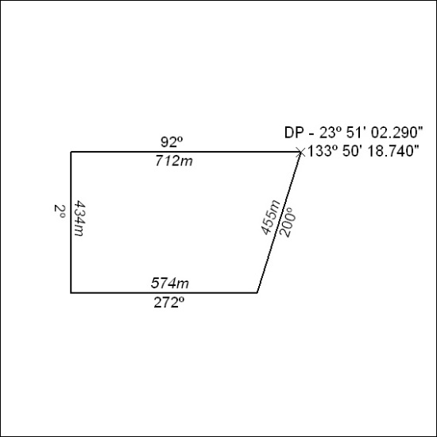

181/19

