Mineral Titles Act 2010
NOTICE OF LAND CEASING TO BE A MINERAL TITLE AREA
Title Type and Number: | Mineral Claim (Central) 1552
Area ceased on: | 16 September 2019
Area: | 5.00 Hectare
Locality: | HATCHES
Name of Applicants(s)Holder(s): | 50% LILLIS Michael Kevin, 50% MELDRUM Peta
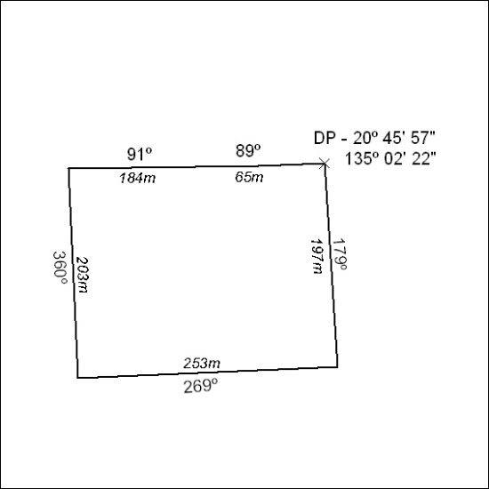

387/19

Mineral Titles Act 2010
NOTICE OF LAND CEASING TO BE A MINERAL TITLE AREA
Title Type and Number: | Mineral Lease 31396
Area ceased on: | 16 September 2019
Area: | 39.00 Hectare
Locality: | QUARTZ
Name of Applicants(s)Holder(s): | 100% BARFUSS CORPORATION PTY. LTD. [ACN. 006 917 666]
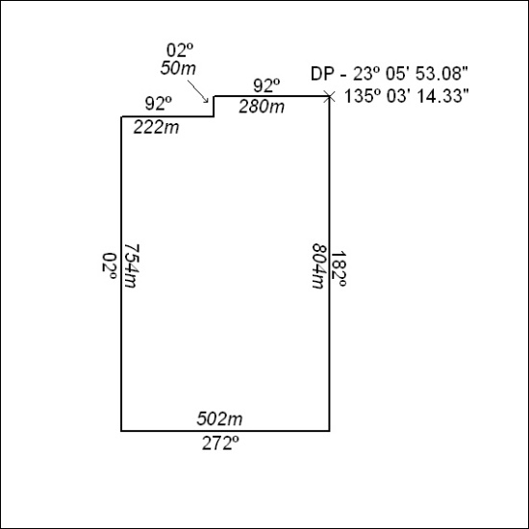

388/19

Mineral Titles Act 2010
NOTICE OF LAND CEASING TO BE A MINERAL TITLE AREA
Title Type and Number: | Mineral Lease 31398
Area ceased on: | 16 September 2019
Area: | 38.00 Hectare
Locality: | QUARTZ
Name of Applicants(s)Holder(s): | 100% BARFUSS CORPORATION PTY. LTD. [ACN. 006 917 666]
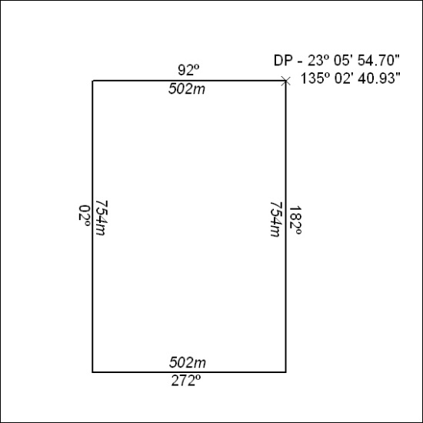

389/19

