Mineral Titles Act 2010
NOTICE OF LAND CEASING TO BE A MINERAL TITLE AREA
Title Type and Number: | Exploration Licence 30280
Area Ceased on: | 04 September 2020
Area: | 1 Block, 3.34 km²
Locality: | McKINLAY RIVER
Name of Applicant(s)/Holder(s): | 100% MT ROMANCE (NT) PTY LTD [ACN. 623 930 594]
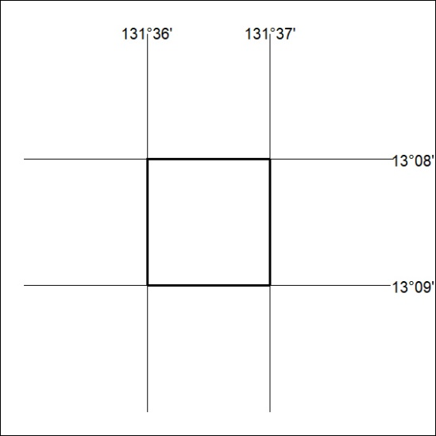

307/20

