Mineral Titles Act 2010
NOTICE OF LAND CEASING TO BE A MINERAL TITLE AREA
Title Type and Number: | Exploration Licence 31851
Area Ceased on: | 13 November 2020
Area: | 21 Blocks, 66.54 km²
Locality: | TARLTON
Name of Applicant(s)/Holder(s): | 100% BOWGAN MINERALS LTD [ACN. 137 527 336]
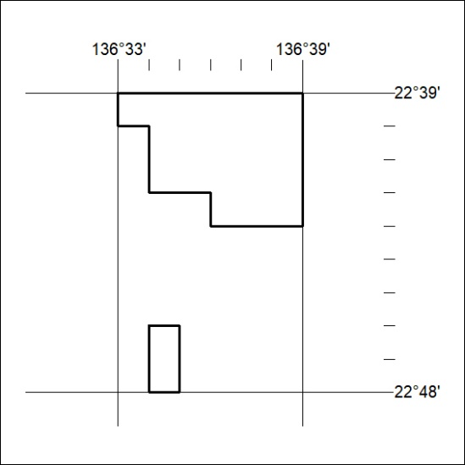

364/20

Mineral Titles Act 2010
NOTICE OF LAND CEASING TO BE A MINERAL TITLE AREA
Title Type and Number: | Extractive Mineral Permit 25079
Area ceased on: | 11 November 2020
Area: | 31.00 Hectare
Locality: | MARY RIVER
Name of Applicants(s)Holder(s): | 100% BERNO BROS. PTY. LIMITED [ACN. 009 592 741]
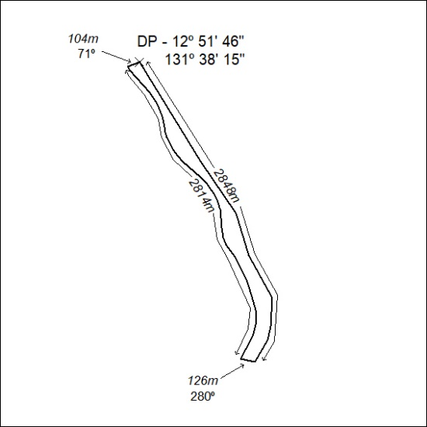

365/20

Mineral Titles Act
NOTICE OF GRANT OF AN EXPLORATION LICENCE IN RETENTION
Title Type and Number: | Exploration Licence in Retention 32552
Granted: | 16 November 2020, for a period of 5 Years
Area: | 1214.00 Hectares
Locality: | DOREEN
Name of Holder/s: | 100% ENERGY METALS LTD [ACN. 111 306 533]
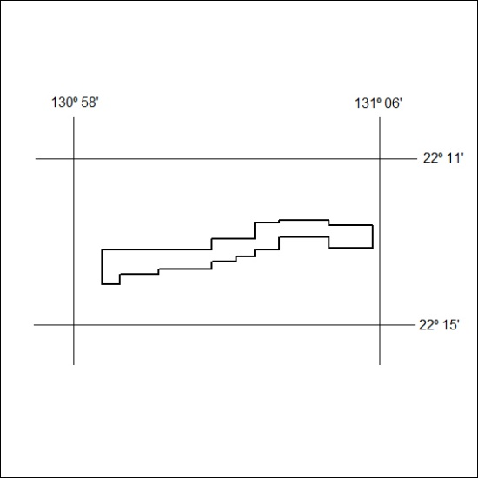

366/20

