Mineral Titles Act
NOTICE OF GRANT OF A MINERAL TITLE
Title Type and Number: | Extractive Mineral Exploration Licence 31663
Granted: | 08 March 2018, for a period of 2 Years
Area: | 2 Blocks, 3.33 km²
Locality: | NOONAMAH
Name of Holder/s: | 100% BERNO BROS. PTY. LIMITED [ACN. 009 592 741]
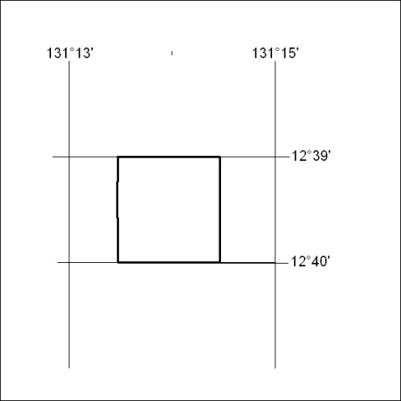
Area granted is indicated above. The titleholder is not permitted to exercise occupational rights on any land that is subject to a development title, or an application for a development title. Any land the subject of a Reserved Land gazettal under the Mineral Titles Act and all land vested in the Commonwealth of Australia is also excluded by description but not excised from the grant area.

110/18

Mineral Titles Act
NOTICE OF GRANT OF A MINERAL TITLE
Title Type and Number: | Exploration Licence 23602
Granted: | 07 March 2018, for a period of 6 Years
Area: | 250 Blocks, 814.65 km²
Locality: | RENEHAN
Name of Holder/s: | 100% ASIAN MINERALS PTY LTD [ACN. 099 804 467]
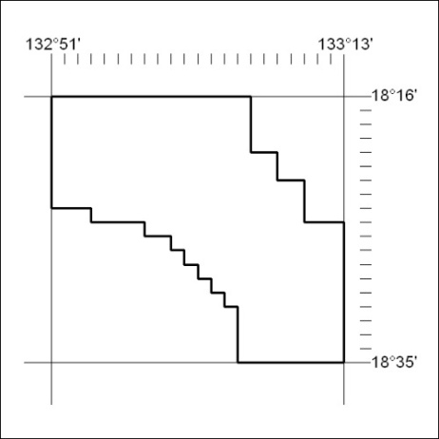
Area granted is indicated above. The titleholder is not permitted to exercise occupational rights on any land that is subject to a development title, or an application for a development title. Any land the subject of a Reserved Land gazettal under the Mineral Titles Act and all land vested in the Commonwealth of Australia is also excluded by description but not excised from the grant area.

111/18

Mineral Titles Act
NOTICE OF GRANT OF A MINERAL TITLE
Title Type and Number: | Exploration Licence 23603
Granted: | 07 March 2018, for a period of 6 Years
Area: | 232 Blocks, 754.81 km²
Locality: | THRING
Name of Holder/s: | 100% ASIAN MINERALS PTY LTD [ACN. 099 804 467]
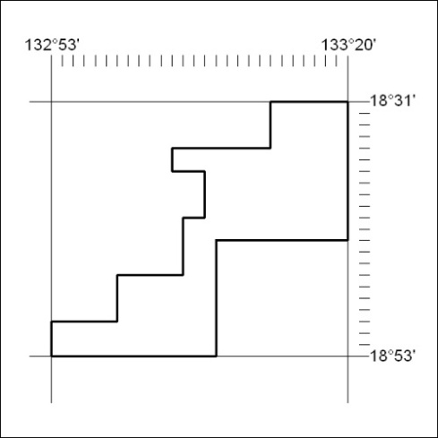
Area granted is indicated above. The titleholder is not permitted to exercise occupational rights on any land that is subject to a development title, or an application for a development title. Any land the subject of a Reserved Land gazettal under the Mineral Titles Act and all land vested in the Commonwealth of Australia is also excluded by description but not excised from the grant area.

112/18

Mineral Titles Act
NOTICE OF GRANT OF A MINERAL TITLE
Title Type and Number: | Exploration Licence 23780
Granted: | 08 March 2018, for a period of 6 Years
Area: | 250 Blocks, 815.87 km²
Locality: | RENEHAN
Name of Holder/s: | 100% ASIAN MINERALS PTY LTD [ACN. 099 804 467]
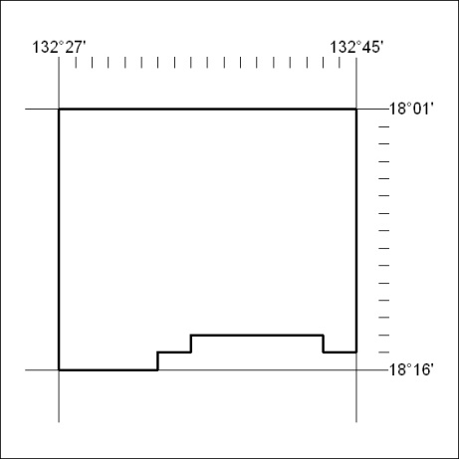
Area granted is indicated above. The titleholder is not permitted to exercise occupational rights on any land that is subject to a development title, or an application for a development title. Any land the subject of a Reserved Land gazettal under the Mineral Titles Act and all land vested in the Commonwealth of Australia is also excluded by description but not excised from the grant area.

113/18

Mineral Titles Act
NOTICE OF GRANT OF A MINERAL TITLE
Title Type and Number: | Exploration Licence 31757
Granted: | 08 March 2018, for a period of 6 Years
Area: | 188 Blocks, 612.32 km²
Locality: | KOOKABURRA
Name of Holder/s: | 100% ASIAN MINERALS PTY LTD [ACN. 099 804 467]
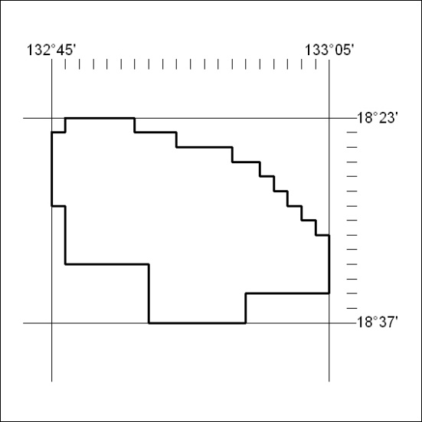
Area granted is indicated above. The titleholder is not permitted to exercise occupational rights on any land that is subject to a development title, or an application for a development title. Any land the subject of a Reserved Land gazettal under the Mineral Titles Act and all land vested in the Commonwealth of Australia is also excluded by description but not excised from the grant area.

114/18

