Mineral Titles Act
NOTICE OF LAND CEASING TO BE A MINERAL TITLE AREA
Title Type and Number: | Exploration Licence 24253
Area Ceased on: | 12 April 2018
Area: | 26 Blocks, 83.02 km²
Locality: | HOME OF BULLION
Name of Applicant(s)/Holder(s): | 100% MITHRIL RESOURCES LTD [ACN. 099 883 922]
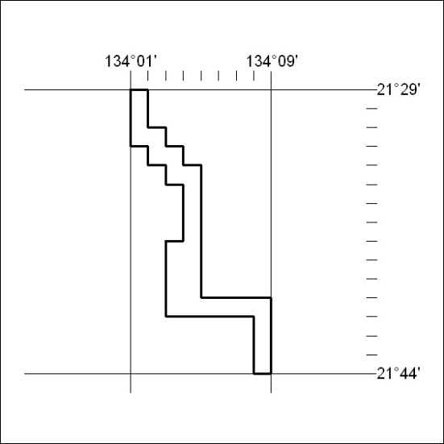

127/18

Mineral Titles Act
NOTICE OF LAND CEASING TO BE A MINERAL TITLE AREA
Title Type and Number: | Exploration Licence 24453
Area Ceased on: | 29 March 2018
Area: | 111 Blocks, 325.51 km²
Locality: | DOREEN
Name of Applicant(s)/Holder(s): | 100% ENERGY METALS LTD [ACN. 111 306 533]
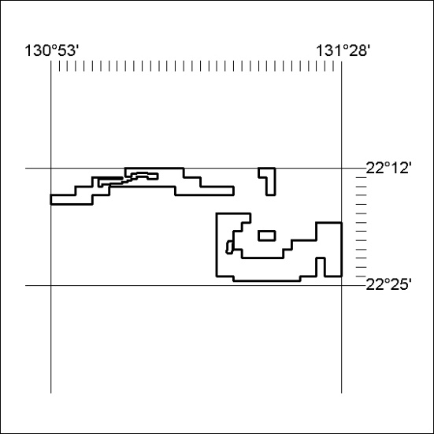
(Area now amalgamated into Exploration Licences 31820 & 31821 under s102 – EL moratorium period does not apply)

128/18

Mineral Titles Act
NOTICE OF LAND CEASING TO BE A MINERAL TITLE AREA
Title Type and Number: | Exploration Licence 24807
Area Ceased on: | 29 March 2018
Area: | 10 Blocks, 31.78 km²
Locality: | DOREEN
Name of Applicant(s)/Holder(s): | 100% ENERGY METALS LTD [ACN. 111 306 533]
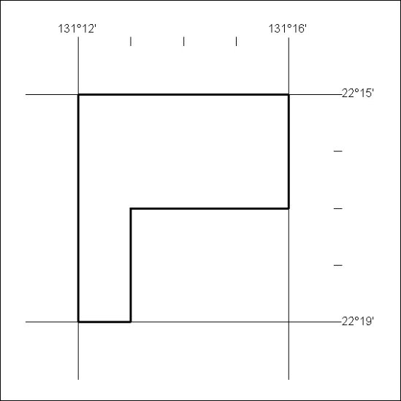
(Area now amalgamated into Exploration Licence 31821 under s102 – EL moratorium period does not apply)

129/18

Mineral Titles Act
NOTICE OF LAND CEASING TO BE A MINERAL TITLE AREA
Title Type and Number: | Exploration Licence 29903
Area Ceased on: | 12 April 2018
Area: | 20 Blocks, 63.31 km²
Locality: | MT WEDGE
Name of Applicant(s)/Holder(s): | 100% PIPER PRESTON PTY LTD [ACN. 142 962 409]
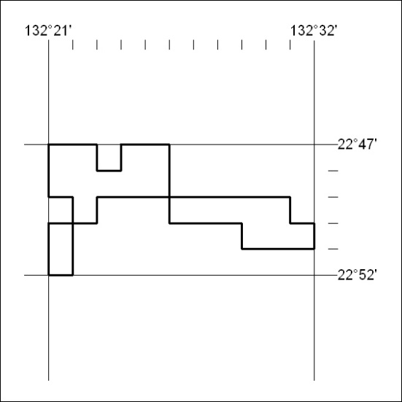

130/18

Mineral Titles Act
NOTICE OF LAND CEASING TO BE A MINERAL TITLE AREA
Title Type and Number: | Exploration Licence 30002
Area Ceased on: | 09 April 2018
Area: | 7 Blocks, 10.91 km²
Locality: | DOREEN
Name of Applicant(s)/Holder(s): | 100% ENERGY METALS LTD [ACN. 111 306 533]
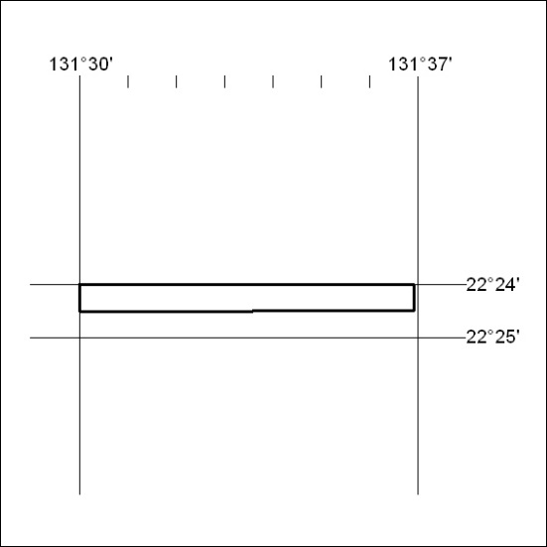

131/18

Mineral Titles Act
NOTICE OF LAND CEASING TO BE A MINERAL TITLE AREA
Title Type and Number: | Exploration Licence 30006
Area Ceased on: | 09 April 2018
Area: | 4 Blocks, 12.71 km²
Locality: | DOREEN
Name of Applicant(s)/Holder(s): | 100% ENERGY METALS LTD [ACN. 111 306 533]
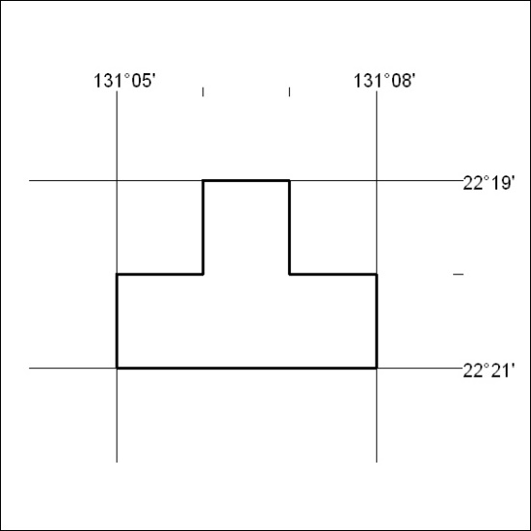

132/18

Mineral Titles Act
NOTICE OF LAND CEASING TO BE A MINERAL TITLE AREA
Title Type and Number: | Exploration Licence 30054
Area Ceased on: | 12 April 2018
Area: | 12 Blocks, 39.36 km²
Locality: | CAMFIELD
Name of Applicant(s)/Holder(s): | 100% JETTNER Peter John
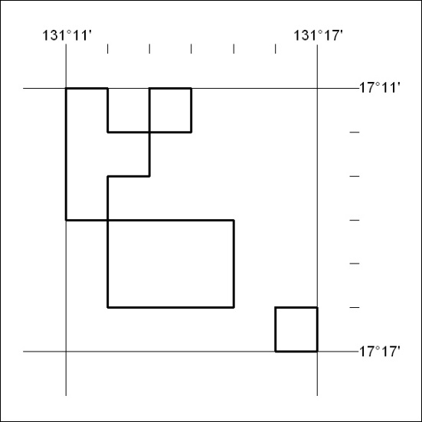

133/18

Mineral Titles Act
NOTICE OF LAND CEASING TO BE A MINERAL TITLE AREA
Title Type and Number: | Exploration Licence 31636
Area Ceased on: | 29 March 2018
Area: | 33 Blocks, 104.84 km²
Locality: | VAUGHAN
Name of Applicant(s)/Holder(s): | 100% ENERGY METALS LTD [ACN. 111 306 533]
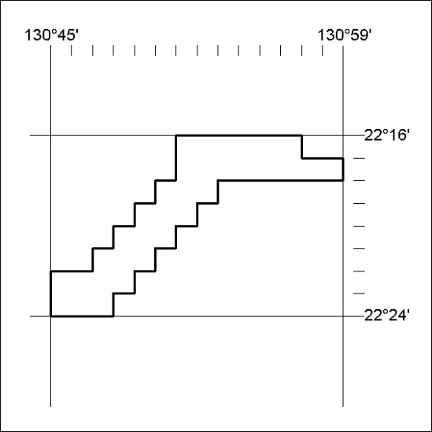
(Area now amalgamated into Exploration Licence 31820 under s102 – EL moratorium period does not apply)

134/18

Mineral Titles Act
NOTICE OF LAND CEASING TO BE A MINERAL TITLE AREA
Title Type and Number: | Exploration Licence 31843
Area Ceased on: | 11 April 2018
Area: | 38 Blocks, 83.76 km²
Locality: | BATCHELOR
Name of Applicant(s)/Holder(s): | 100% URANIUM GENERATION PTY LTD [ACN. 617 270 283]
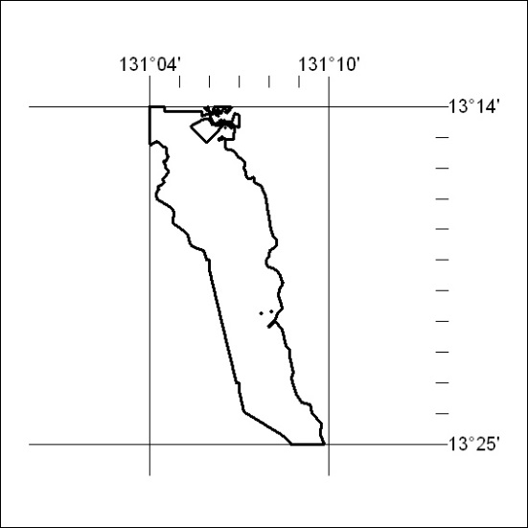

135/18

Mineral Titles Act
NOTICE OF LAND CEASING TO BE A MINERAL TITLE AREA
Title Type and Number: | Exploration Licence 31884
Area Ceased on: | 29 March 2018
Area: | 9 Blocks, 28.60 km²
Locality: | DOREEN
Name of Applicant(s)/Holder(s): | 100% ENERGY METALS LTD [ACN. 111 306 533]
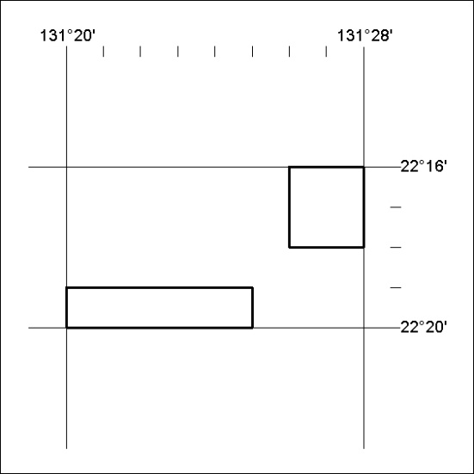
(Area now amalgamated into Exploration Licence 31821 under s102 – EL moratorium period does not apply)

136/18

Mineral Titles Act
NOTICE OF GRANT OF A MINERAL TITLE
Title Type and Number: | Extractive Mineral Permit 31110
Granted: | 10 April 2018, for a period of 5 Years
Area: | 12.00 Hectares
Locality: | MATARANKA
Name of Holder/s: | 100% CAVE CREEK STATION PTY LTD [ACN. 050514791]
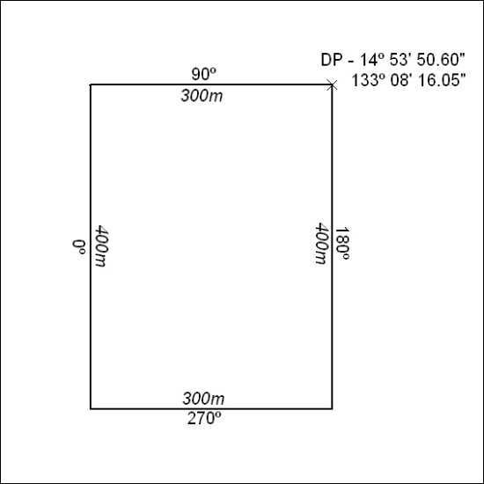

137/18

