Mineral Titles Act
NOTICE OF LAND CEASING TO BE A MINERAL TITLE
Title Type and Number: | Extractive Mineral Permit (Northern) 1133
Area ceased on: | 22 July 2004
Locality: | PINE CREEK
Name of Applicants(s)Holder(s): | 100% A AND SF MADDALOZZO PTY. LIMITED [ACN. 009 624 015]
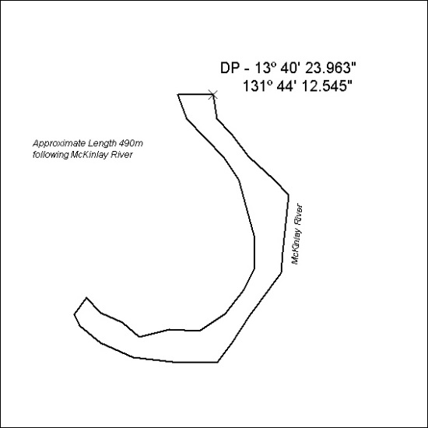

316/18

Mineral Titles Act
NOTICE OF LAND CEASING TO BE A MINERAL TITLE
Title Type and Number: | Extractive Mineral Permit 22932
Area ceased on: | 26 July 2018
Area: | 4.00 Hectare
Locality: | PINE CREEK
Name of Applicants(s)Holder(s): | 100% A AND SF MADDALOZZO PTY. LIMITED [ACN. 009 624 015]
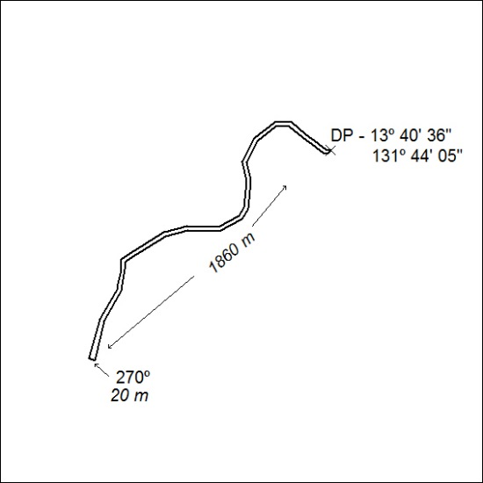

317/18

Mineral Titles Act
NOTICE OF LAND CEASING TO BE A MINERAL TITLE
Title Type and Number: | Extractive Mineral Permit 26261
Area ceased on: | 26 July 2018
Area: | 9.00 Hectare
Locality: | PINE CREEK
Name of Applicants(s)Holder(s): | 100% A AND SF MADDALOZZO PTY. LIMITED [ACN. 009 624 015]
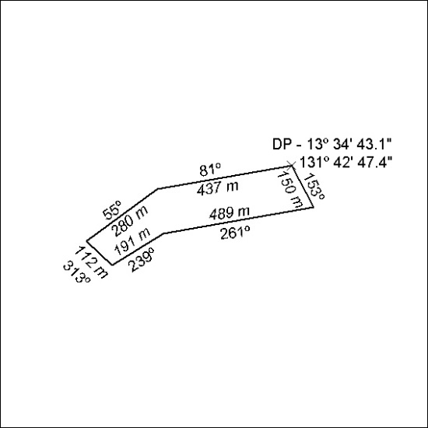

318/18

Mineral Titles Act
NOTICE OF LAND CEASING TO BE A MINERAL TITLE
Title Type and Number: | Extractive Mineral Permit 27397
Area ceased on: | 26 July 2018
Area: | 10.00 Hectare
Locality: | PINE CREEK
Name of Applicants(s)Holder(s): | 100% A AND SF MADDALOZZO PTY. LIMITED [ACN. 009 624 015]
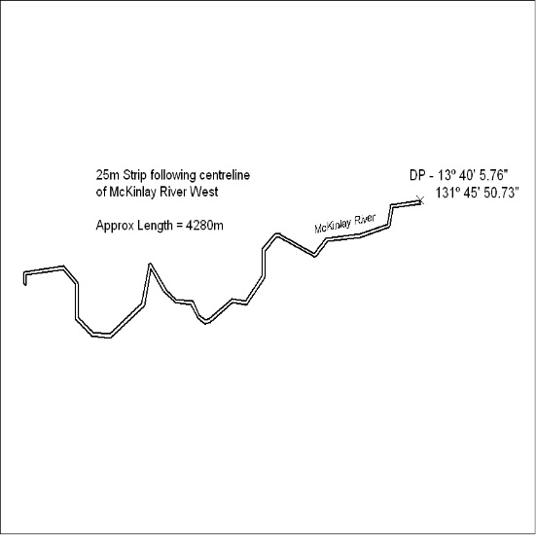

319/18

Mineral Titles Act
NOTICE OF LAND CEASING TO BE A MINERAL TITLE
Title Type and Number: | Extractive Mineral Permit 27486
Area ceased on: | 26 July 2018
Area: | 7.00 Hectare
Locality: | PINE CREEK
Name of Applicants(s)Holder(s): | 100% A AND SF MADDALOZZO PTY. LIMITED [ACN. 009 624 015]
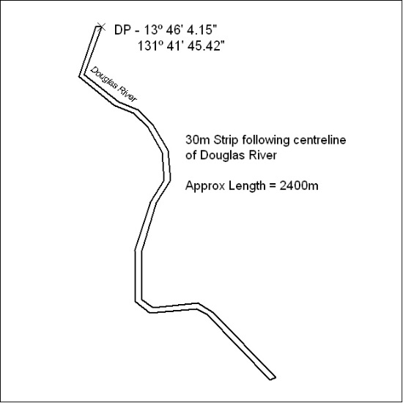

320/18

Mineral Titles Act
NOTICE OF LAND CEASING TO BE A MINERAL TITLE
Title Type and Number: | Extractive Mineral Permit 30298
Area ceased on: | 26 July 2018
Area: | 4.00 Hectare
Locality: | PINE CREEK
Name of Applicants(s)Holder(s): | 100% A AND SF MADDALOZZO PTY. LIMITED [ACN. 009 624 015]
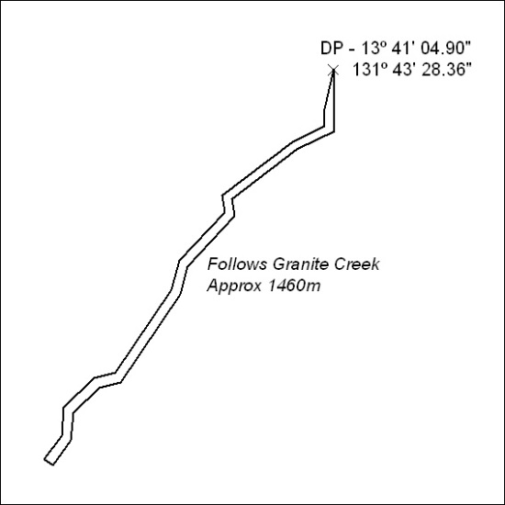

321/18

Mineral Titles Act
NOTICE OF LAND CEASING TO BE A MINERAL TITLE AREA
Title Type and Number: | Exploration Licence 23933
Area Ceased on: | 25 July 2018
Area: | 118 Blocks, 348.93 km²
Locality: | TANAMI
Name of Applicant(s)/Holder(s): | 100% NORTHERN STAR (TANAMI) PTY LTD [ACN. 603 860 831]
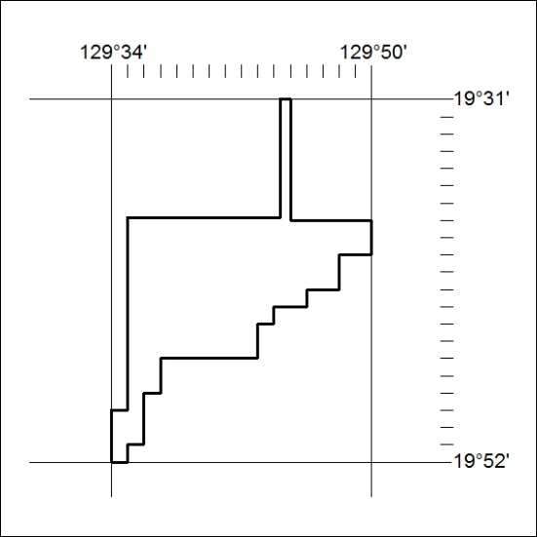

322/18

Mineral Titles Act
NOTICE OF LAND CEASING TO BE A MINERAL TITLE AREA
Title Type and Number: | Exploration Licence 23935
Area Ceased on: | 25 July 2018
Area: | 157 Blocks, 506.31 km²
Locality: | FRANKENIA
Name of Applicant(s)/Holder(s): | 100% NORTHERN STAR (TANAMI) PTY LTD [ACN. 603 860 831]
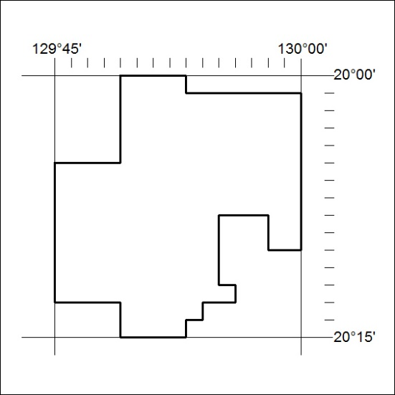

323/18

Mineral Titles Act
NOTICE OF LAND CEASING TO BE A MINERAL TITLE AREA
Title Type and Number: | Exploration Licence 29800
Area Ceased on: | 27 July 2018
Area: | 79 Blocks, 184.96 km²
Locality: | CROKER
Name of Applicant(s)/Holder(s): | 100% MZI RESOURCES LTD* [ACN. 077 221 722]
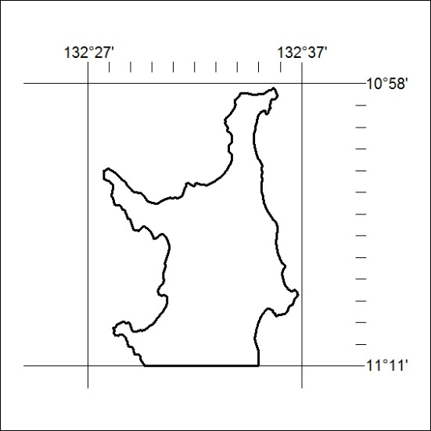

324/18

Mineral Titles Act
NOTICE OF LAND CEASING TO BE A MINERAL TITLE AREA
Title Type and Number: | Exploration Licence 29839
Area Ceased on: | 27 July 2018
Area: | 49 Blocks, 135.95 km²
Locality: | MILINGIMBI
Name of Applicant(s)/Holder(s): | 100% MZI RESOURCES LTD* [ACN. 077 221 722]
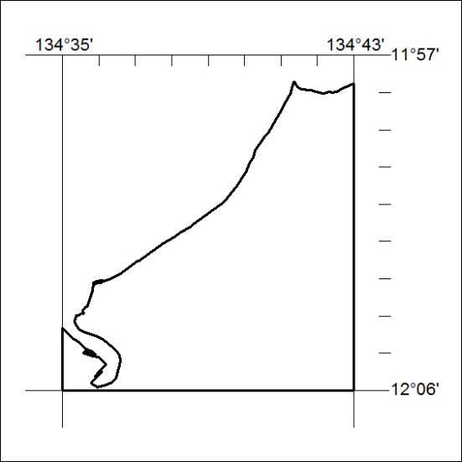

325/18

Mineral Titles Act
NOTICE OF LAND CEASING TO BE A MINERAL TITLE AREA
Title Type and Number: | Exploration Licence 31699
Area Ceased on: | 26 July 2018
Area: | 27 Blocks, 85.66 km²
Locality: | NAPPERBY
Name of Applicant(s)/Holder(s): | 100% BENGER John William
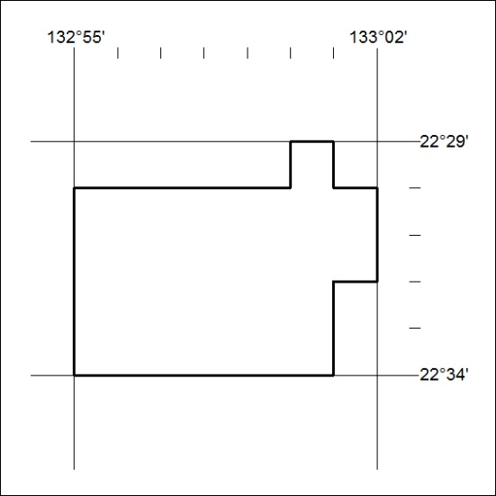

326/18

