Mineral Titles Act
NOTICE OF LAND CEASING TO BE A MINERAL TITLE AREA
Title Type and Number: | Exploration Licence 31432
Area Ceased on: | 26 September 2018
Area: | 36 Blocks, 112.82 km²
Locality: | PEACHY
Name of Applicant(s)/Holder(s): | 100% CYAN STONE PTY LTD [ACN. 606 864 840]
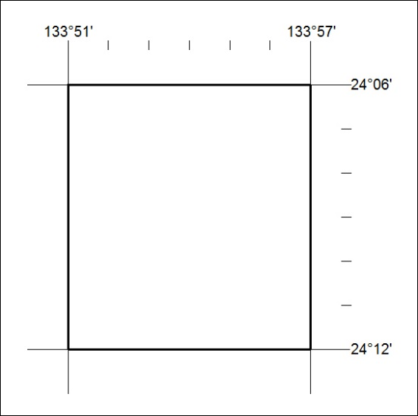

417/18

Mineral Titles Act
NOTICE OF LAND CEASING TO BE A MINERAL TITLE AREA
Title Type and Number: | Exploration Licence 31940
Area Ceased on: | 14 August 2018
Area: | 6 Blocks, 20.04 km²
Locality: | BATCHELOR
Name of Applicant(s)/Holder(s): | 100% PNX METALS LIMITED* [ACN. 127 446 271]
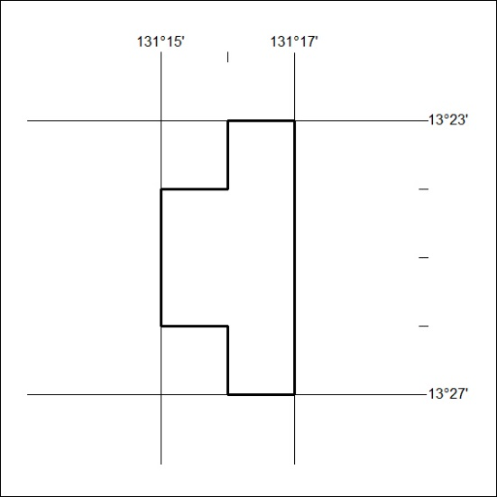

418/18

