Mineral Titles Act
NOTICE OF LAND CEASING TO BE A MINERAL TITLE
Title Type and Number: | Mineral Authority 28192
Area ceased on: | 29 September 2018
Area: | 4.00 Hectare
Locality: | ALICE SPRINGS
Name of Applicants(s)Holder(s): | 100% NORTH CONCRETE (NT) PTY LTD [ACN. 128 802 997]
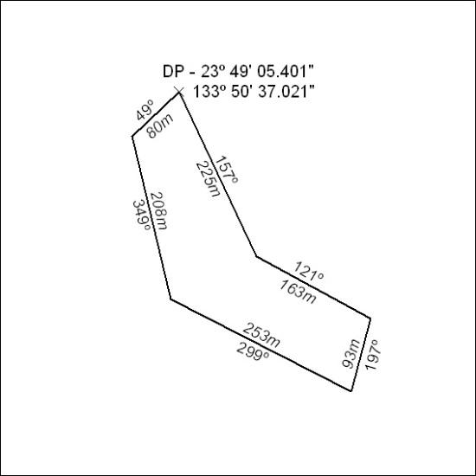

419/18

