Mineral Titles Act
NOTICE OF LAND CEASING TO BE A MINERAL TITLE AREA
Title Type and Number: | Exploration Licence 31776
Area Ceased on: | 02 October 2018
Area: | 216 Blocks, 683.50 km²
Locality: | DNEIPER
Name of Applicant(s)/Holder(s): | 100% XAVIER RESOURCES PTY LTD [ACN. 623 262 304]
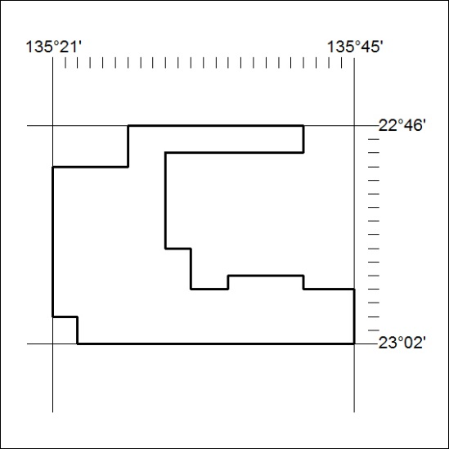

439/18

Mineral Titles Act
NOTICE OF GRANT OF A MINERAL TITLE
Title Type and Number: | Exploration Licence 31777
Granted: | 02 October 2018, for a period of 6 Years
Area: | 250 Blocks, 780.55 km²
Locality: | DNEIPER
Name of Holder/s: | 100% XAVIER RESOURCES PTY LTD [ACN. 623 262 304]
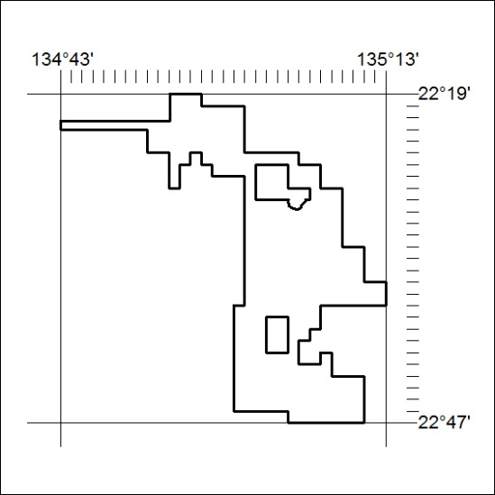
Area granted is indicated above. The titleholder is not permitted to exercise occupational rights on any land that is subject to a development title, or an application for a development title. Any land the subject of a Reserved Land gazettal under the Mineral Titles Act and all land vested in the Commonwealth of Australia is also excluded by description but not excised from the grant area.

440/18

Mineral Titles Act
NOTICE OF GRANT OF A MINERAL TITLE
Title Type and Number: | Exploration Licence 31778
Granted: | 02 October 2018, for a period of 6 Years
Area: | 94 Blocks, 297.48 km²
Locality: | DELNY
Name of Holder/s: | 100% XAVIER RESOURCES PTY LTD [ACN. 623 262 304]
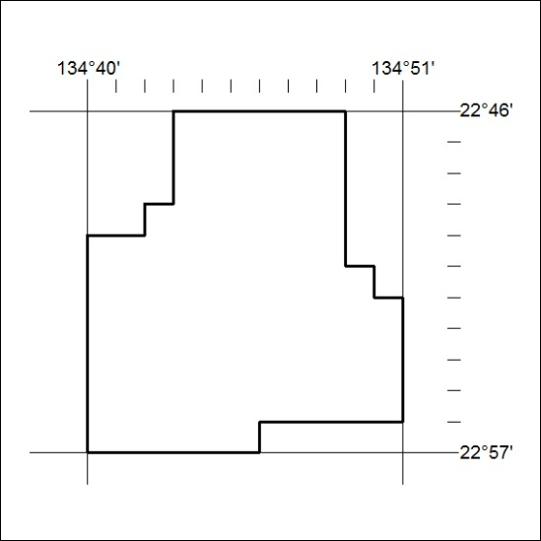
Area granted is indicated above. The titleholder is not permitted to exercise occupational rights on any land that is subject to a development title, or an application for a development title. Any land the subject of a Reserved Land gazettal under the Mineral Titles Act and all land vested in the Commonwealth of Australia is also excluded by description but not excised from the grant area.
441/18

Mineral Titles Act
NOTICE OF GRANT OF A MINERAL TITLE
Title Type and Number: | Exploration Licence 31779
Granted: | 02 October 2018, for a period of 6 Years
Area: | 175 Blocks, 554.46 km²
Locality: | DELNY
Name of Holder/s: | 100% XAVIER RESOURCES PTY LTD [ACN. 623 262 304]
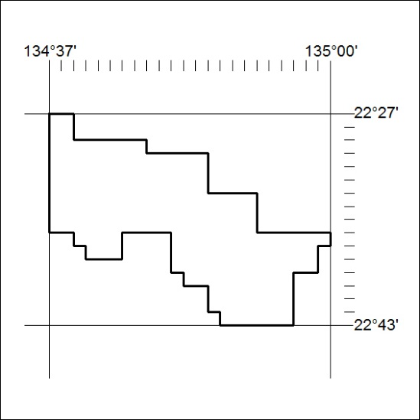
Area granted is indicated above. The titleholder is not permitted to exercise occupational rights on any land that is subject to a development title, or an application for a development title. Any land the subject of a Reserved Land gazettal under the Mineral Titles Act and all land vested in the Commonwealth of Australia is also excluded by description but not excised from the grant area.

442/18

