Mineral Titles Act
NOTICE OF LAND CEASING TO BE A MINERAL TITLE AREA
Title Type and Number: | Exploration Licence 31012
Area Ceased on: | 11 October 2018
Area: | 28 Blocks, 91.82 km²
Locality: | LANCEWOOD
Name of Applicant(s)/Holder(s): | 100% RIPPLE RESOURCES PTY LTD [ACN. 127 220 768]
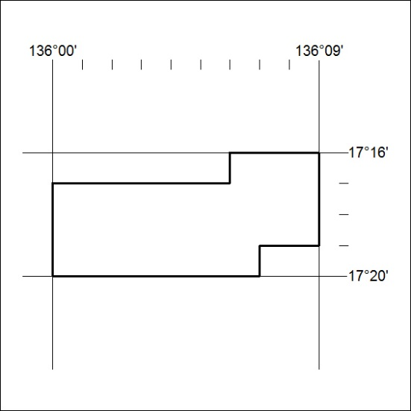

444/18

