Mineral Titles Act
NOTICE OF LAND CEASING TO BE A MINERAL TITLE AREA
Title Type and Number: | Exploration Licence 23885
Area Ceased on: | 17 October 2018
Area: | 16 Blocks, 51.33 km²
Locality: | JARRAH JARRAH
Name of Applicant(s)/Holder(s): | 100% PRODIGY GOLD NL* [ACN. 009 127 020]
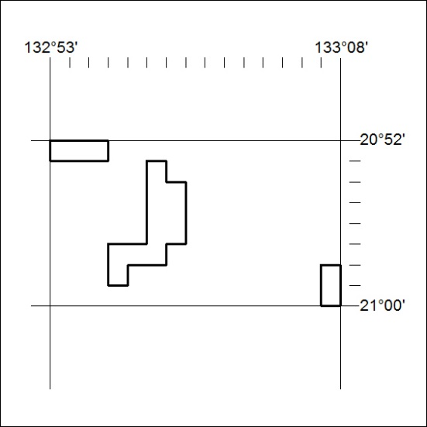

454/18

Mineral Titles Act
NOTICE OF LAND CEASING TO BE A MINERAL TITLE AREA
Title Type and Number: | Exploration Licence 23886
Area Ceased on: | 17 October 2018
Area: | 45 Blocks, 137.89 km²
Locality: | JARRAH JARRAH
Name of Applicant(s)/Holder(s): | 100% PRODIGY GOLD NL* [ACN. 009 127 020]
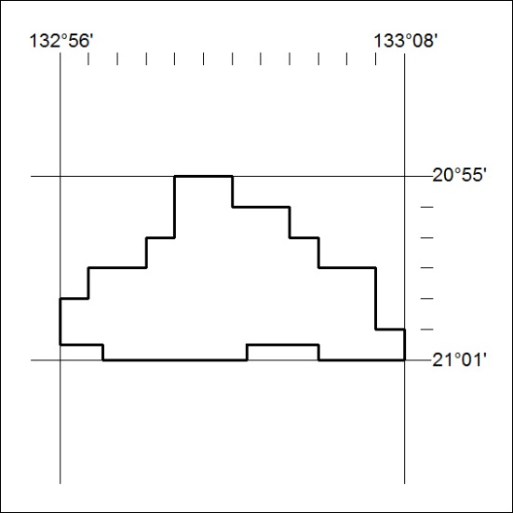

455/18

Mineral Titles Act
NOTICE OF LAND CEASING TO BE A MINERAL TITLE
Title Type and Number: | Extractive Mineral Permit 30684
Area ceased on: | 17 October 2018
Area: | 1.836 Hectare
Locality: | NOONAMAH
Name of Applicants(s)Holder(s): | 100% OSTOJIC GROUP PTY LTD* [ACN. 009 629 805]
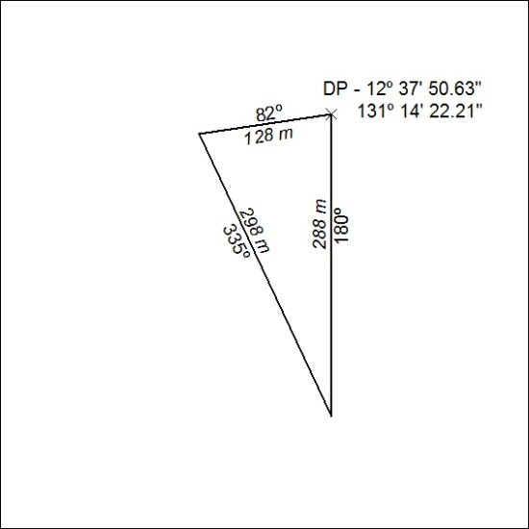

456/18

