Mineral Titles Act
NOTICE OF LAND CEASING TO BE A MINERAL TITLE AREA
Title Type and Number: | Exploration Licence 30780
Area Ceased on: | 18 October 2018
Area: | 63 Blocks, 198.92 km²
Locality: | LAUGHLEN
Name of Applicant(s)/Holder(s): | 100% TERRITORY EXPLORATION PTY LTD [ACN. 123 338 376]
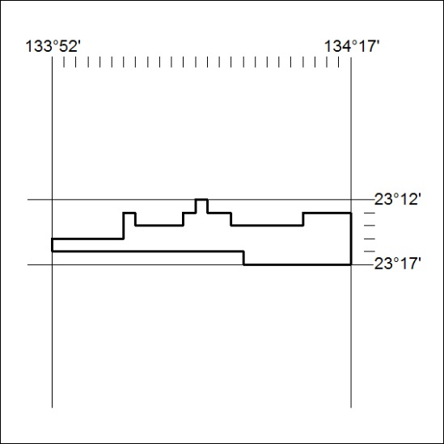

459/18

Mineral Titles Act
NOTICE OF LAND CEASING TO BE A MINERAL TITLE AREA
Title Type and Number: | Exploration Licence 30786
Area Ceased on: | 18 October 2018
Area: | 36 Blocks, 112.70 km²
Locality: | BURT
Name of Applicant(s)/Holder(s): | 100% TERRITORY EXPLORATION PTY LTD [ACN. 123 338 376]
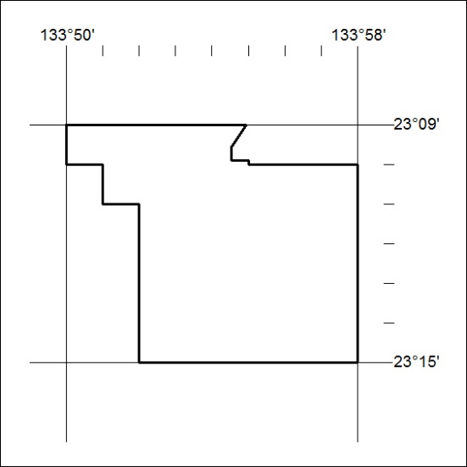

460/18

Mineral Titles Act
NOTICE OF LAND CEASING TO BE A MINERAL TITLE AREA
Title Type and Number: | Exploration Licence 31286
Area Ceased on: | 18 October 2018
Area: | 82 Blocks, 251.68 km²
Locality: | BURT
Name of Applicant(s)/Holder(s): | 100% TERRITORY EXPLORATION PTY LTD [ACN. 123 338 376]
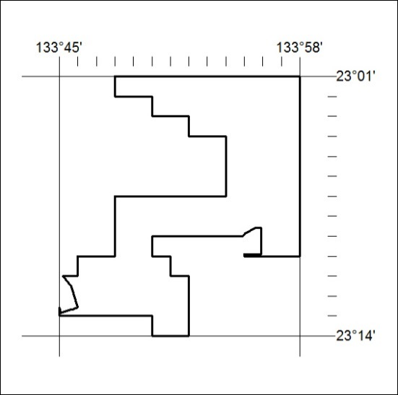

461/18

Mineral Titles Act
NOTICE OF LAND CEASING TO BE A MINERAL TITLE AREA
Title Type and Number: | Exploration Licence 27367
Area Ceased on: | 19 October 2018
Area: | 24 Blocks, 77.82 km²
Locality: | MALLEE
Name of Applicant(s)/Holder(s): | 100% NORTHERN STAR (TANAMI) PTY LTD [ACN. 603 860 831]
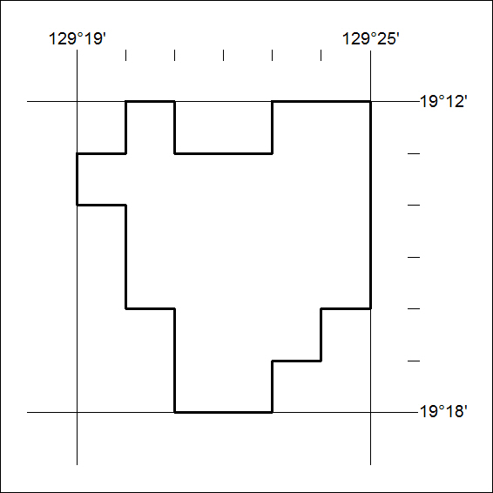

462/18

Mineral Titles Act
NOTICE OF LAND CEASING TO BE A MINERAL TITLE AREA
Title Type and Number: | Exploration Licence 29592
Area Ceased on: | 19 October 2018
Area: | 38 Blocks, 123.21 km²
Locality: | MALLEE
Name of Applicant(s)/Holder(s): | 100% NORTHERN STAR (TANAMI) PTY LTD [ACN. 603 860 831]
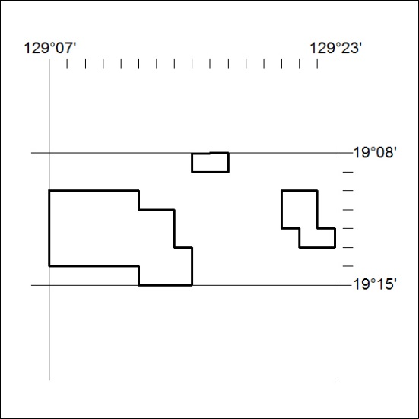

463/18

Mineral Titles Act
NOTICE OF LAND CEASING TO BE A MINERAL TITLE AREA
Title Type and Number: | Exploration Licence 29593
Area Ceased on: | 19 October 2018
Area: | 31 Blocks, 100.48 km²
Locality: | MALLEE
Name of Applicant(s)/Holder(s): | 100% NORTHERN STAR (TANAMI) PTY LTD [ACN. 603 860 831]
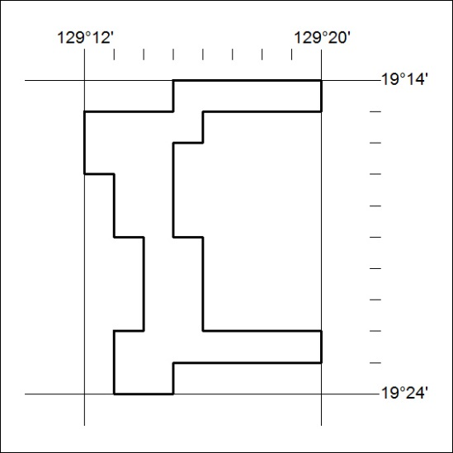

464/18

Mineral Titles Act
NOTICE OF LAND CEASING TO BE A MINERAL TITLE AREA
Title Type and Number: | Exploration Licence 29595
Area Ceased on: | 19 October 2018
Area: | 30 Blocks, 96.96 km²
Locality: | PARGEE
Name of Applicant(s)/Holder(s): | 100% NORTHERN STAR (TANAMI) PTY LTD [ACN. 603 860 831]
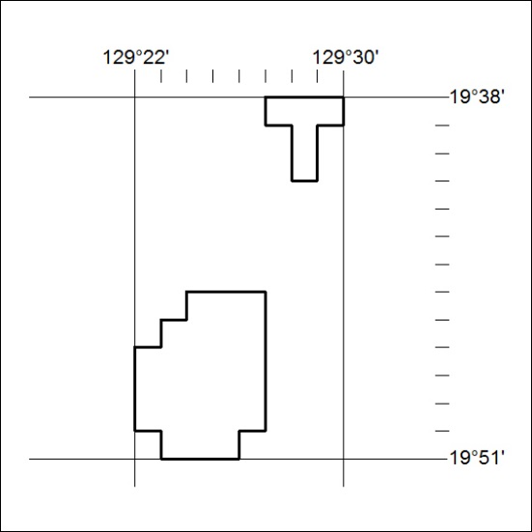

465/18

Mineral Titles Act
NOTICE OF GRANT OF A MINERAL TITLE
Title Type and Number: | Exploration Licence 31730
Granted: | 18 October 2018, for a period of 6 Years
Area: | 4 Blocks, 13.35 km²
Locality: | PINE CREEK
Name of Holder/s: | 100% CELLIER Leon John
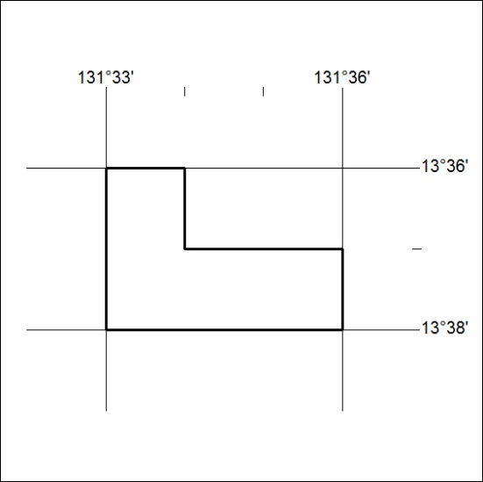
Area granted is indicated above. The titleholder is not permitted to exercise occupational rights on any land that is subject to a development title, or an application for a development title. Any land the subject of a Reserved Land gazettal under the Mineral Titles Act and all land vested in the Commonwealth of Australia is also excluded by description but not excised from the grant area.

466/18

Mineral Titles Act
NOTICE OF GRANT OF A MINERAL TITLE
Title Type and Number: | Exploration Licence 31850
Granted: | 17 October 2018, for a period of 6 Years
Area: | 5 Blocks, 11.97 km²
Locality: | ANNINGIE
Name of Holder/s: | 100% ENIGMA MINING LIMITED [ACN. 009 225 558]
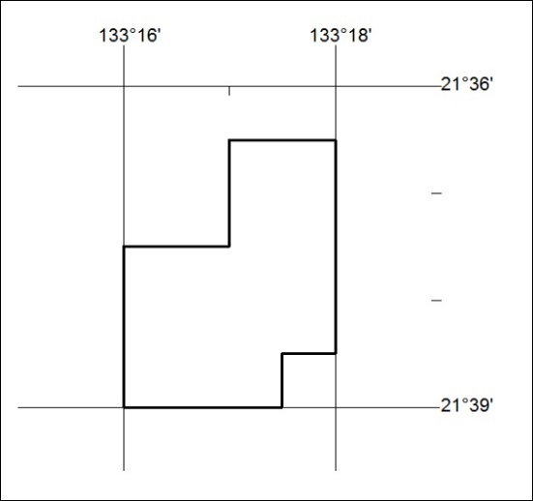
Area granted is indicated above. The titleholder is not permitted to exercise occupational rights on any land that is subject to a development title, or an application for a development title. Any land the subject of a Reserved Land gazettal under the Mineral Titles Act and all land vested in the Commonwealth of Australia is also excluded by description but not excised from the grant area.

467/18

