Mineral Titles Act
NOTICE OF LAND CEASING TO BE A MINERAL TITLE AREA
Title Type and Number: | Exploration Licence 28026
Area Ceased on: | 21 November 2018
Area: | 37 Blocks, 122.65 km²
Locality: | WILLEROO
Name of Applicant(s)/Holder(s): | 100% AUSTRALIAN MINERA RESOURCES PTY LTD [ACN. 152 123 754]
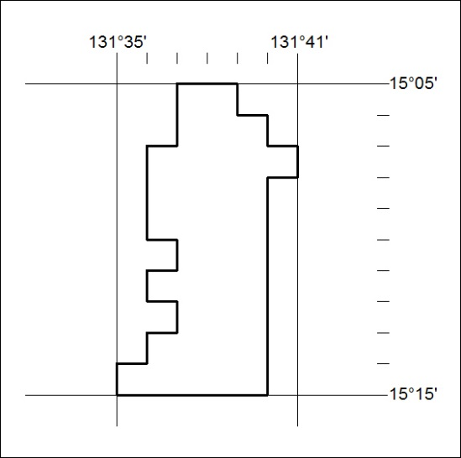
531/18

Mineral Titles Act
NOTICE OF GRANT OF A MINERAL TITLE
Title Type and Number: | Exploration Licence 31803
Granted: | 20 November 2018, for a period of 6 Years
Area: | 84 Blocks, 277.45 km²
Locality: | NUTWOOD
Name of Holder/s: | 100% MMG EXPLORATION PTY LTD* [ACN. 119 136 659]
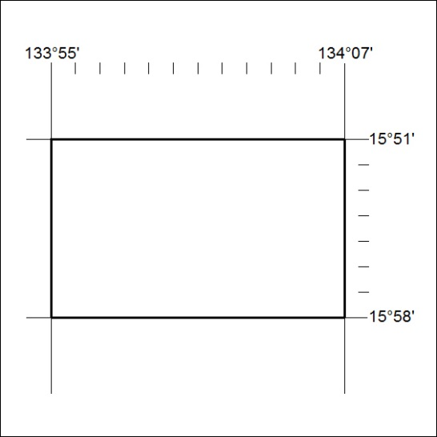
Area granted is indicated above. The titleholder is not permitted to exercise occupational rights on any land that is subject to a development title, or an application for a development title. Any land the subject of a Reserved Land gazettal under the Mineral Titles Act and all land vested in the Commonwealth of Australia is also excluded by description but not excised from the grant area.
532/18

Mineral Titles Act
NOTICE OF GRANT OF A MINERAL TITLE
Title Type and Number: | Exploration Licence 31804
Granted: | 20 November 2018, for a period of 6 Years
Area: | 240 Blocks, 793.08 km²
Locality: | NUTWOOD
Name of Holder/s: | 100% MMG EXPLORATION PTY LTD* [ACN. 119 136 659]
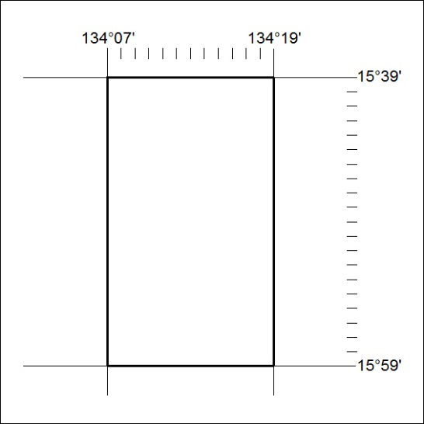
Area granted is indicated above. The titleholder is not permitted to exercise occupational rights on any land that is subject to a development title, or an application for a development title. Any land the subject of a Reserved Land gazettal under the Mineral Titles Act and all land vested in the Commonwealth of Australia is also excluded by description but not excised from the grant area.
533/18

Mineral Titles Act
NOTICE OF GRANT OF A MINERAL TITLE
Title Type and Number: | Exploration Licence 31805
Granted: | 20 November 2018, for a period of 6 Years
Area: | 238 Blocks, 787.56 km²
Locality: | NUTWOOD
Name of Holder/s: | 100% MMG EXPLORATION PTY LTD* [ACN. 119 136 659]
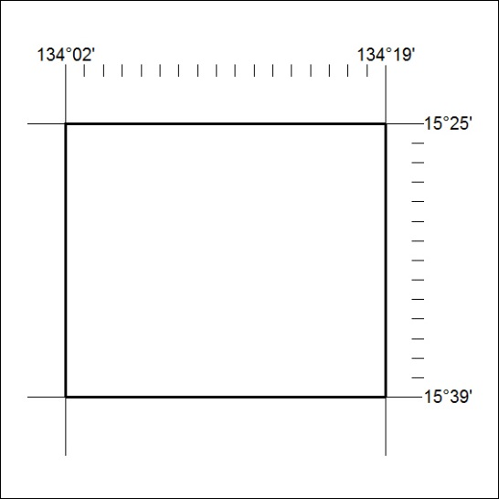
Area granted is indicated above. The titleholder is not permitted to exercise occupational rights on any land that is subject to a development title, or an application for a development title. Any land the subject of a Reserved Land gazettal under the Mineral Titles Act and all land vested in the Commonwealth of Australia is also excluded by description but not excised from the grant area.
534/18

Mineral Titles Act
NOTICE OF GRANT OF A MINERAL TITLE
Title Type and Number: | Exploration Licence 31806
Granted: | 20 November 2018, for a period of 6 Years
Area: | 240 Blocks, 793.34 km²
Locality: | MARYFIELD
Name of Holder/s: | 100% MMG EXPLORATION PTY LTD* [ACN. 119 136 659]
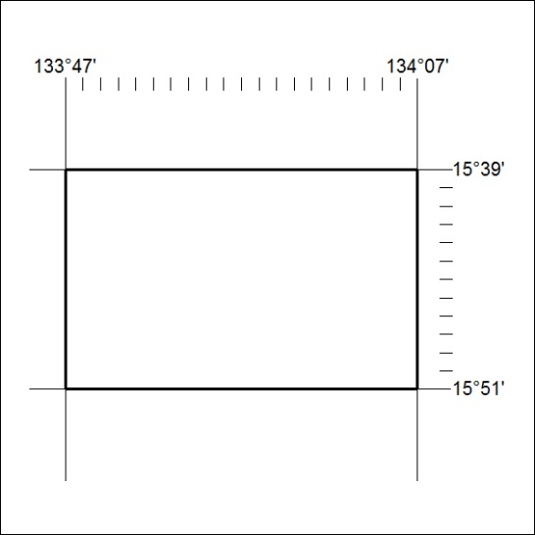
Area granted is indicated above. The titleholder is not permitted to exercise occupational rights on any land that is subject to a development title, or an application for a development title. Any land the subject of a Reserved Land gazettal under the Mineral Titles Act and all land vested in the Commonwealth of Australia is also excluded by description but not excised from the grant area.
535/18

Mineral Titles Act
NOTICE OF GRANT OF A MINERAL TITLE
Title Type and Number: | Exploration Licence 31807
Granted: | 20 November 2018, for a period of 6 Years
Area: | 226 Blocks, 747.93 km²
Locality: | MARYFIELD
Name of Holder/s: | 100% MMG EXPLORATION PTY LTD* [ACN. 119 136 659]
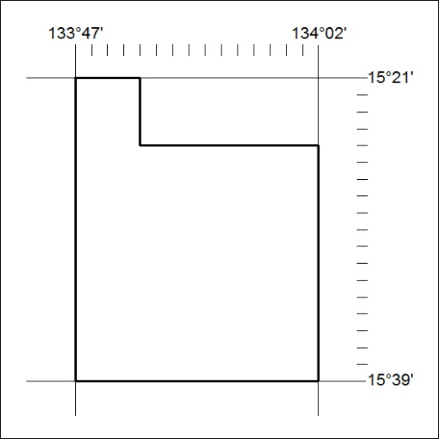
Area granted is indicated above. The titleholder is not permitted to exercise occupational rights on any land that is subject to a development title, or an application for a development title. Any land the subject of a Reserved Land gazettal under the Mineral Titles Act and all land vested in the Commonwealth of Australia is also excluded by description but not excised from the grant area.
536/18

Mineral Titles Act
NOTICE OF GRANT OF A MINERAL TITLE
Title Type and Number: | Exploration Licence 31808
Granted: | 20 November 2018, for a period of 6 Years
Area: | 234 Blocks, 774.20 km²
Locality: | MARYFIELD
Name of Holder/s: | 100% MMG EXPLORATION PTY LTD* [ACN. 119 136 659]
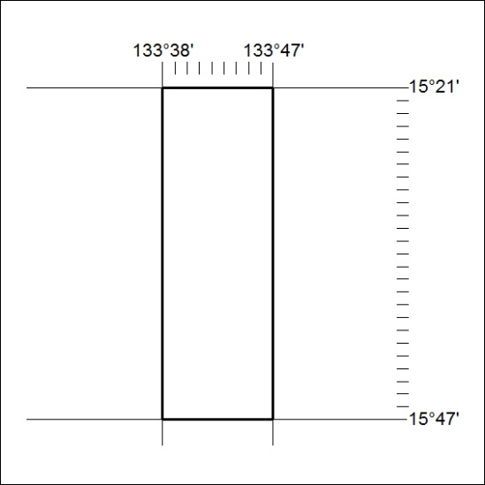
Area granted is indicated above. The titleholder is not permitted to exercise occupational rights on any land that is subject to a development title, or an application for a development title. Any land the subject of a Reserved Land gazettal under the Mineral Titles Act and all land vested in the Commonwealth of Australia is also excluded by description but not excised from the grant area.
537/18

Mineral Titles Act
NOTICE OF GRANT OF A MINERAL TITLE
Title Type and Number: | Exploration Licence 31809
Granted: | 20 November 2018, for a period of 6 Years
Area: | 234 Blocks, 774.20 km²
Locality: | MARYFIELD
Name of Holder/s: | 100% MMG EXPLORATION PTY LTD* [ACN. 119 136 659]
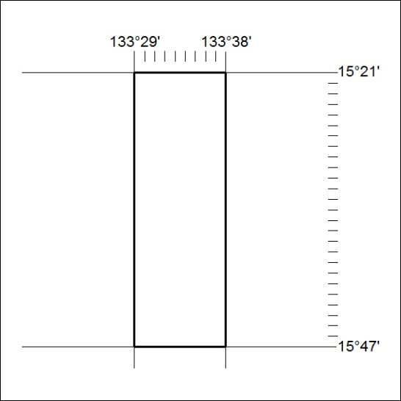
Area granted is indicated above. The titleholder is not permitted to exercise occupational rights on any land that is subject to a development title, or an application for a development title. Any land the subject of a Reserved Land gazettal under the Mineral Titles Act and all land vested in the Commonwealth of Australia is also excluded by description but not excised from the grant area.
538/18

Mineral Titles Act
NOTICE OF GRANT OF A MINERAL TITLE
Title Type and Number: | Exploration Licence 31810
Granted: | 20 November 2018, for a period of 6 Years
Area: | 228 Blocks, 754.34 km²
Locality: | LARRIMAH
Name of Holder/s: | 100% MMG EXPLORATION PTY LTD* [ACN. 119 136 659]
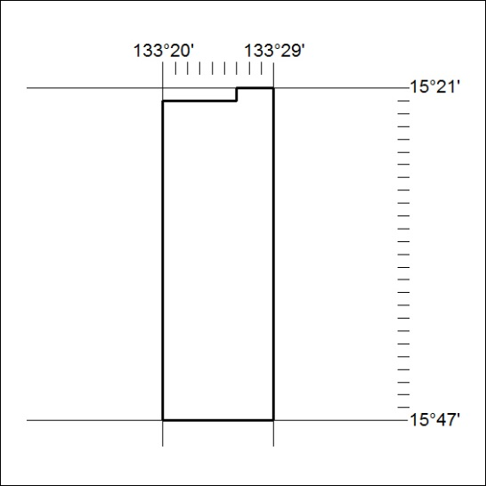
Area granted is indicated above. The titleholder is not permitted to exercise occupational rights on any land that is subject to a development title, or an application for a development title. Any land the subject of a Reserved Land gazettal under the Mineral Titles Act and all land vested in the Commonwealth of Australia is also excluded by description but not excised from the grant area.
539/18

