Mineral Titles Act
NOTICE OF GRANT OF A MINERAL TITLE
Title Type and Number: | Extractive Mineral Lease 31404
Granted: | 23 November 2018, for a period of 10 Years
Area: | 6.50 Hectares
Locality: | MARY RIVER
Name of Holder/s: | 100% DARWIN CHRISTIAN MINISTRIES INC
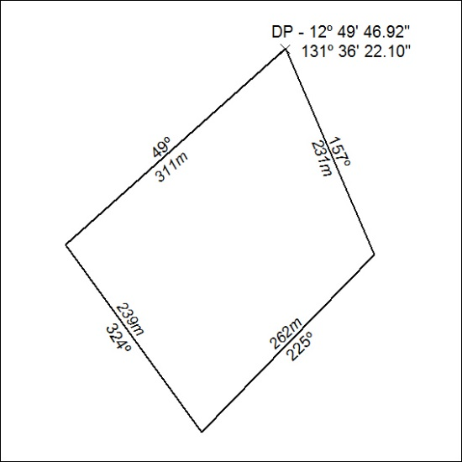

541/18

Mineral Titles Act
NOTICE OF GRANT OF A MINERAL TITLE
Title Type and Number: | Mineral Lease 29855
Granted: | 21 November 2018, for a period of 24 Years
Area: | 1460.00 Hectares
Locality: | ANNINGIE
Name of Holder/s: | 100% ENIGMA MINING LIMITED [ACN. 009 225 558]
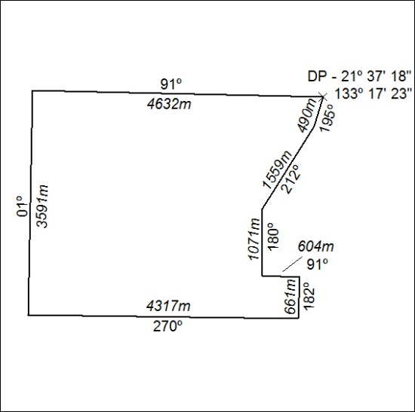

542/18

Mineral Titles Act
NOTICE OF GRANT OF A MINERAL TITLE
Title Type and Number: | Mineral Lease 29856
Granted: | 21 November 2018, for a period of 24 Years
Area: | 164.20 Hectares
Locality: | ANNINGIE
Name of Holder/s: | 100% ENIGMA MINING LIMITED [ACN. 009 225 558]
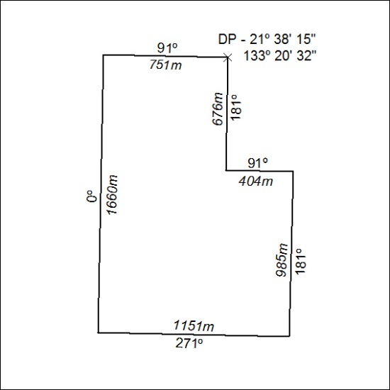

543/18

Mineral Titles Act
NOTICE OF GRANT OF A MINERAL TITLE
Title Type and Number: | Mineral Lease 30686
Granted: | 21 November 2018, for a period of 24 Years
Area: | 104.00 Hectares
Locality: | HOME OF BULLION
Name of Holder/s: | 100% ENIGMA MINING LIMITED [ACN. 009 225 558]
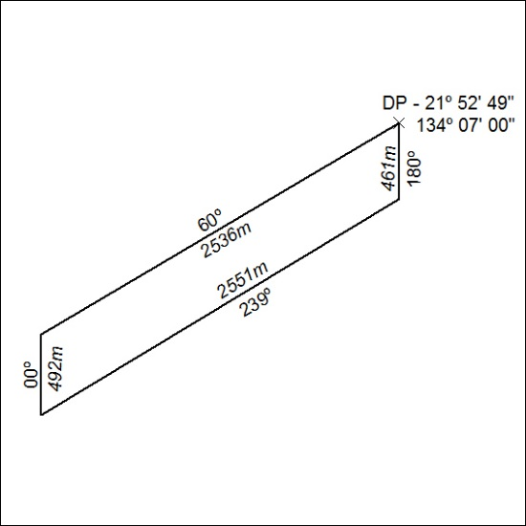

544/18

