Mineral Titles Act
NOTICE OF LAND CEASING TO BE A MINERAL TITLE AREA
Title Type and Number: | Exploration Licence 23971
Area Ceased on: | 11 December 2018
Area: | 2 Blocks, 6.72 km²
Locality: | WELLINGTON RANGE
Name of Applicant(s)/Holder(s): | 100% RIO TINTO EXPLORATION PTY LIMITED [ACN. 000 057 125]
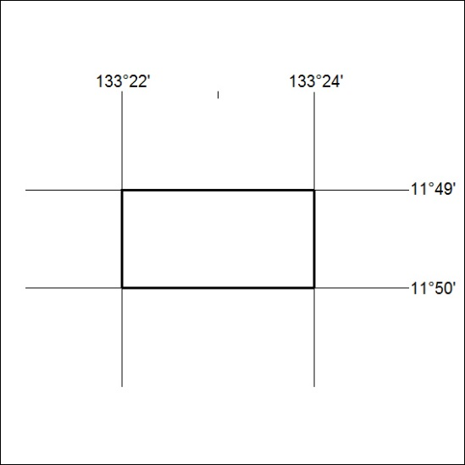

569/18

Mineral Titles Act
NOTICE OF LAND CEASING TO BE A MINERAL TITLE AREA
Title Type and Number: | Exploration Licence 24009
Area Ceased on: | 11 December 2018
Area: | 3 Blocks, 9.69 km²
Locality: | GOSSE RIVER
Name of Applicant(s)/Holder(s): | 100% RED METAL LIMITED [ACN. 103 367 684]
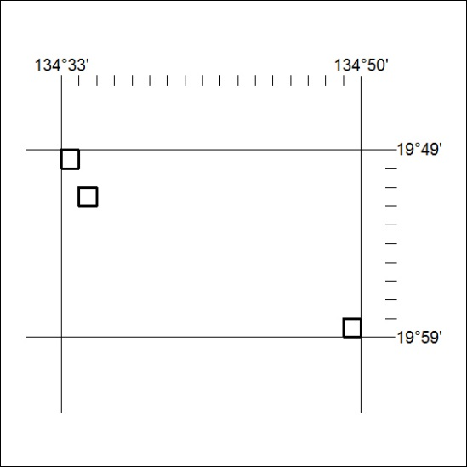

570/18

Mineral Titles Act
NOTICE OF LAND CEASING TO BE A MINERAL TITLE AREA
Title Type and Number: | Exploration Licence 28528
Area Ceased on: | 06 December 2018
Area: | 74 Blocks, 243.49 km²
Locality: | MALLAPUNYAH
Name of Applicant(s)/Holder(s): | 100% LEGEND INTERNATIONAL HOLDINGS, INC. [ACN. 120 855 352]
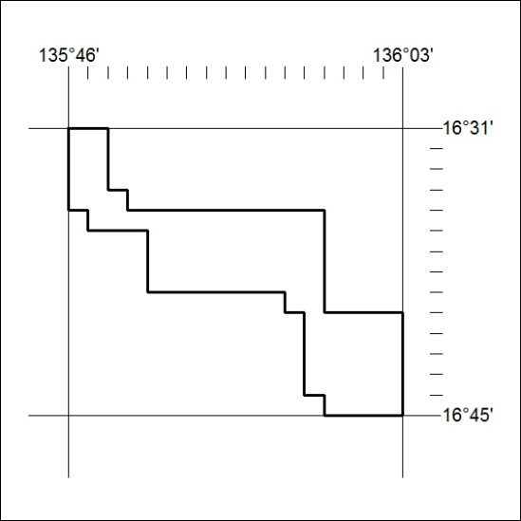

571/18

Mineral Titles Act
NOTICE OF LAND CEASING TO BE A MINERAL TITLE AREA
Title Type and Number: | Exploration Licence 29487
Area Ceased on: | 06 December 2018
Area: | 85 Blocks, 279.42 km²
Locality: | MALLAPUNYAH
Name of Applicant(s)/Holder(s): | 100% LEGEND INTERNATIONAL HOLDINGS, INC. [ACN. 120 855 352]
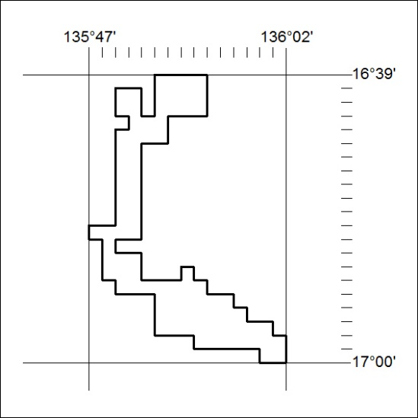

572/18

Mineral Titles Act
NOTICE OF LAND CEASING TO BE A MINERAL TITLE AREA
Title Type and Number: | Exploration Licence 31209
Area Ceased on: | 11 December 2018
Area: | 91 Blocks, 283.72 km²
Locality: | WINGATE MOUNTAINS
Name of Applicant(s)/Holder(s): | 100% TODD RIVER METALS PTY LTD [ACN. 600 314 038]
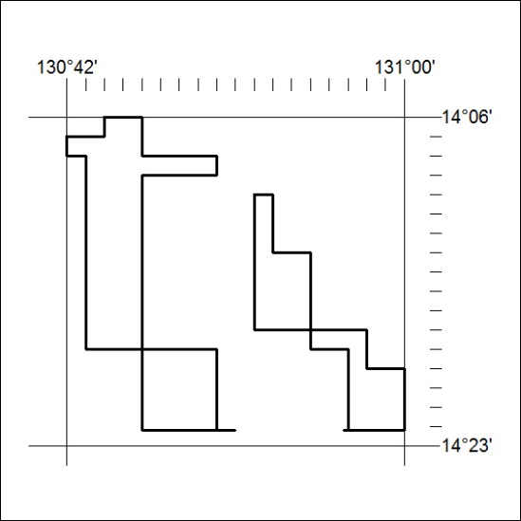

573/18

Mineral Titles Act
NOTICE OF LAND CEASING TO BE A MINERAL TITLE
Title Type and Number: | Extractive Mineral Permit (Northern) 1308
Area ceased on: | 11 December 2018
Area: | 6.00 Hectare
Locality: | KOOLPINYAH
Name of Applicants(s)Holder(s): | 100% ALISANTE HOLDINGS PTY LTD [ACN. 067 361 559]
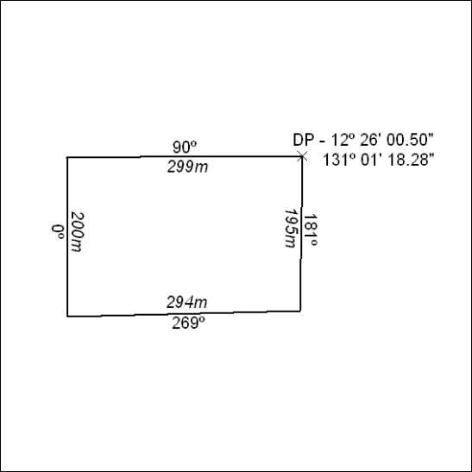

574/18

Mineral Titles Act
NOTICE OF LAND CEASING TO BE A MINERAL TITLE
Title Type and Number: | Extractive Mineral Permit 23449
Area ceased on: | 11 December 2018
Area: | 28.00 Hectare
Locality: | KOOLPINYAH
Name of Applicants(s)Holder(s): | 100% ALISANTE HOLDINGS PTY LTD [ACN. 067 361 559]
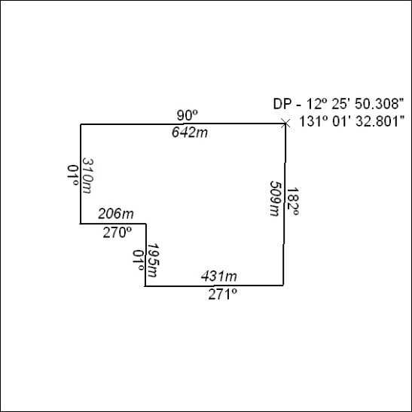

575/18

Corrigendum
Notice Number 556/18 appearing in MN159/18 on 4 DECEMBER 2018 is hereby cancelled and replaced by the following:

Mineral Titles Act
NOTICE OF GRANT OF A MINERAL TITLE
Title Type and Number: | Exploration Licence 31872
Granted: | 30 November 2018, for a period of 6 Years
Area: | 236 Blocks, 695.40 km²
Locality: | CONICAL HILL
Name of Holder/s: | 100% INDEPENDENCE GROUP NL* [ACN. 092 786 304]
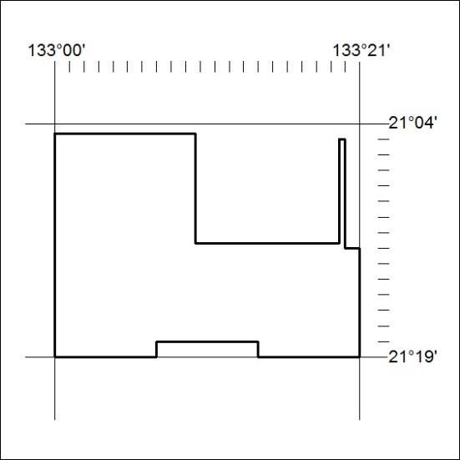
Area granted is indicated above. The titleholder is not permitted to exercise occupational rights on any land that is subject to a development title, or an application for a development title. Any land the subject of a Reserved Land gazettal under the Mineral Titles Act and all land vested in the Commonwealth of Australia is also excluded by description but not excised from the grant area.

576/18

